Report Editor - Rainbow Version 4 #64639
Prototype:https://www.figma.com/proto/3y9k70uCIOpcrBw8zqZ2yR/Email-Campaign?page-id=5143%3A13945&node-id=5143-18164&viewport=241%2C258%2C0.13&t=gwfMoGzq7R78OFGi-1&scaling=min-zoom&content-scaling=fixed&starting-point-node-id=5143%3A18164
Stake Holder:
Rainbow
Feature and Functionality:
We removed the Financial Information from the Company profile,
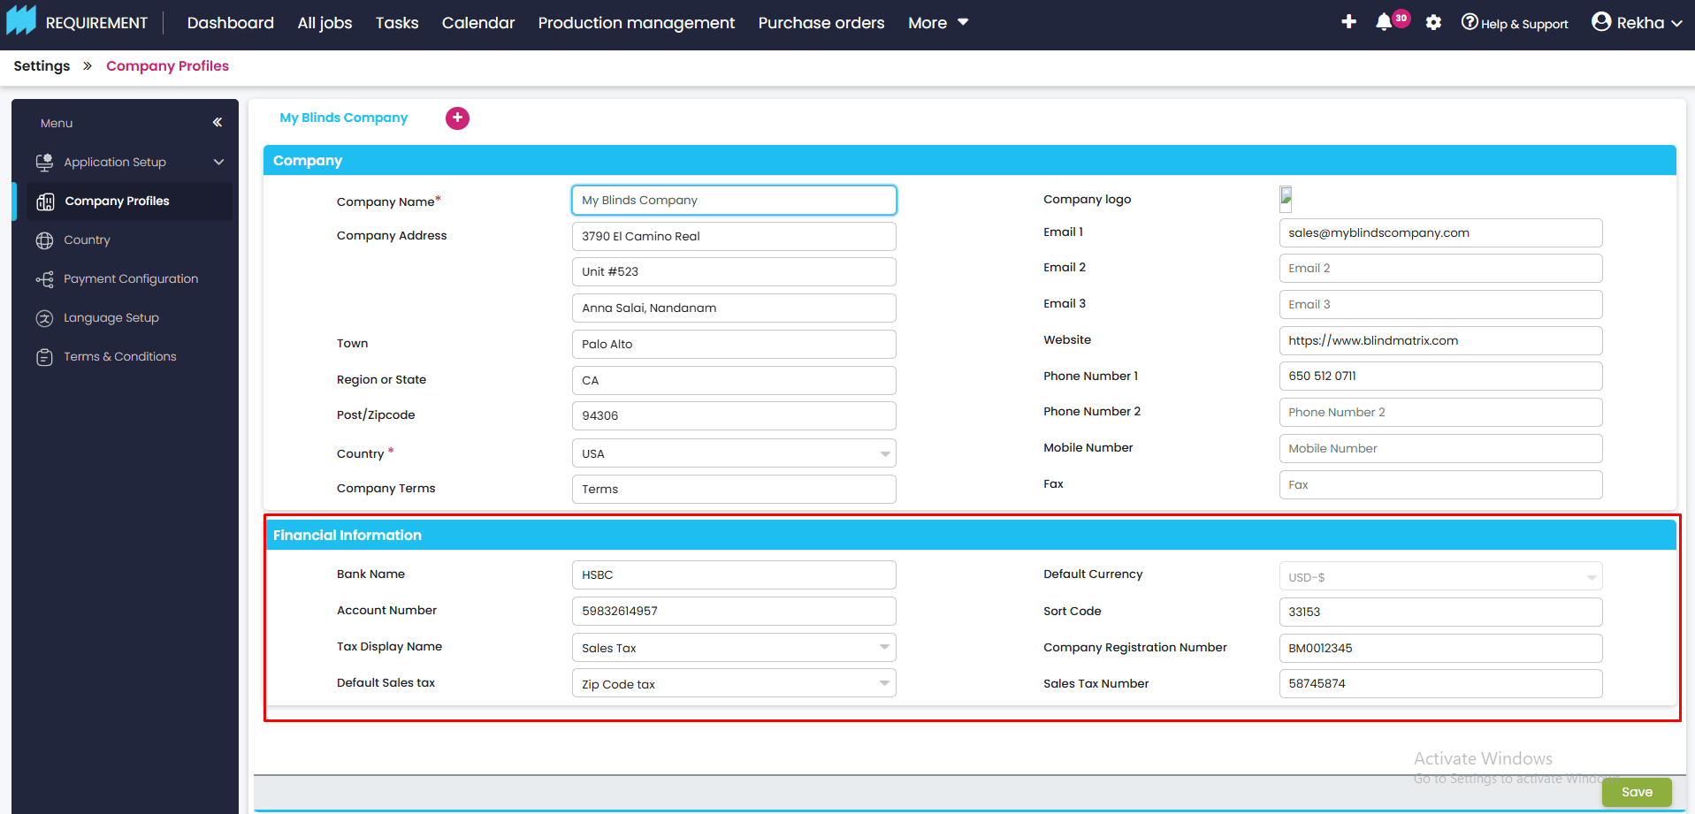
placed underneath of company profile,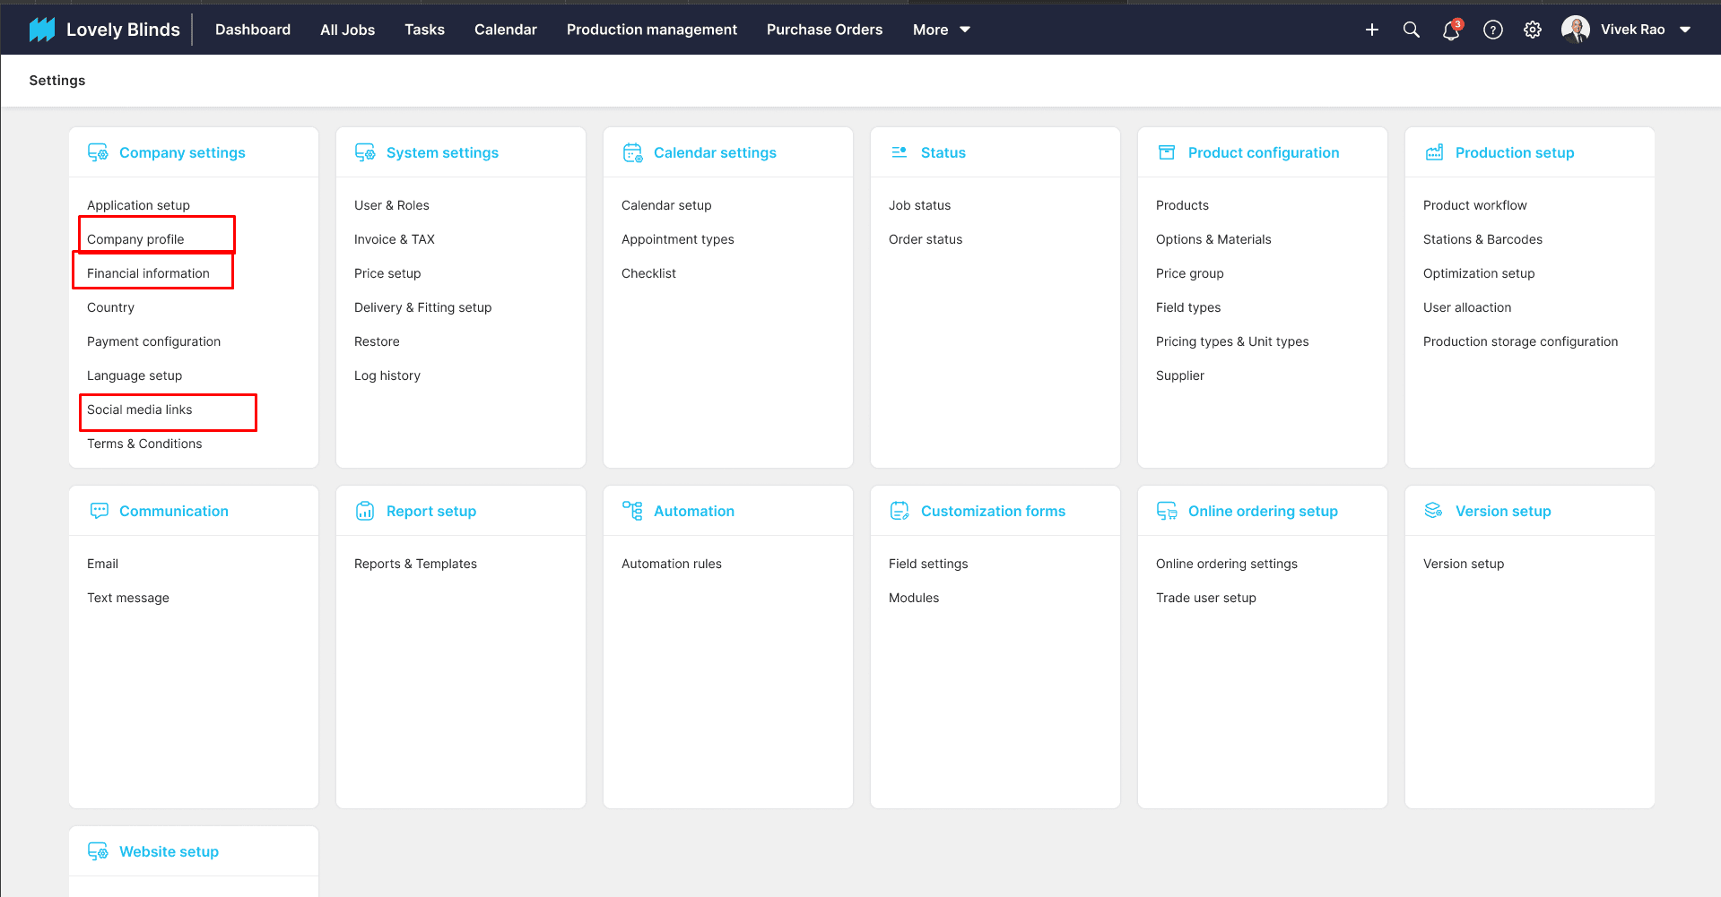

Updated company profile screen without financial information,
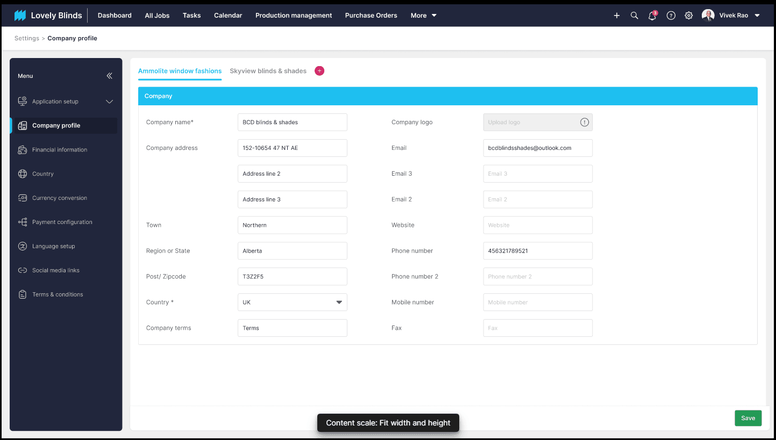
If we click on "Financial Information," we'll show this based on the company profile.
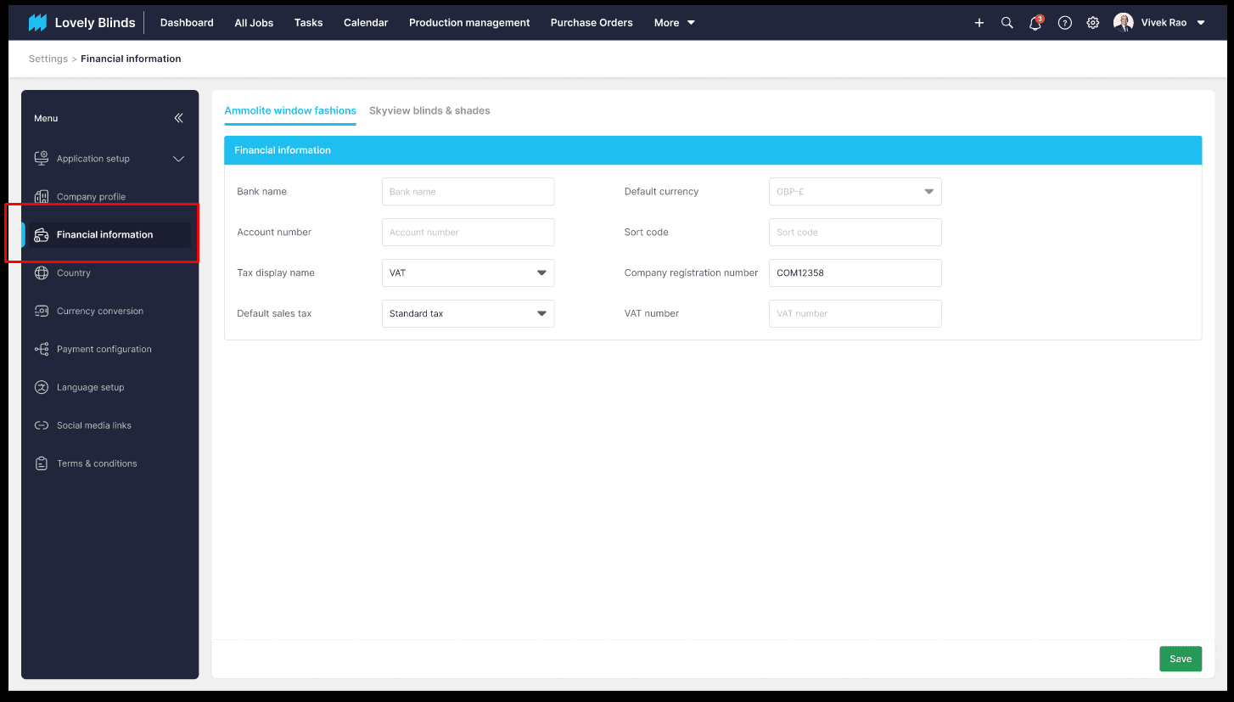
We've added one more menu called "Social media links" underneath of Language setup.
These fields are static, and here we could enter the social media links based on company.
If we create the new company from the company profile, the respective company gets added here automatically.
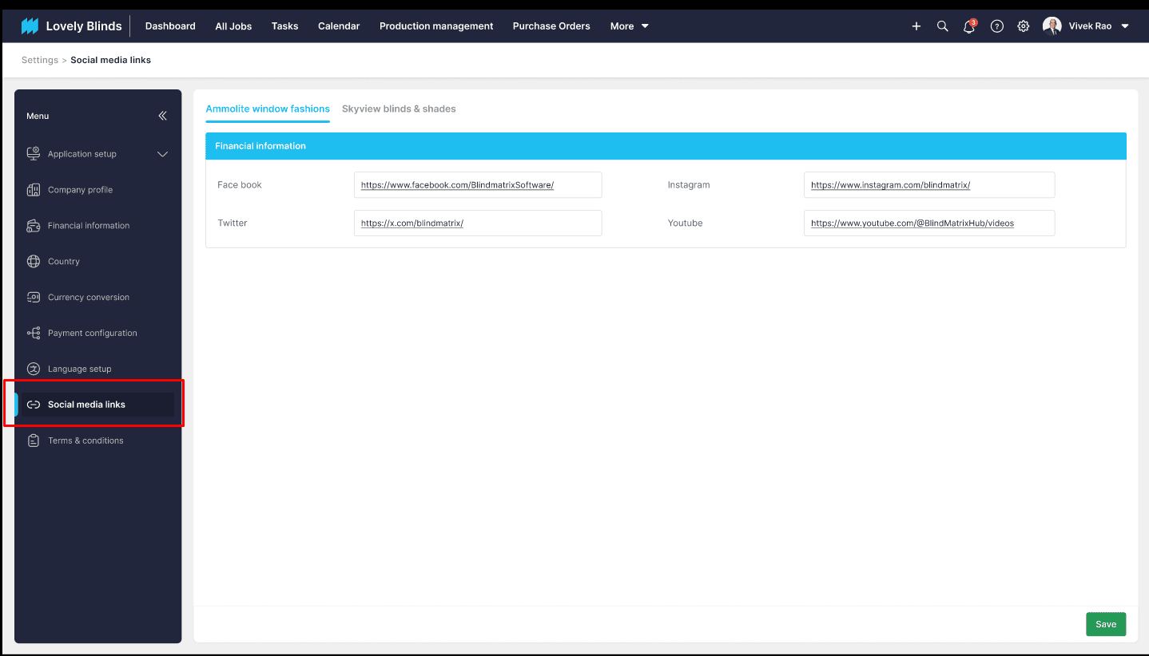
We're going to use these social media links when creating email templates as follows,
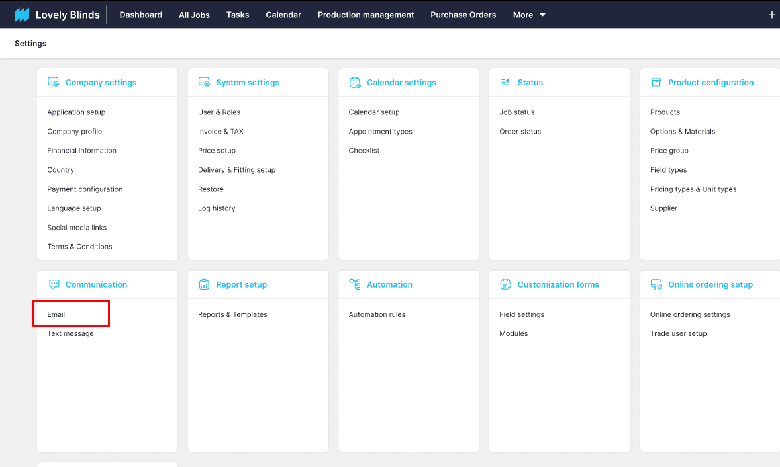
In Email under settings >> Click on the Email Templates >> Click on the edit email templates or create new email templates,
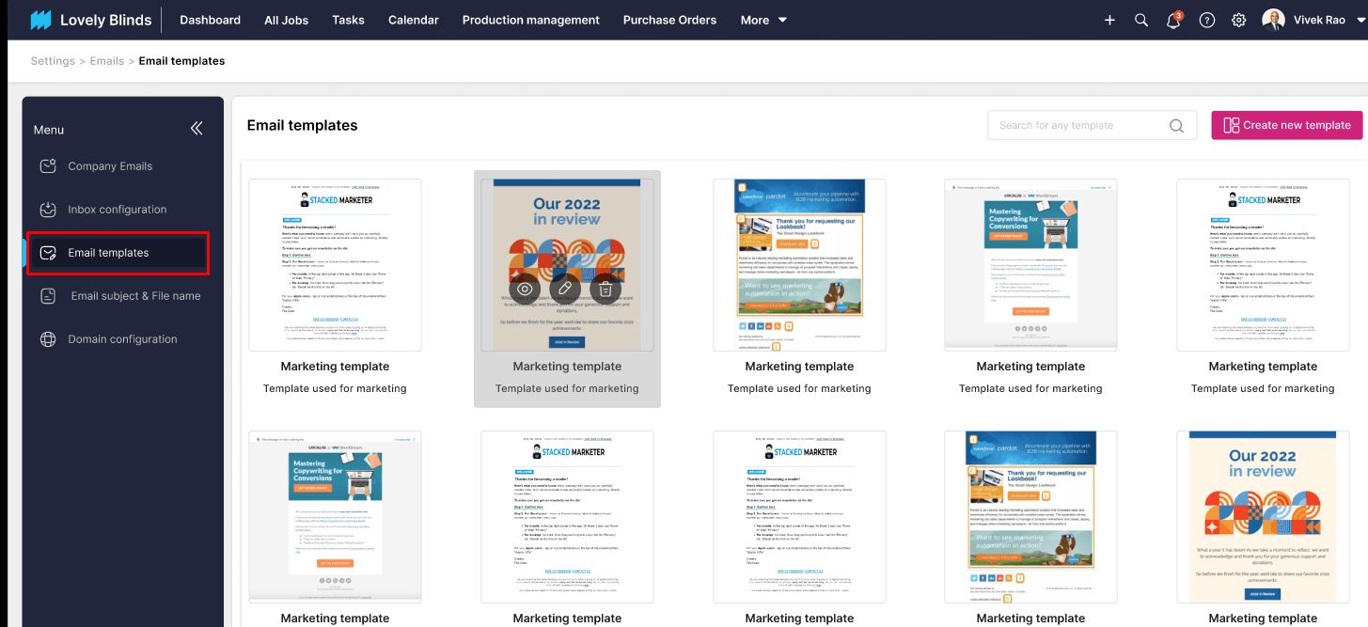
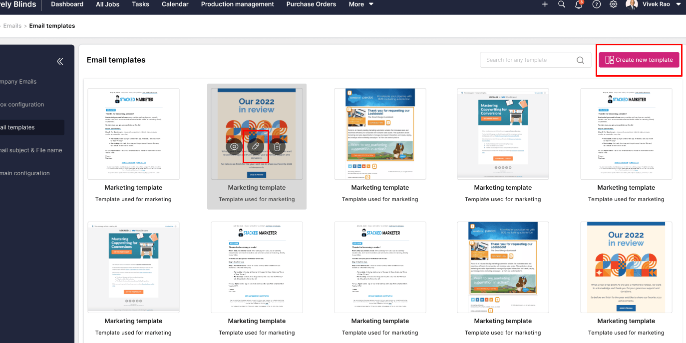
In the email template screen, by default, the system will fetch the social media links provided in the default organization (First organization).
Customer could change these social media links as they required,

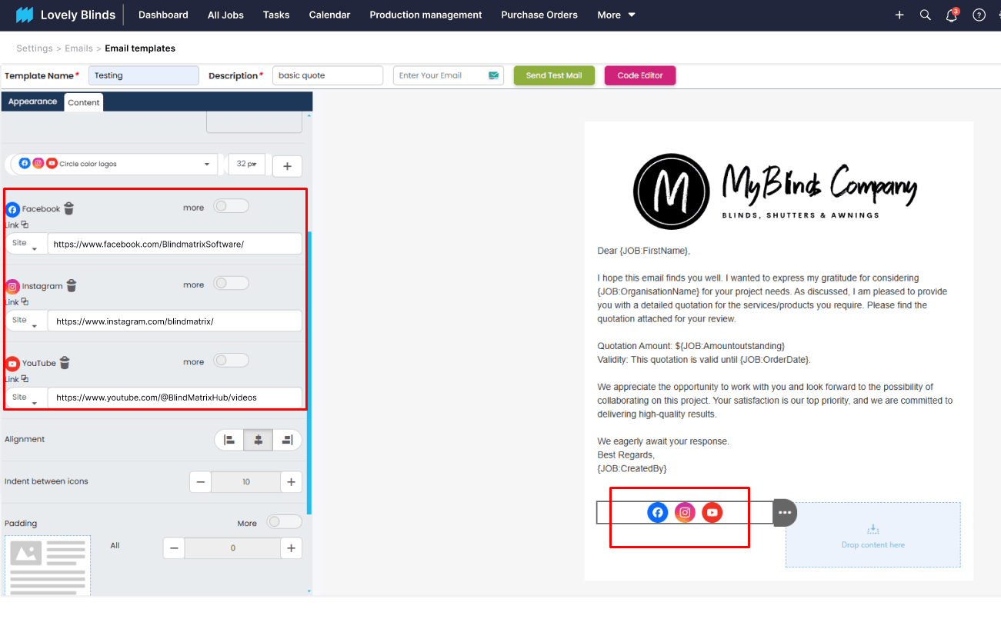
Also, this is applicable for when creating the email templates from the email campaigns,
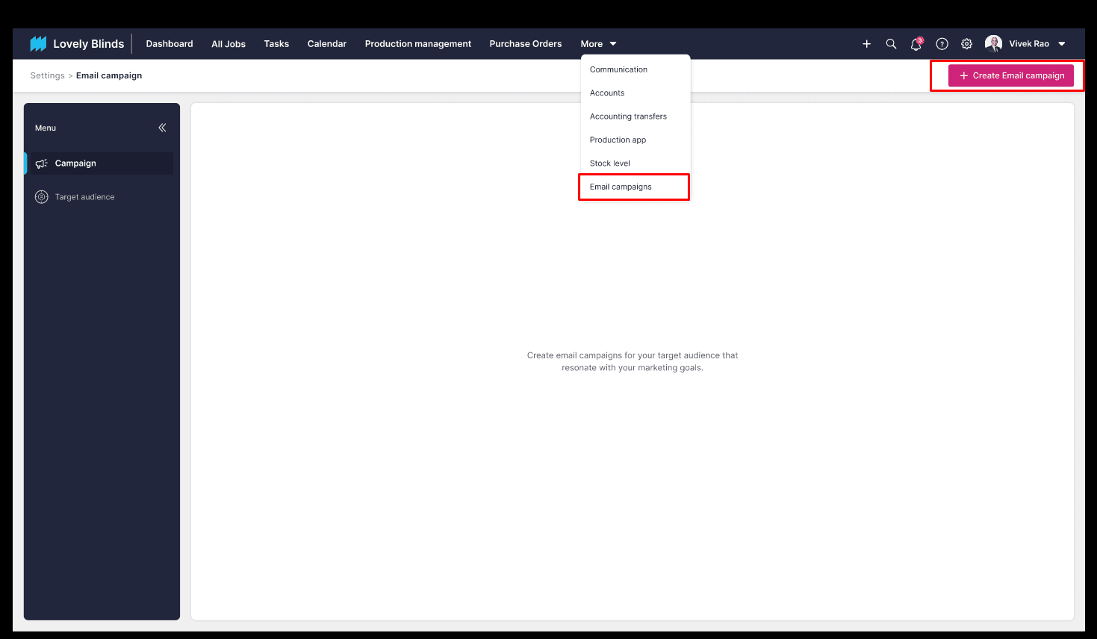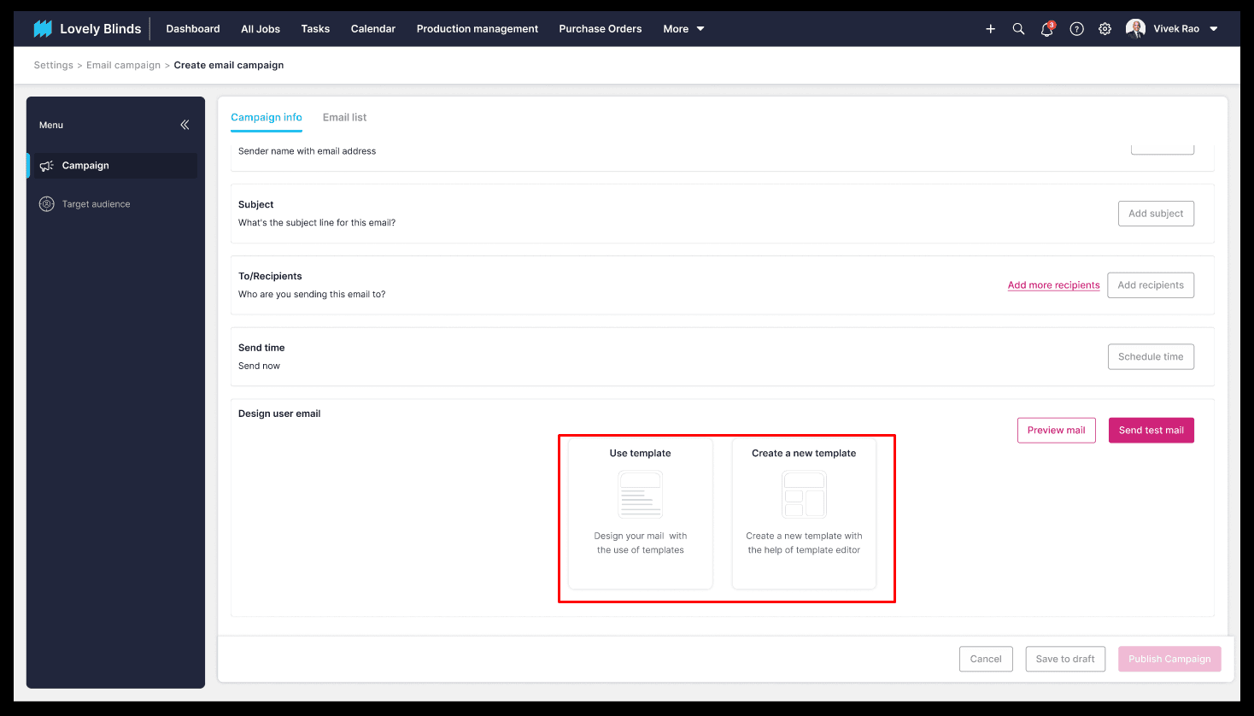
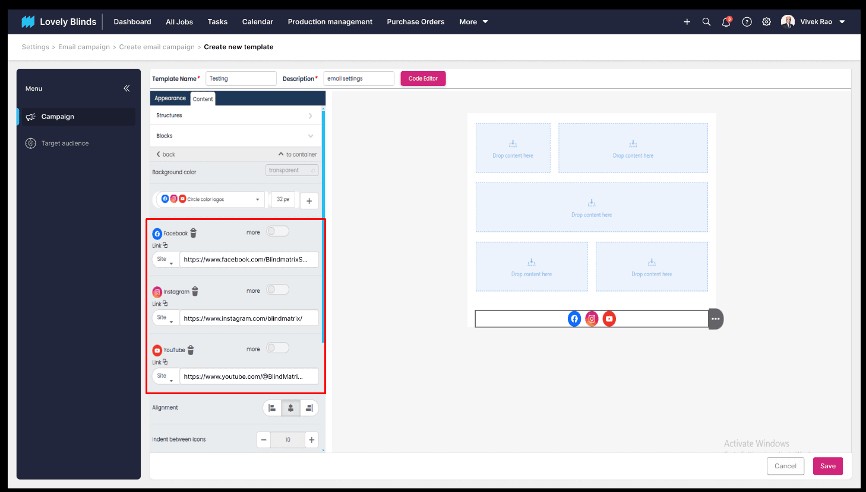

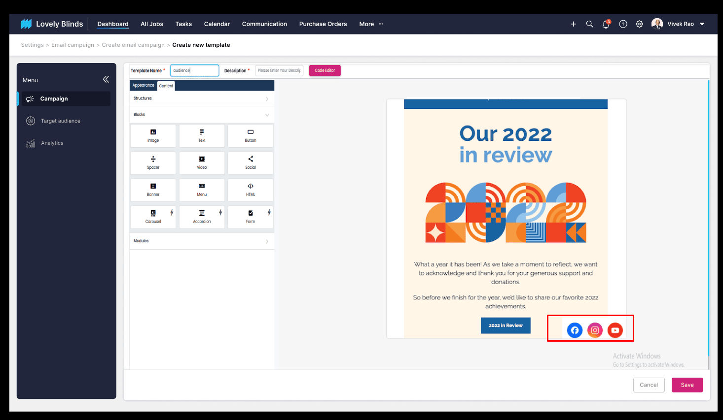
When we click on this social media icons, the respective page will be open as a separate tab as below screen,
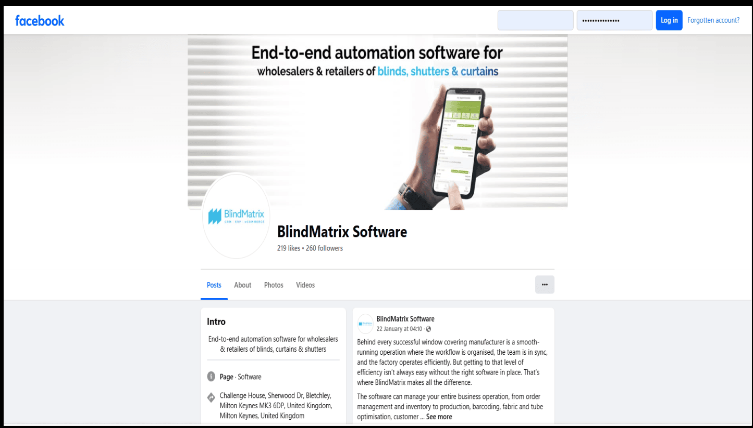
NOTE: Social media links which are not fetched automatically based on organization. Default organization's social media links are only shown by default. Customer could change it.
This is applicable for desktop, mobile, and online portals

