XERO CONFIGURATION
- In Blind Matrix Application
Go to Settings >> Accounting Software Integration and select Xero-v2 in the dropdown

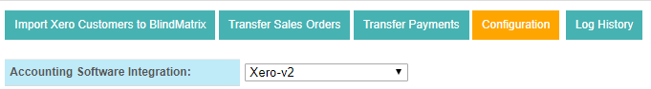
- Login Xero with the URL https://login.xero.com/
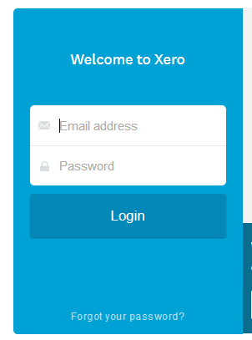

Enter the valid Email Address and Password, the below screen will show up.
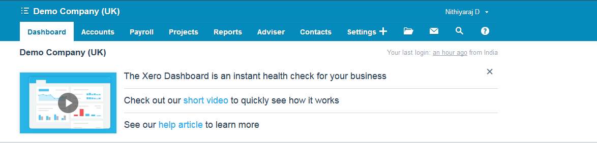

- Open a new page in the browser and enter the URL https://developer.xero.com/
Go to My Apps and click New App
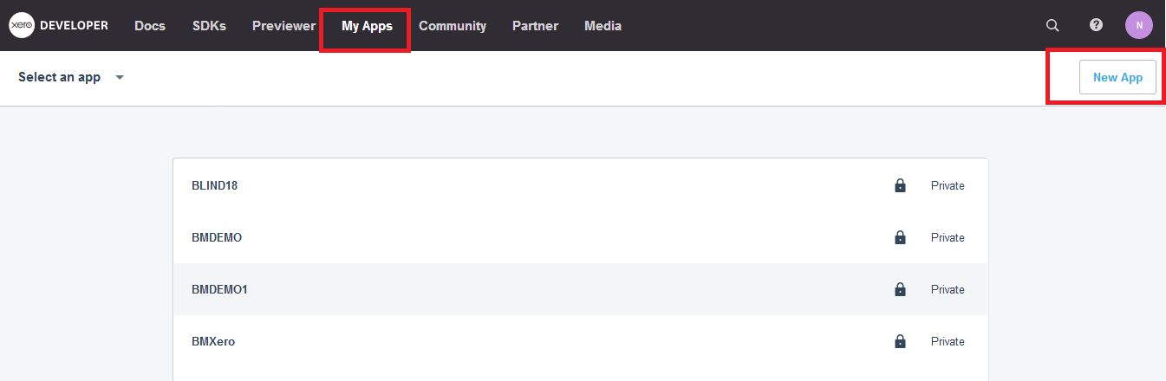

Once the New app is clicked the below pop screen will show.
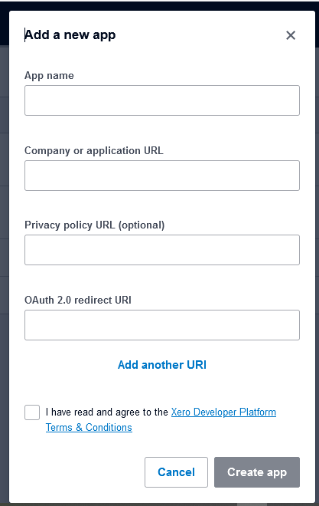
Enter the App Name,Company URL,Privacy policy URL(optional) and enter redirect URI
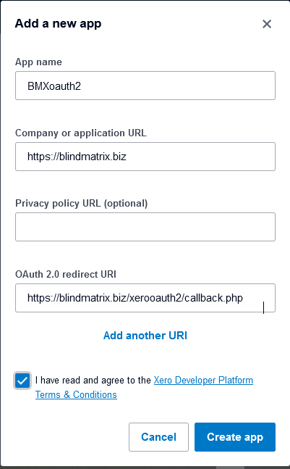
Then tick the terms and conditions and click on Create app.
- Once the app is created you will find the Client id and Click on Generate a secret .

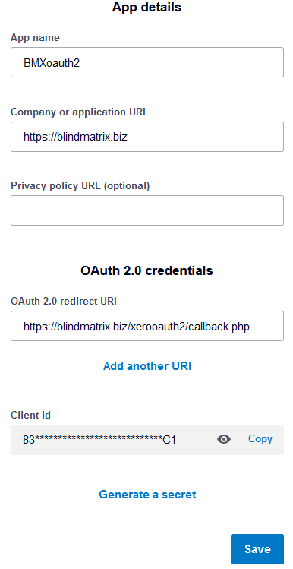
and then generated Client secret.
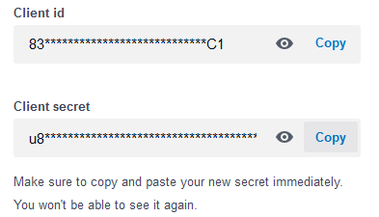
Please copy and paste these key in the respective field on BlindMatrix application. Click on Save

- Now select the transfer type. There are 2 types of Transfer types

  - Transfer line item
  - Transfer Invoice
If you choose transfer line item, follow the below steps
    - Click on Connect the Xero. You will get below screen then click on Allow Access. This will show app name.
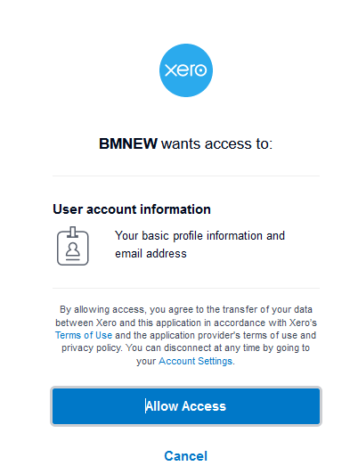
    - Now click Connect and redirect to BM application and click on Save under Configuration tab.
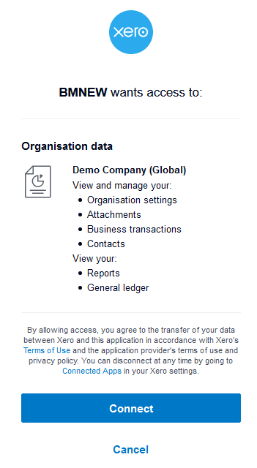

You have now successfully integrated Xero with BM, you could transfer the Invoices and payments.
If you choose transfer Invoice, follow the below steps
- You need to create the new INVENTORY for Accounts to show on Application Xero
- Go to Bussiness >> Product & Services and click “+New Item” button, you will see the below pop up

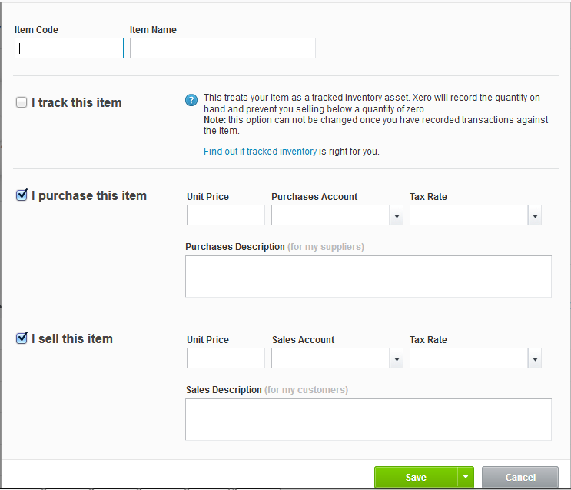

Enter the Item code, Item Name and enter the details for “I sell this item” Sales account and the Tax rate is mandatory, Once entered the details click save.

The Created items will show up in the below screen in BlindMatrix Application in Transfer Sales Orders
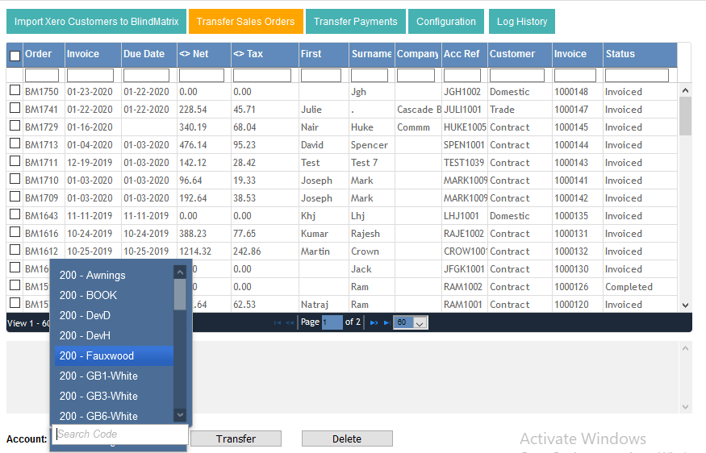

You have now successfully integrated Xero with BM, you could transfer the Invoices and payments.
Frequently asked Questions:
How to transfer sales orders:
Once Xero is configured go to Transfer sales orders tab, select the orders and click transfer. Make sure that the account field is selected.
How to transfer sales orders:
Go to Transfer payments tab, , select the orders and click transfer.
How to Find the Invoice Xero
Go to Business Invoice then search the order we have transferred from application we will get the order details
