1. In all job pages, Copy customer and product, that order are incorrectly fetching the amount outstanding values
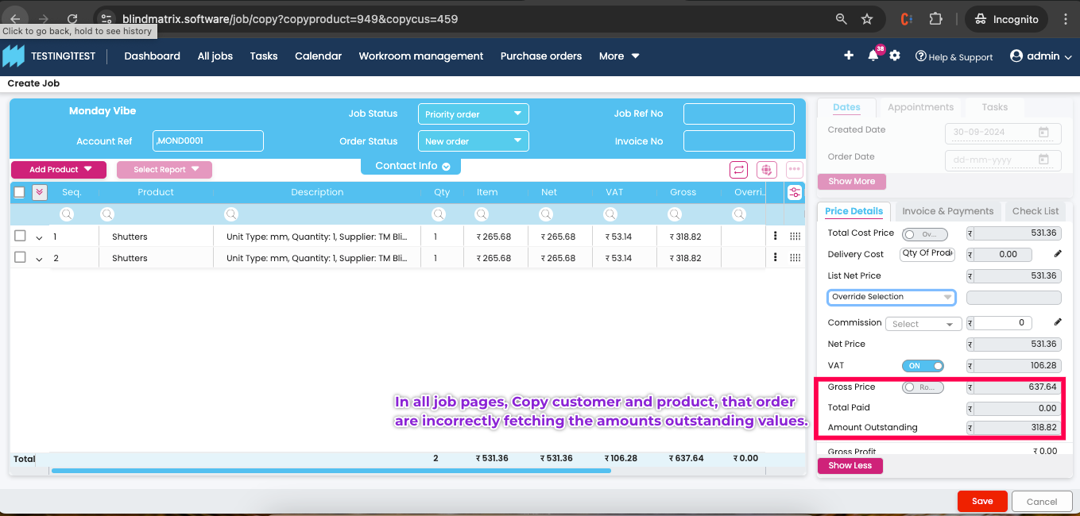
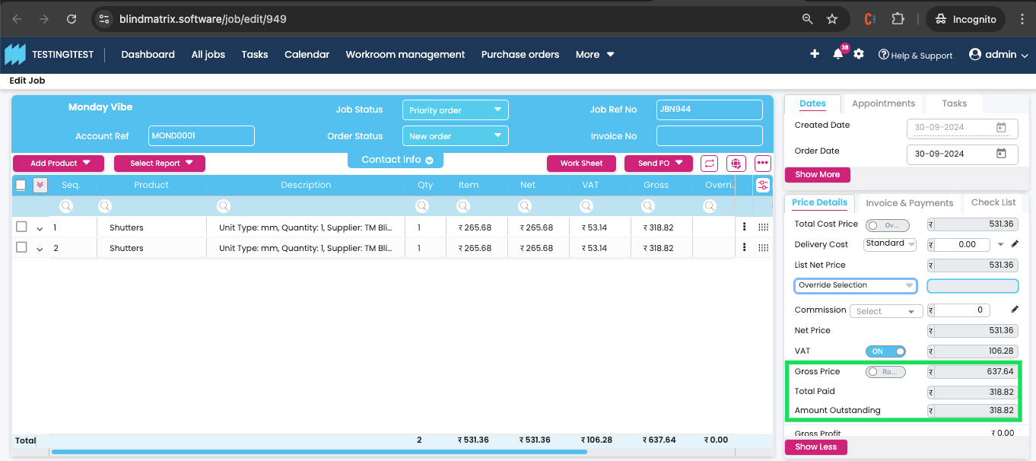
2. DB to DB transfer via the EDI order, the price values are not being fetched on all job pages.
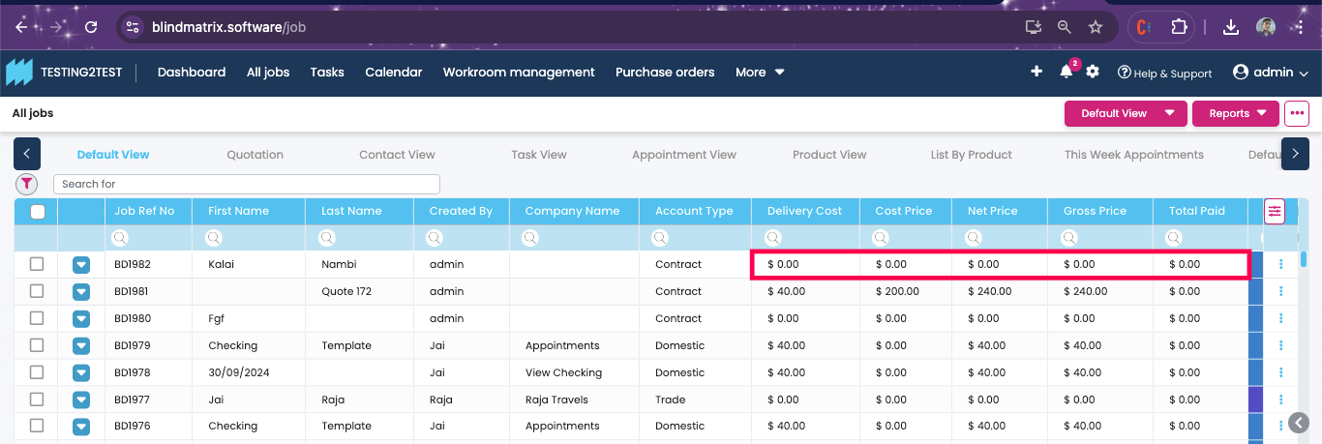
3. If the account is on-hold, the above alert should be shown only on creating a job for the account. Now the alert is shown every time the page is reloaded or Job saved.
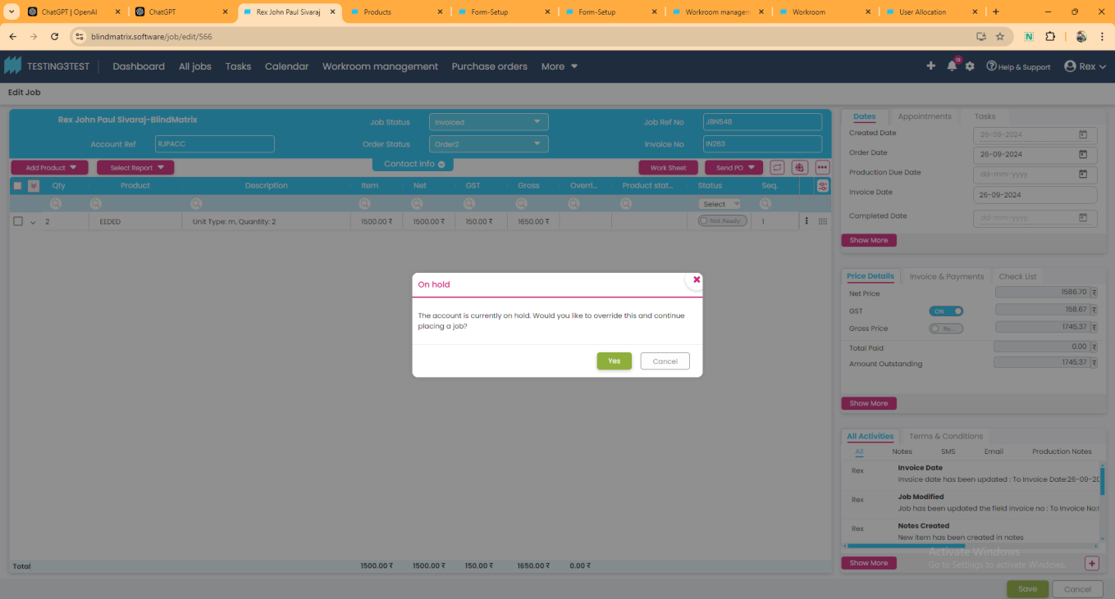

4. Price table issue – order item width only is there that time price table price calculated.
