BUGS - LA-I1430-CHANGES TO THE PRODUCT GENERAL INFO PAGE_BY VIVEK
1 ) while adding multiple images in the images column the alignment changes and then we are not able to scroll down to check
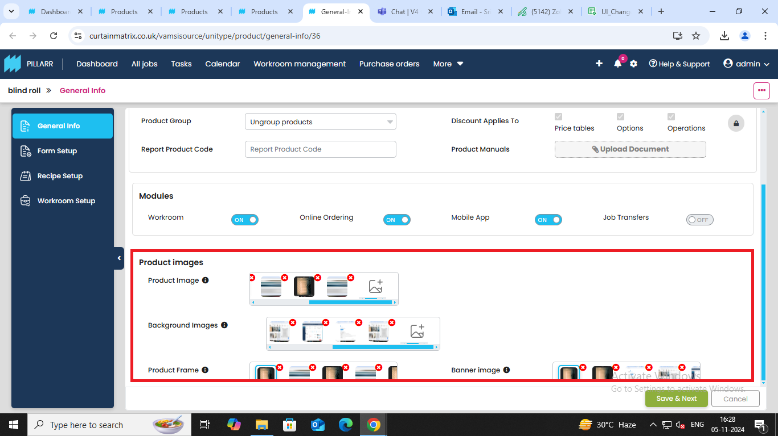

2) While trying to add a different type of file format in product image the error message doesn’t show below the product image space inserted it shows the error in the product manual space.
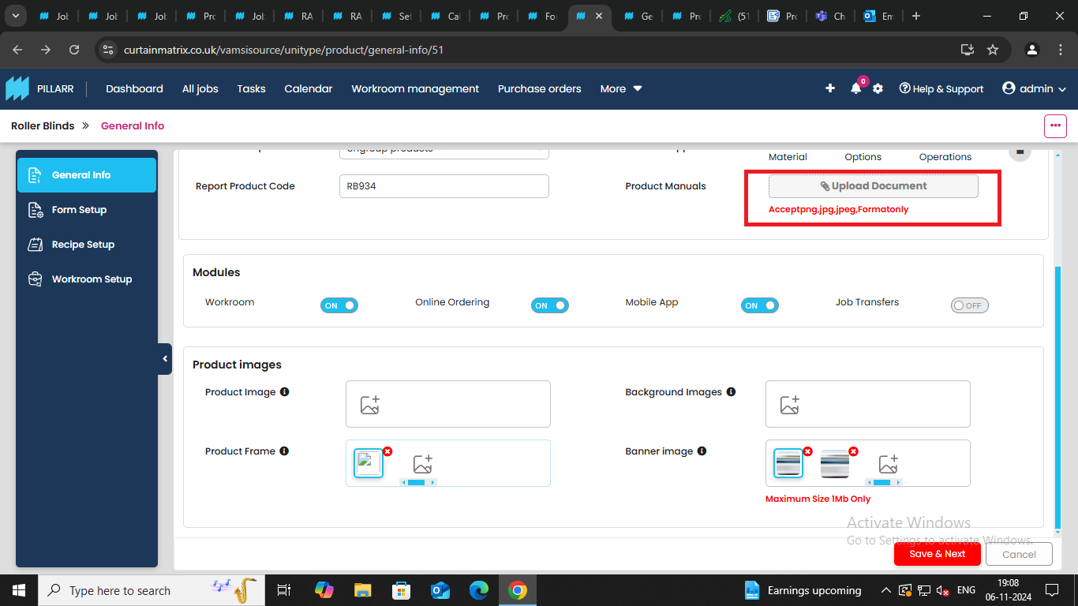
3) while adding a wrong file size image the error message pops up but after adding another image it doesn’t goes off ( this issue is only with the error message max size 1 tb)
