Bugs :
1. The dropdown arrow is not clearly highlighted as shown in the Figma design, and it is positioned at the far right edge instead of being properly aligned within the border as per the Figma layout.
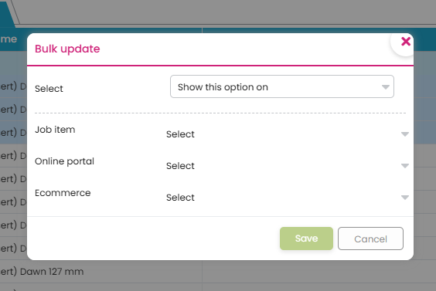
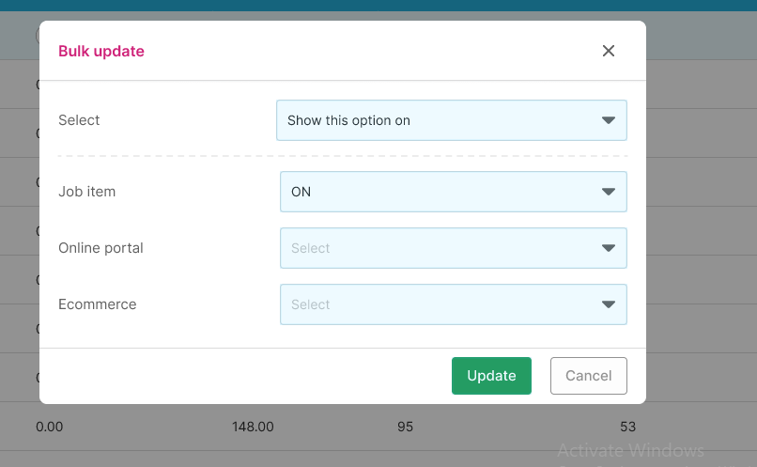
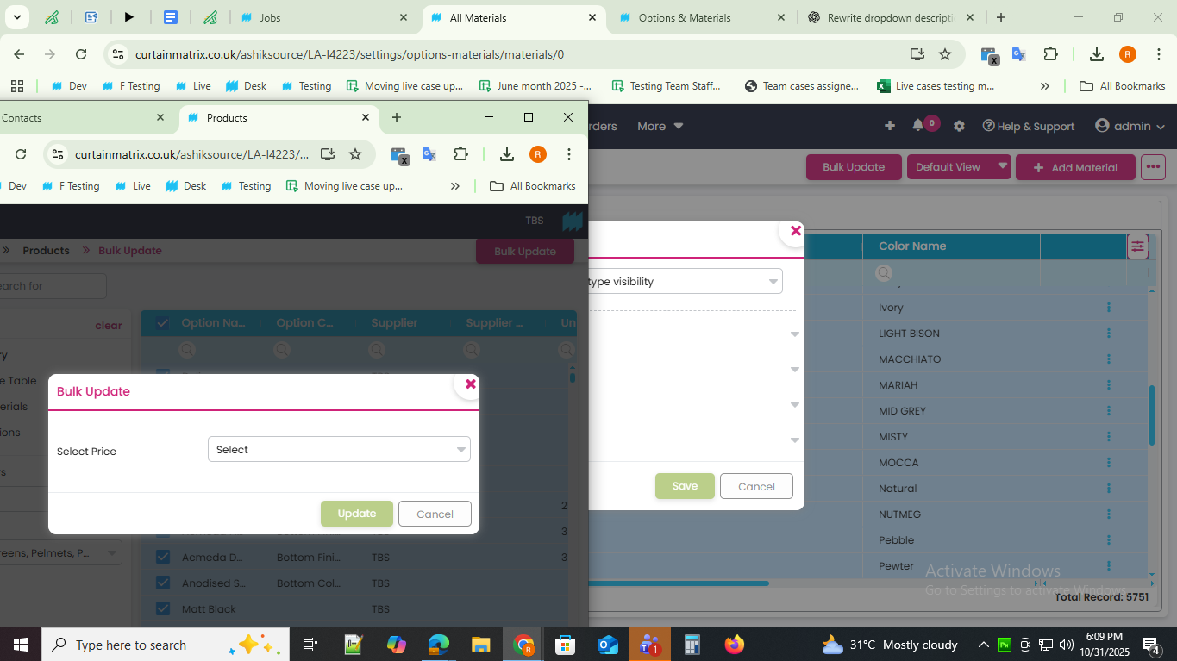

2. Instead of the “Update” button specified in the document and Figma design, a “Save” button is displayed here — this should be corrected to match the design.

3.No data is found when filtering under the supplier field, whereas performing the same action in the dev source successfully retrieves data.
