23/6
4. Filter is not working
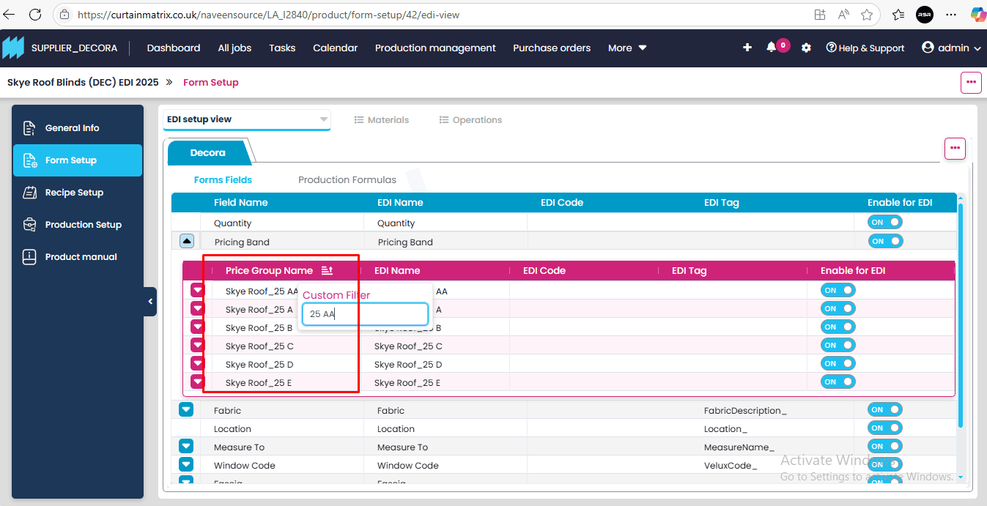
5. LITTLEHAMPTONBLINDS - Colors were not showing under color field
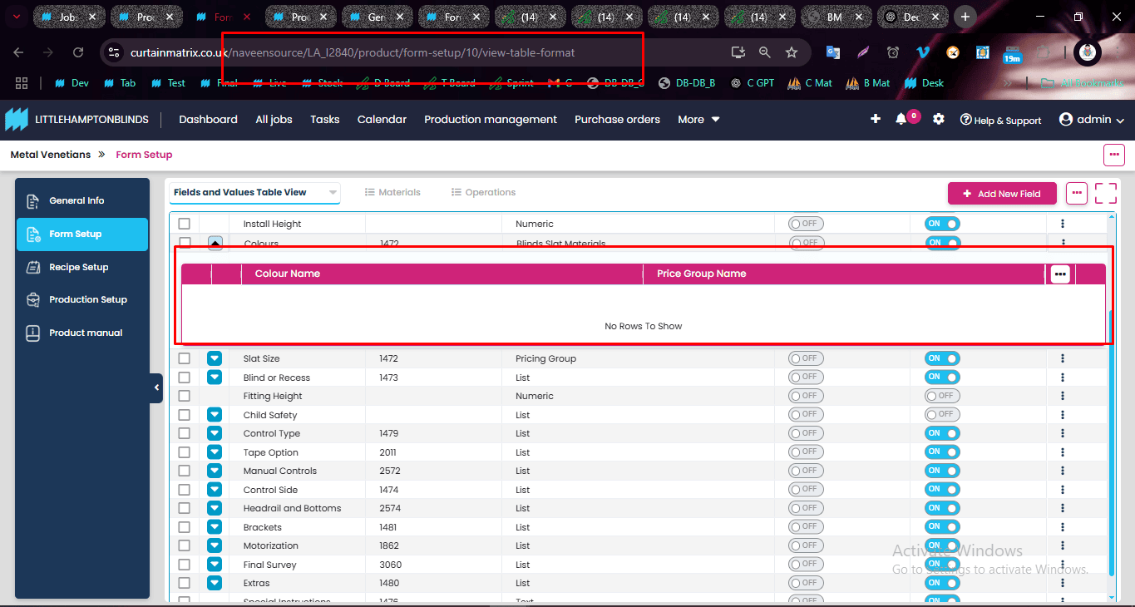

6. UI ISSUE regarding sub- fields ( screen recording uploaded in group )
7. Unable to add 7 th level field and options
