Default staff for Jobs and appointments
Prototype:
https://www.figma.com/proto/Jr90ocsEcVPjgV8H2BpsDm/BlindMatrix-CRM-Job-Module?node-id=7963-20807&p=f&t=U2Ss6kpnYkWNWYHp-0&scaling=scale-down&content-scaling=fixed&page-id=7963%3A2449&starting-point-node-id=7963%3A20807

The purpose of this feature is to streamline account handling by:
- Assigning a default account manager responsible for handling job-related operations.
- Pre-assigning a default staff member to appointments related to this account.

Functional Requirements:
- The "Account Manager" field should be a drop-down populated with all active staff members.
- Only one account manager can be assigned per account.
- The "Default Staff for Appointment" field should be a dropdown displaying active appointment types (e.g., Sales, Fitter).
- Once an appointment type is selected, a "Staff Name" dropdown must appear, showing only those staff members associated with the selected role.
- The "Staff Name" dropdown must support multi-selection, allowing users to assign multiple staff members.
- All selected values must be saved and automatically applied to the job page when a job is created for that account.
- Users must be able to update or modify these selections from the drop-downs at any time during job processing.
- Any updates to the default selections must be saved and retained in the system.

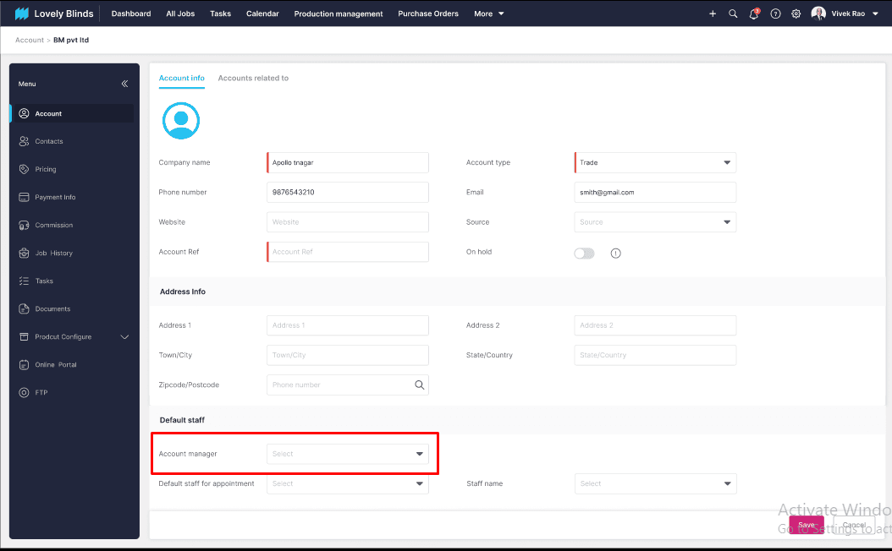
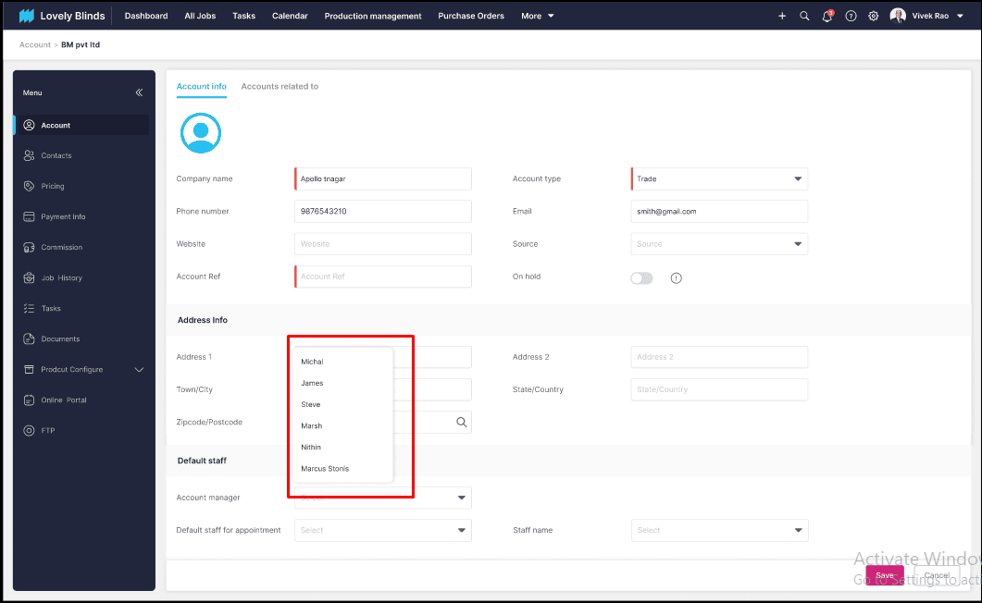
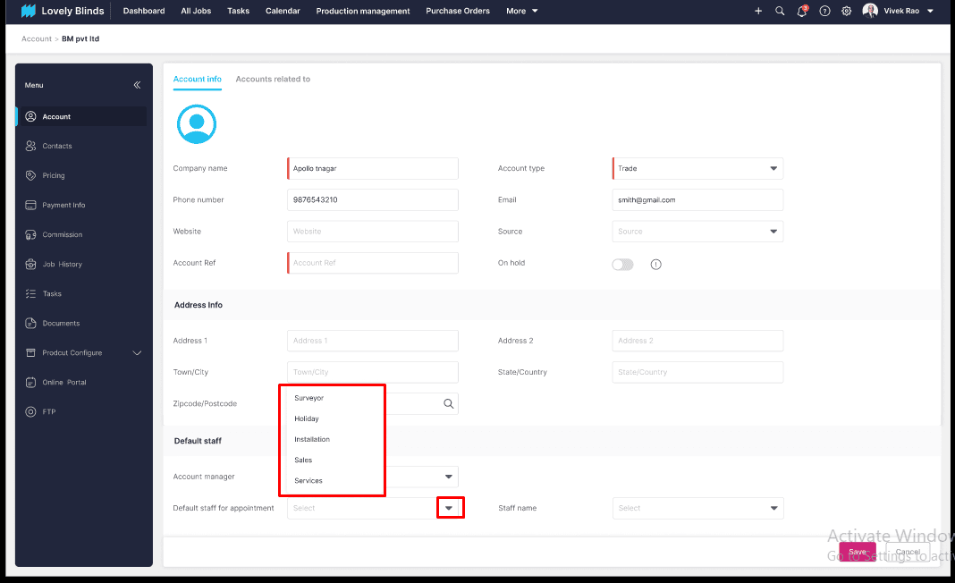
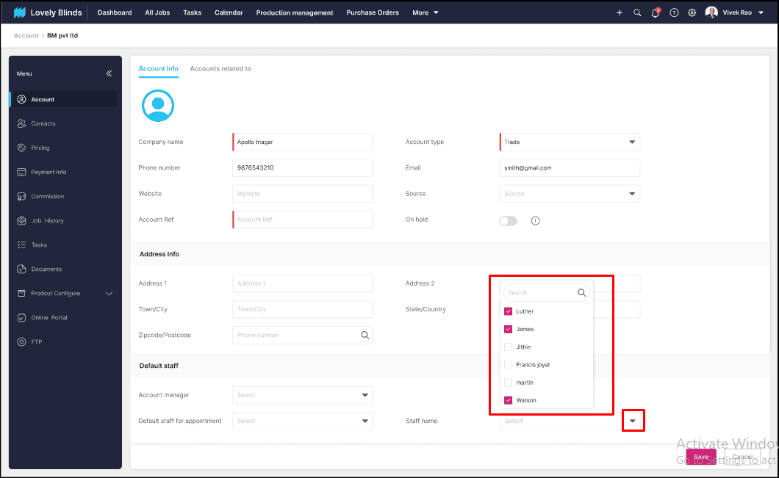
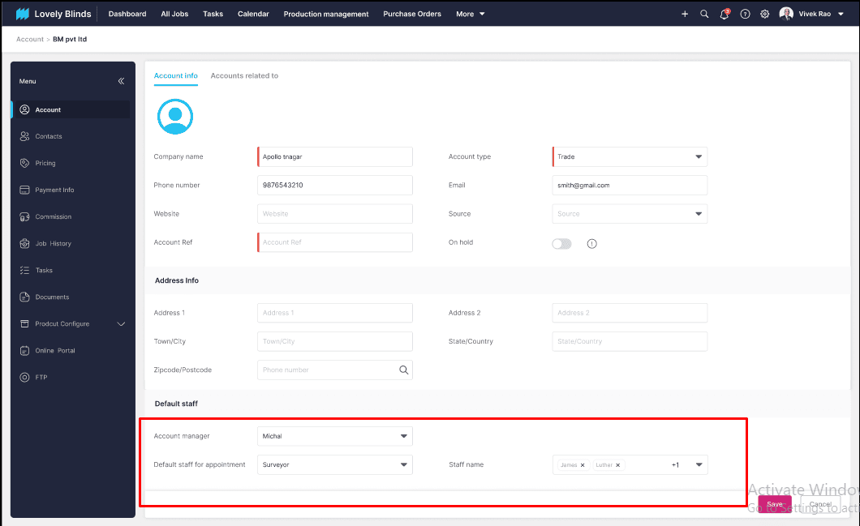
Job page screenshot
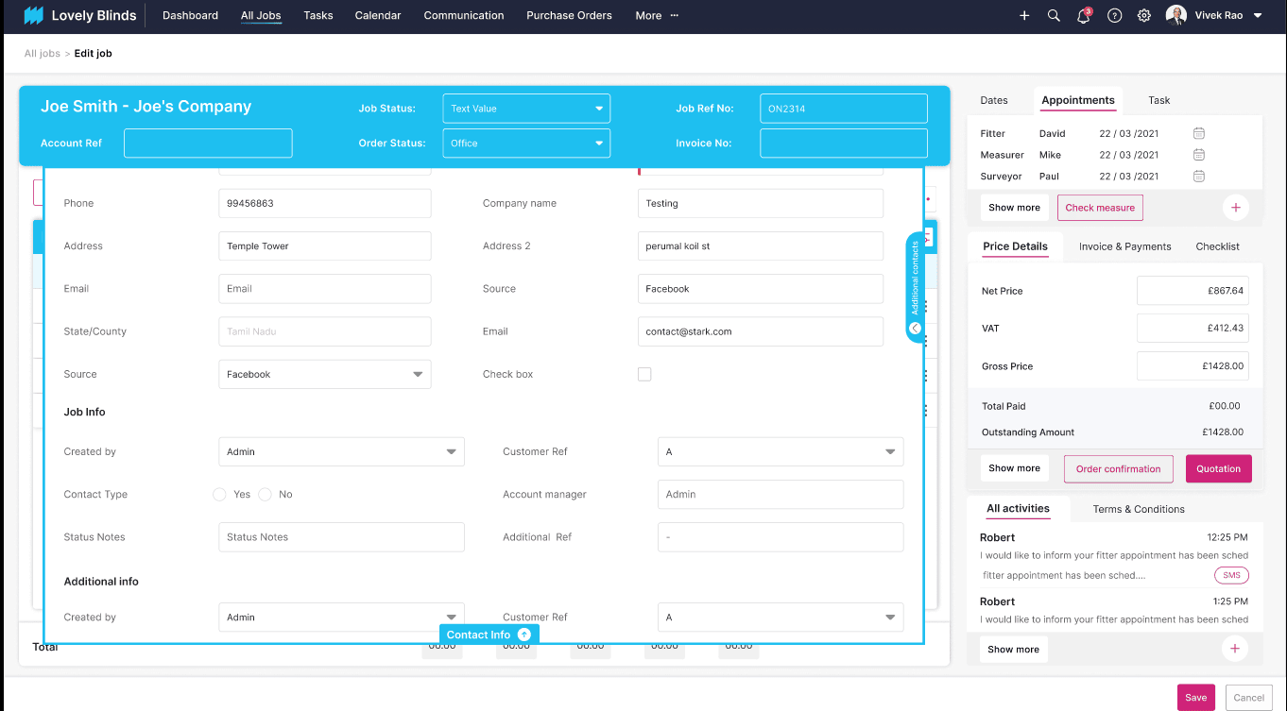

As discussed on 30/05/2025,
Pop up while updating account manager:
Account page:
When updating the account manager for an existing customer account, a confirmation popup will appear upon clicking "Save".
- Clicking "OK" will update the account manager at the account level, making the selected user the default account manager for all future jobs.
- Note: This change will not affect any existing job. They will remain unchanged.
- Clicking "Cancel" will discard the change, and the current account manager will remain the same.

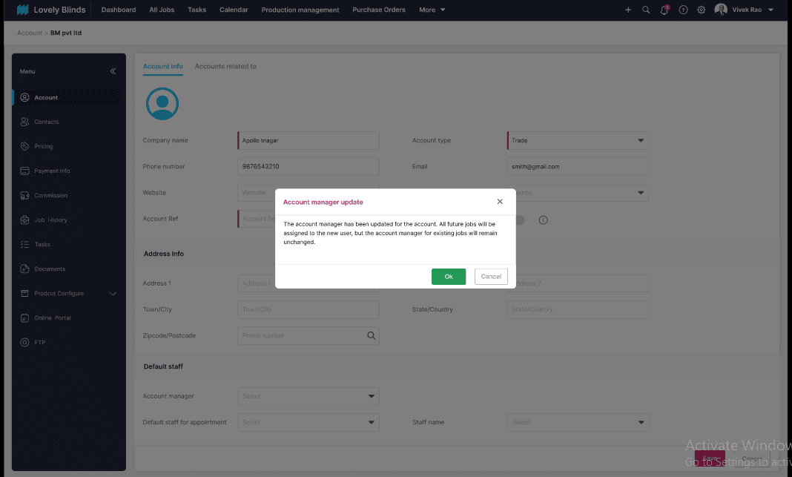
While adding an account manager for a New job :
When assigning an account manager while creating a new job, a confirmation popup will appear. This popup will ask the user whether the selected person should be:
- Set as the permanent account manager for the customer (for all future jobs), or
- Assigned only for the current job.
When the confirmation popup appears during job creation:
- Clicking "Save and Assign" will save the details and assign the selected user as the account manager for the customer account.
- Clicking "Cancel" will not make any updates are changes.
- We can allow the account manager field to be empty while saving the Job.
- The same pop-up will occur while adding a new appointment.

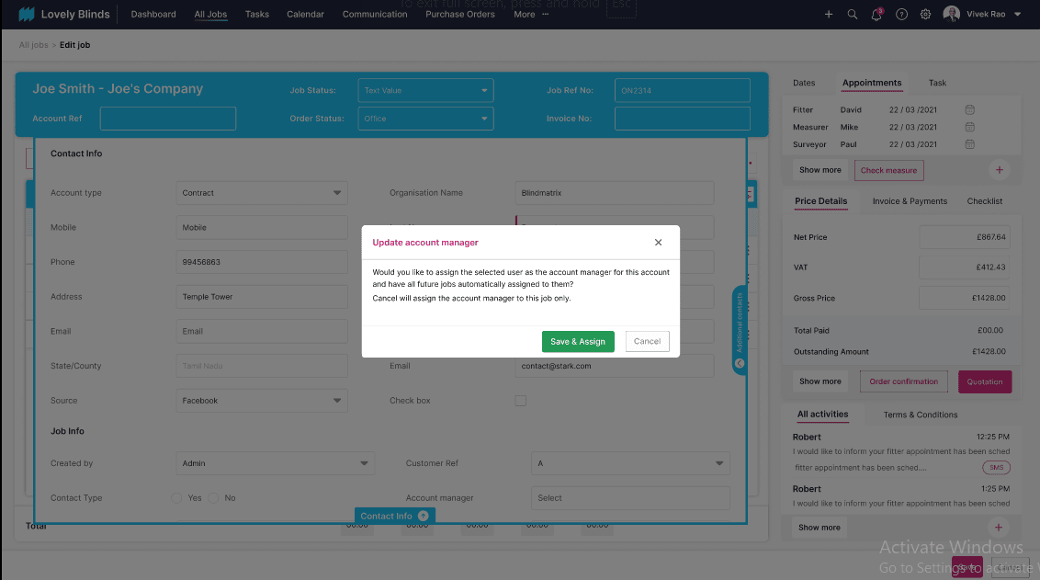

While updating the account manager for existing job:
Assigning Account Manager for Existing Jobs
When assigning an account manager to an existing job, a confirmation popup will appear.
- Clicking the "Yes" checkbox will update the selected user as the default account manager for the account. This change will apply to all future jobs created under this account.
- If the checkbox is not checked, it will assign the user only to the current job
- Clicking "Cancel" will not make any updates or changes.
- The same pop-up will occur while editing the existing appointments.

