- The word domain is misspelled
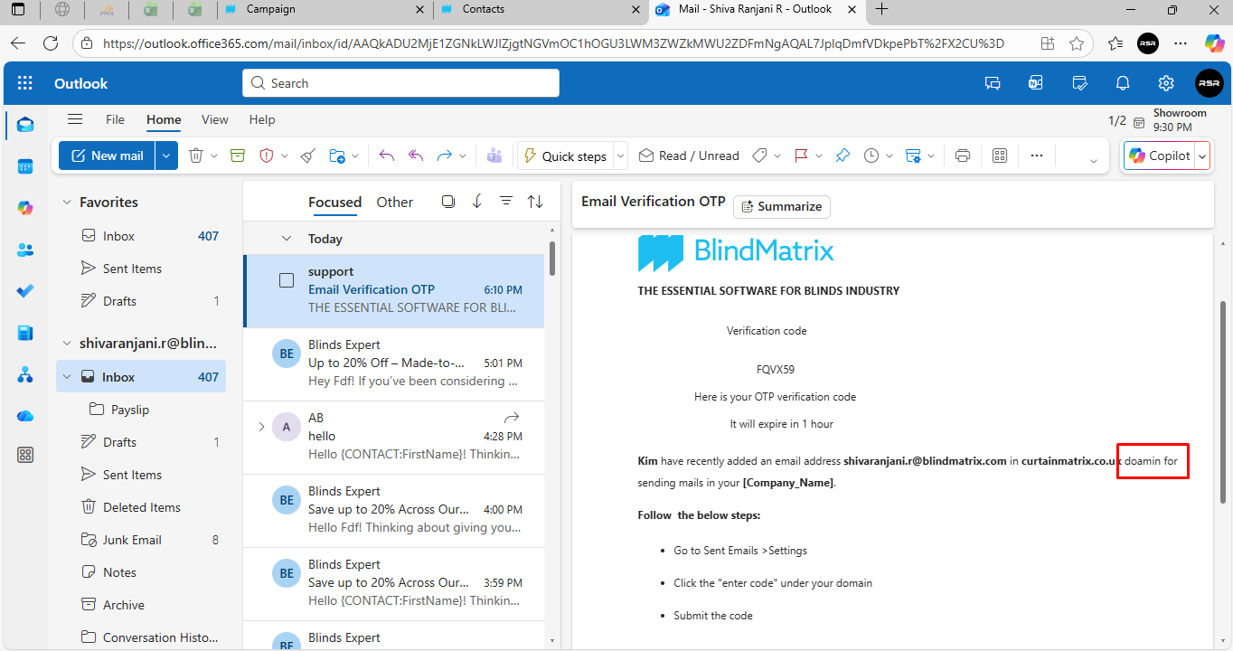
2. The from drop down key remains the same for every actions done their that should be changed like to field
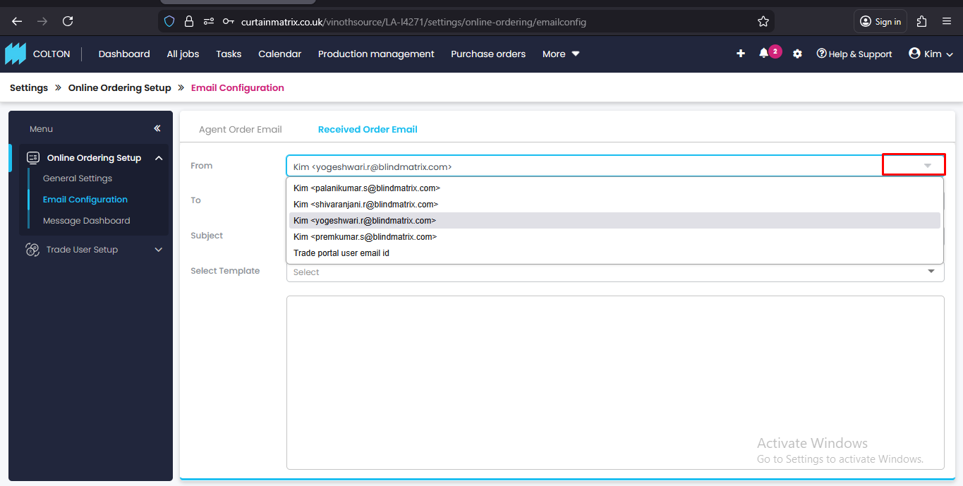
3. When I submit jobs through the online portal, I don’t receive any agent order emails immediately after submission.

4. Additionally, when I submit jobs via the “Unsubmitted Jobs” section, I get an error message saying: “Attempt to read property ‘email’ on null.” No emails are received in this case either.
