Bugs :
1. The dropdown arrow is not clearly highlighted as shown in the Figma design, and it is positioned at the far right edge instead of being properly aligned within the border as per the Figma layout.
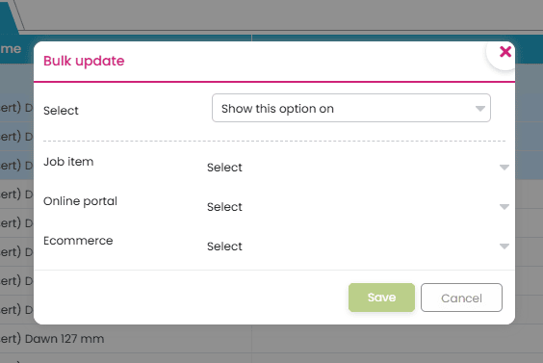
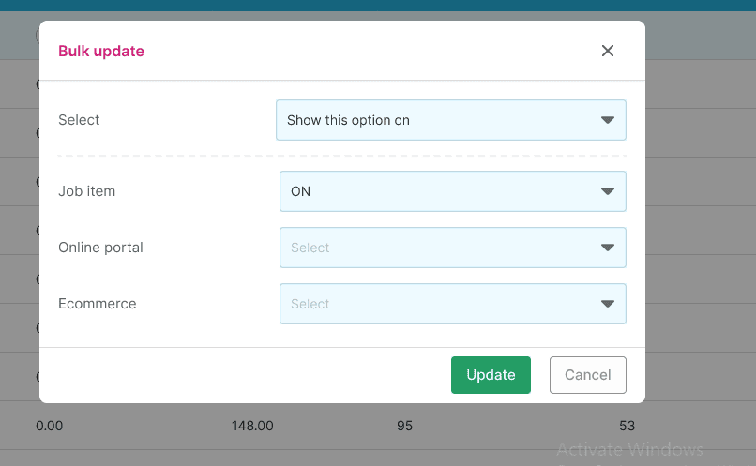
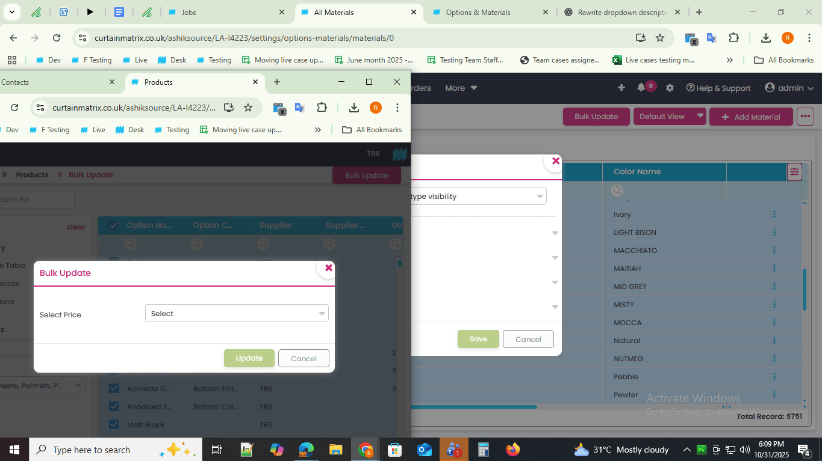

2. Instead of the “Update” button specified in the document and Figma design, a “Save” button is displayed here — this should be corrected to match the design.

3.No data is found when filtering under the supplier field, whereas performing the same action in the dev source successfully retrieves data.
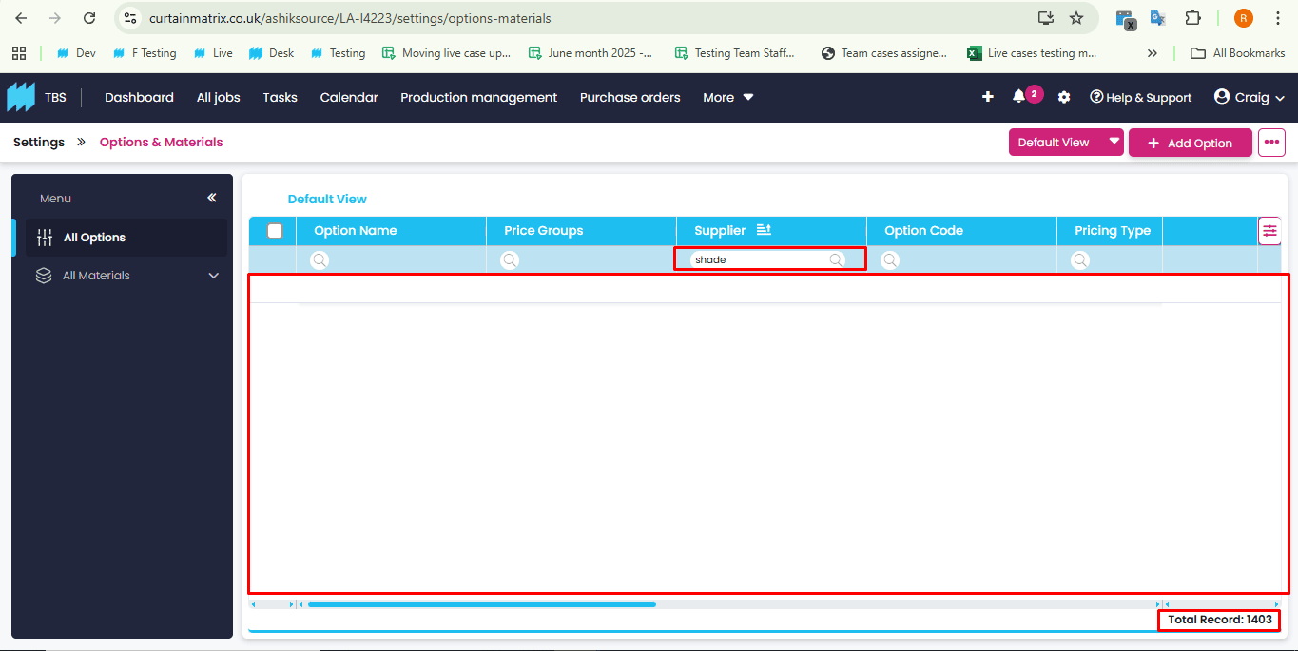
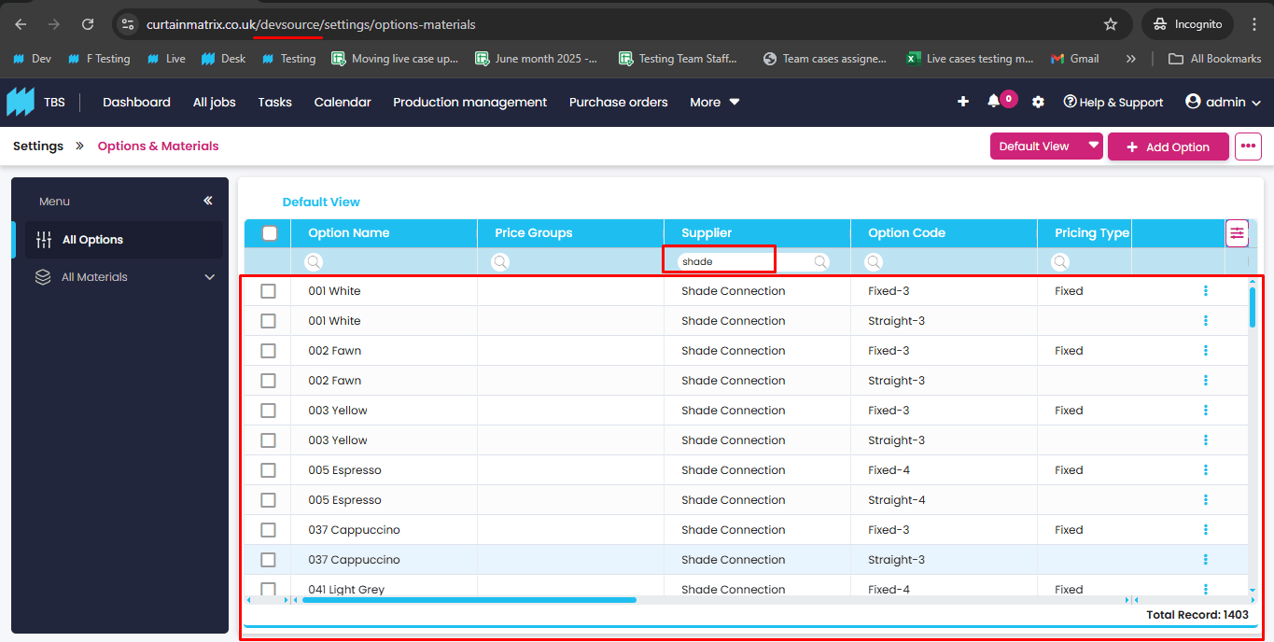
4. When the specific option is turned off for the job portal, it still appears in the order item.
( This is an existing issue that needs to be fixed. )

5.When bulk selecting a page within the Materials/Options section, the top-level checkbox should be automatically selected, as all listed options on that page are being chosen.
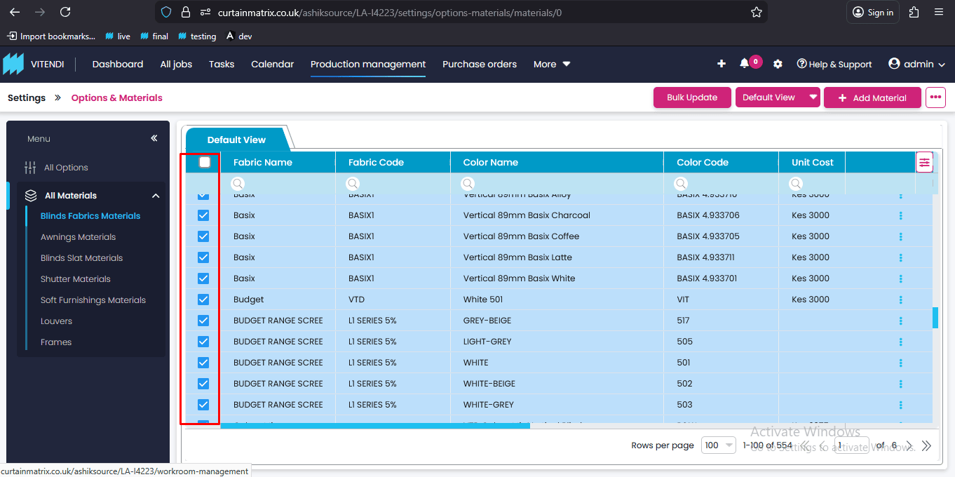
6. Bulk updating to hide fabrics and options based on account visibility is not working correctly. Even after selecting the whole page and setting it to hidden for a contract account type, the fabric still appears (though the color field is blank).
Fix: When a fabric is bulk hidden, the entire fabric option should be removed from view.
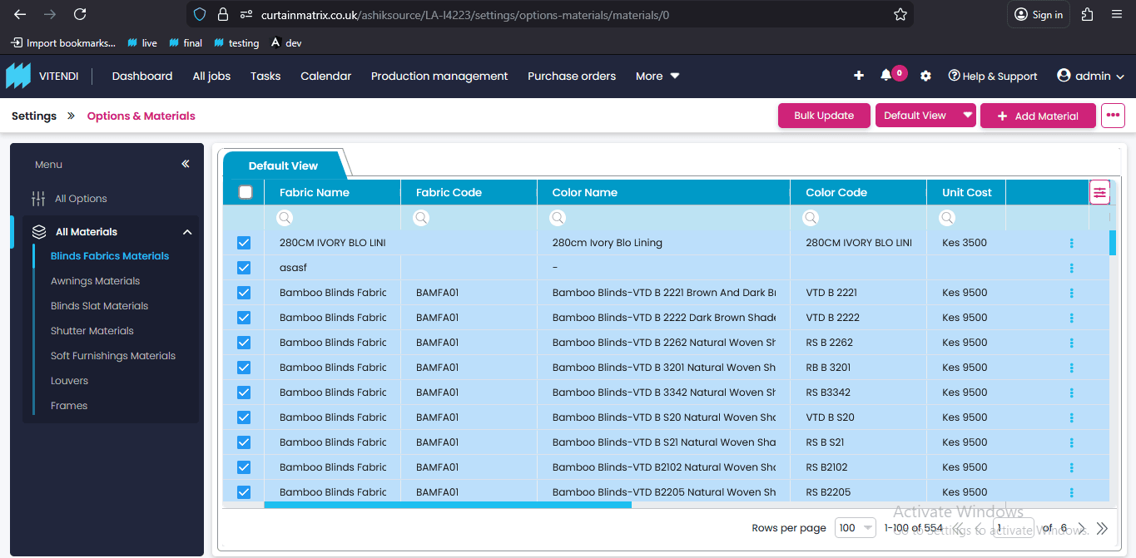
7. UI issues
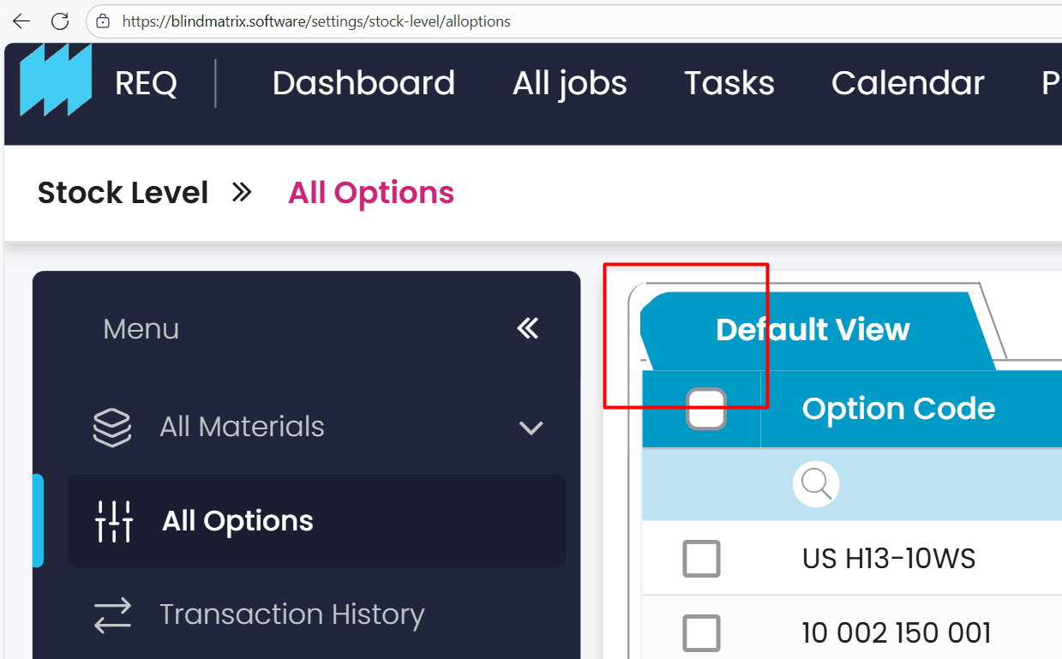
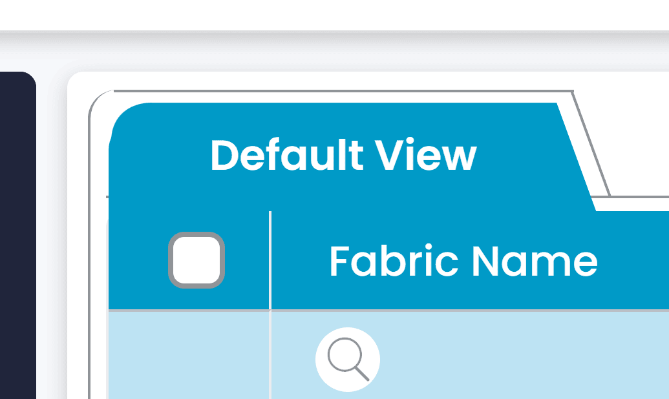

8. Bulk update , U should be in small letter

9. Account type , T should be in small letter
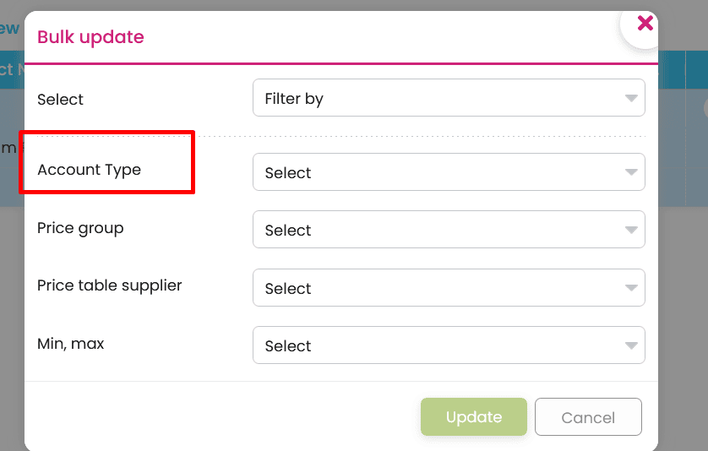

10. “After implementing pagination, the search filters no longer work on the subsequent pages—they only work on the first page. The search filters should function on every page.”
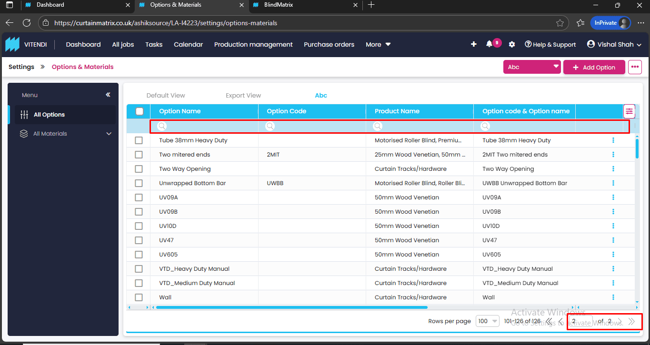

11. “As per the document, both fields should use a select field, and the input field should be grayed out.”
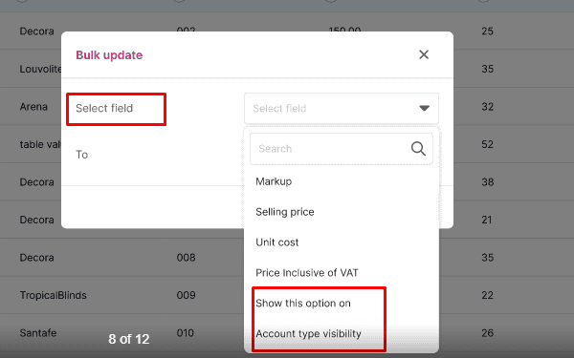
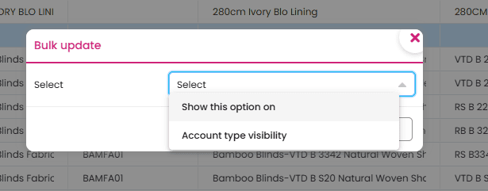

12. “When selecting an option, it should fetch results from all options, not just the selected pagination. It should work like the existing behavior, which searches across all pages—including the last ones.”
13. “When I select options in one view and then switch to another view, the Bulk Update button remains visible. When performing a bulk update in the new view, I can’t verify which options are selected or which ones I’m updating.”

