- Reports should appear in the Received column after submitting the PO.
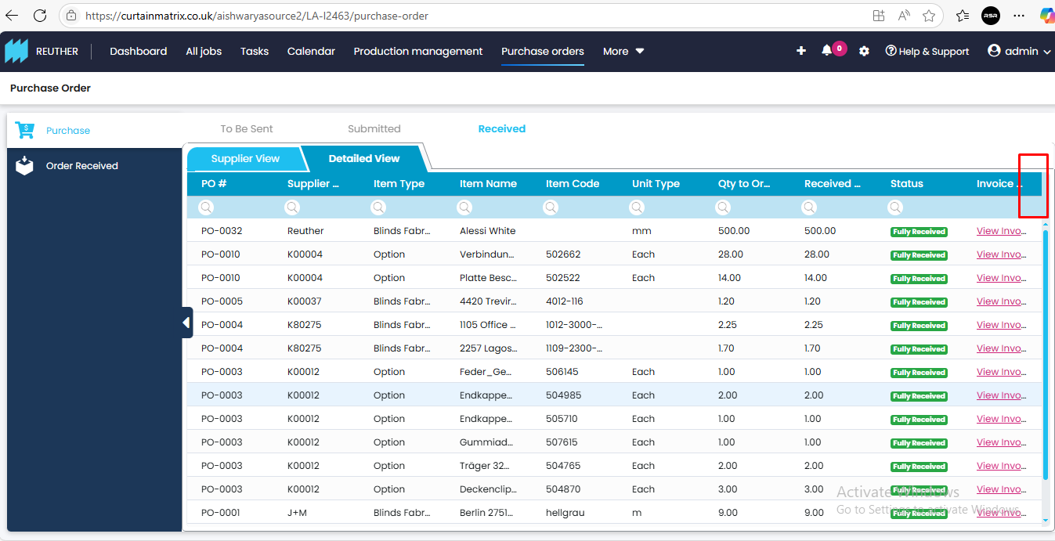
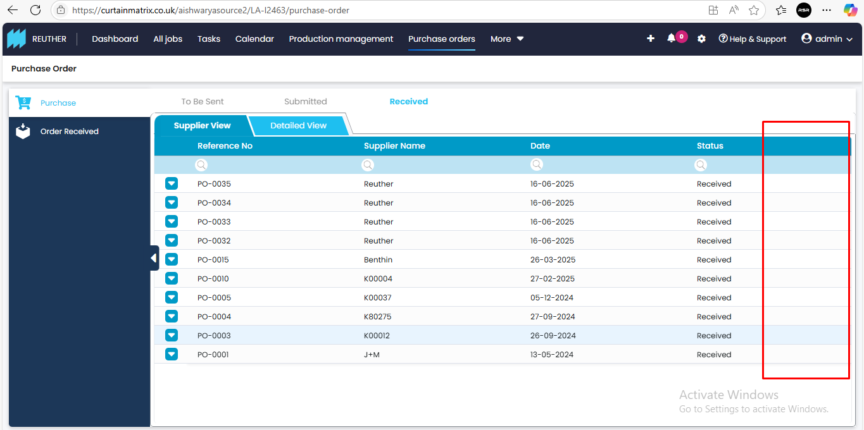
- When a PO is partially received with the Force Close checkbox enabled, the status should display as Partially Received (Force Closed) instead of Fully Received (Force Closed).
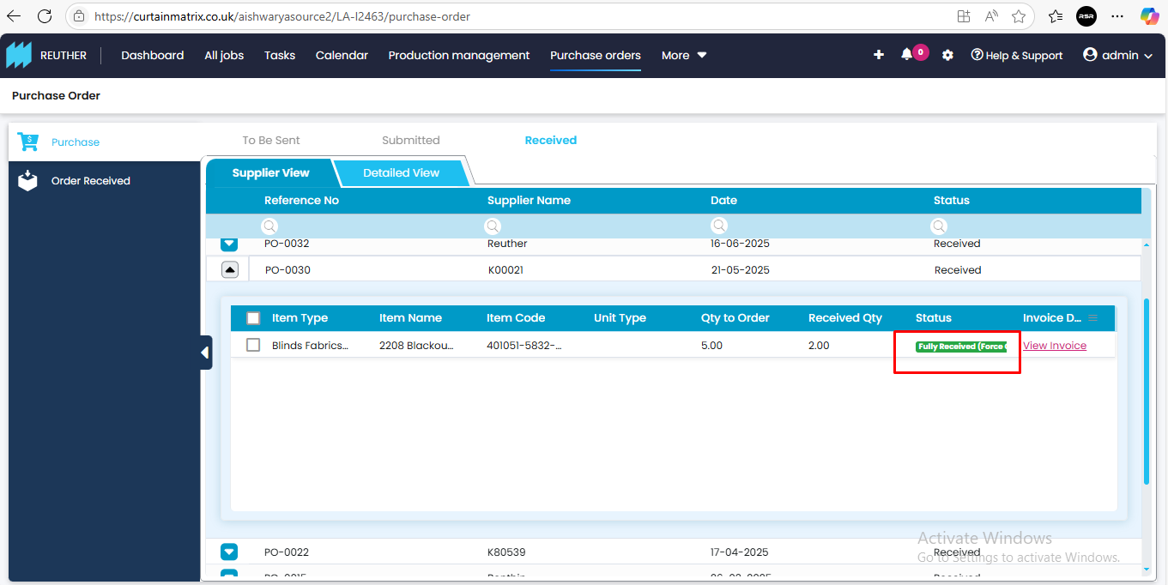
- Stocks added under the Others category in the Supplier View are showing correctly in the Received column, but those added under the Detailed View are not appearing.
- In the PO Received Details pop-up, there are two headings starting with the word Received, which creates confusion. These headings should be fully expanded for clarity, especially since a scrollbar is available.
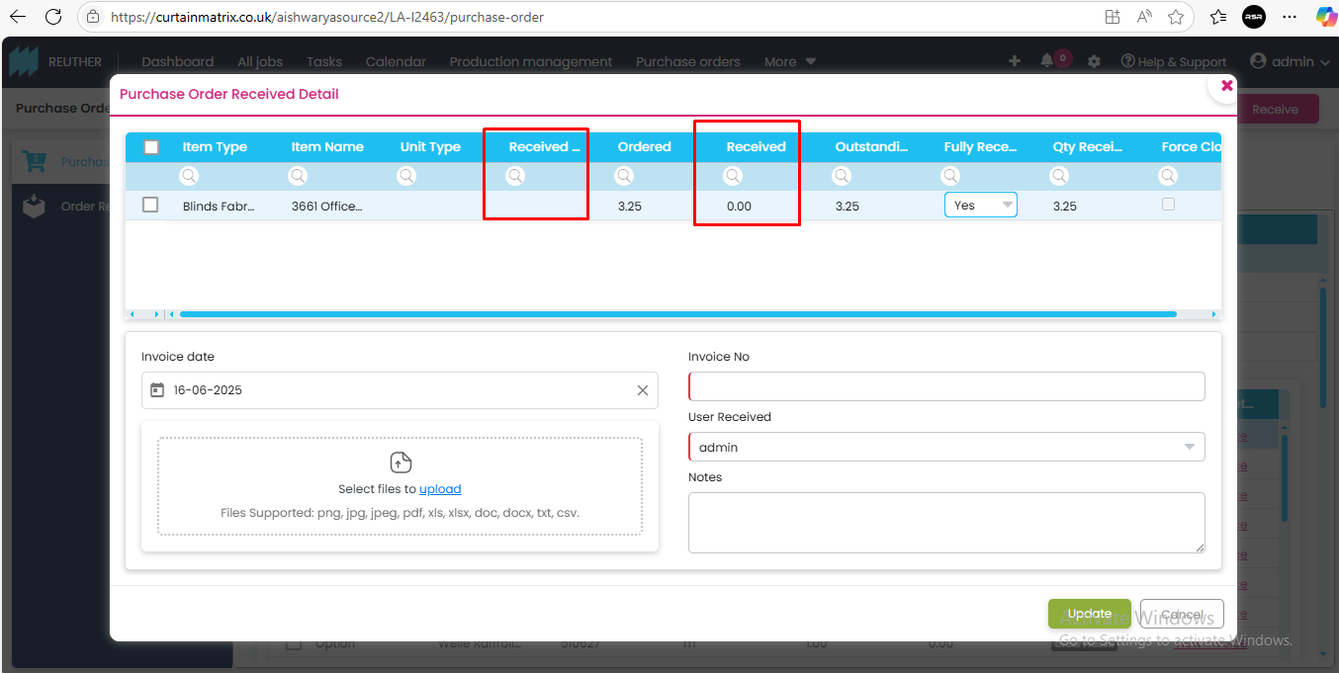
- Search functionality is not enabled in the dropdown headings.
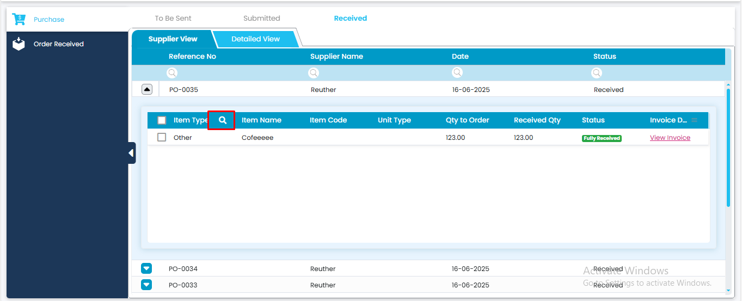
- Sorting is not working correctly for some columns.
- When viewing attachments in the Received column, the headings should be expanded to provide a clearer view for users.
