1.SMS template search box
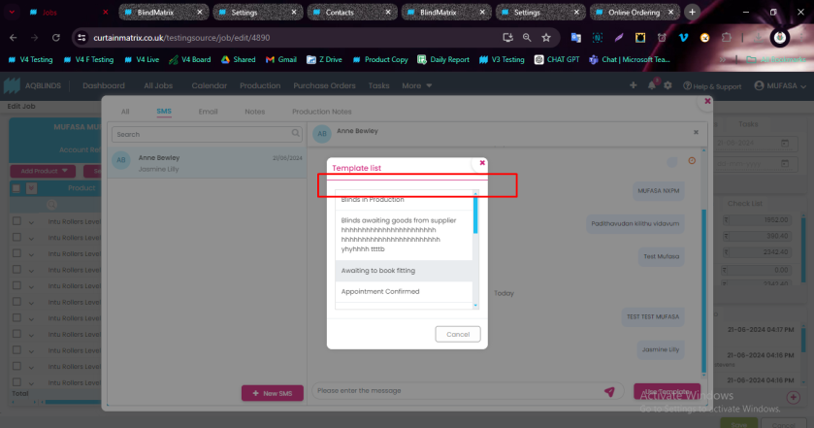
2.Newly saved templates were not showing on template page but its showing on job form page.(After adding 10 templates it was happened)
3.Calendar search design(Sub box)
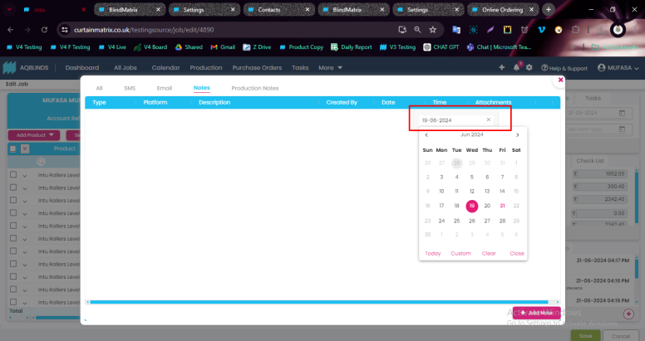
4.All tab - Platform type
5.Existing notes sentence correction
6.Email search is only functioning while click the enter button.
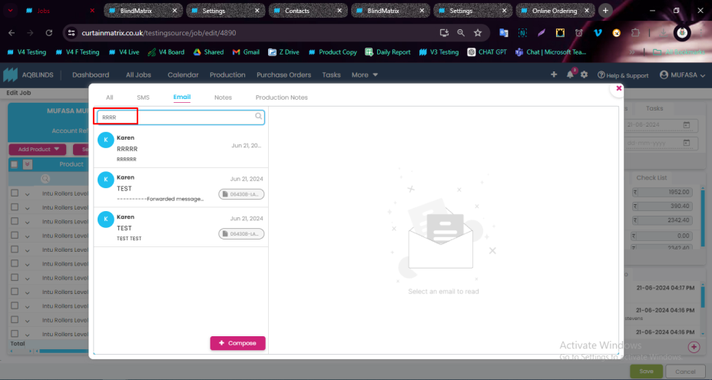
7. If multiple jobs have the same contact, the same SMS thread will be shown for each of those jobs.
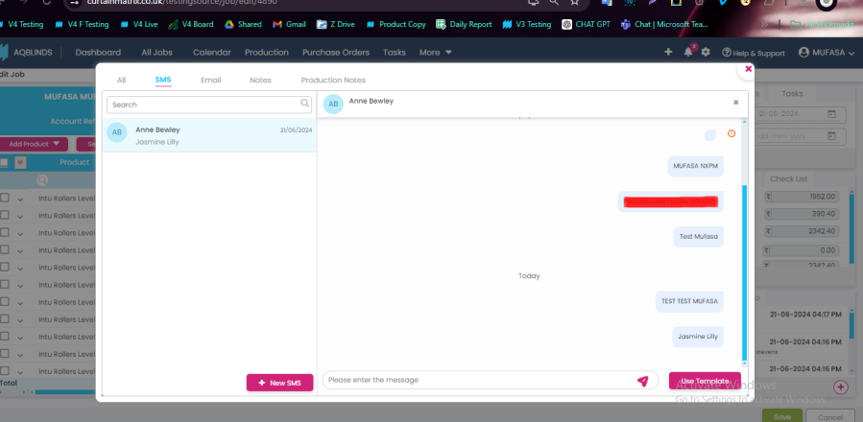
8.Automation Notes platform was not captured. (Need to discuss with Rekha to change the automation notes type name change to Automation Notes)
9.Normal SMS platform was not captured (Notes Tab)
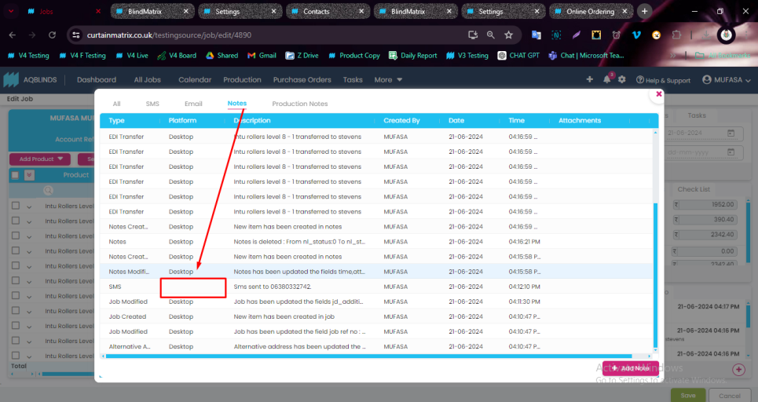
10.Commission notes is added as a Manual Notes. So its having abilty to delete. Need to restrict delete permission.
11.Tool tip not showing on types column
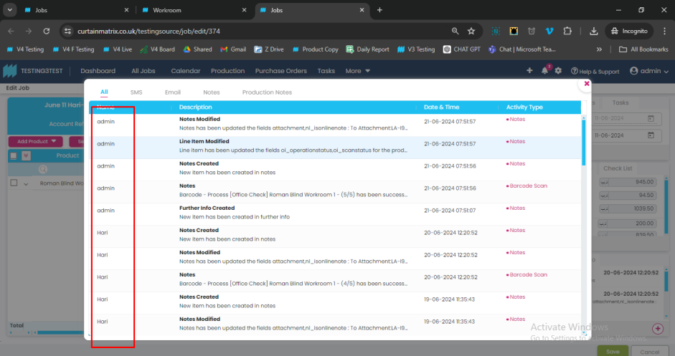
12.When we compose a email from job page, subject field is showing as empty.
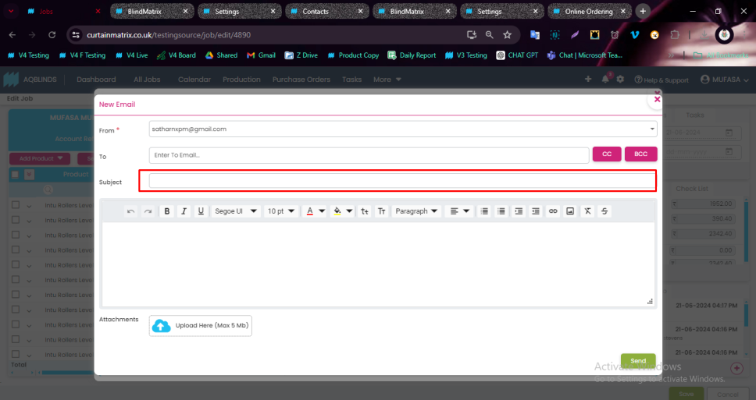
13.Search is not working on online ordering
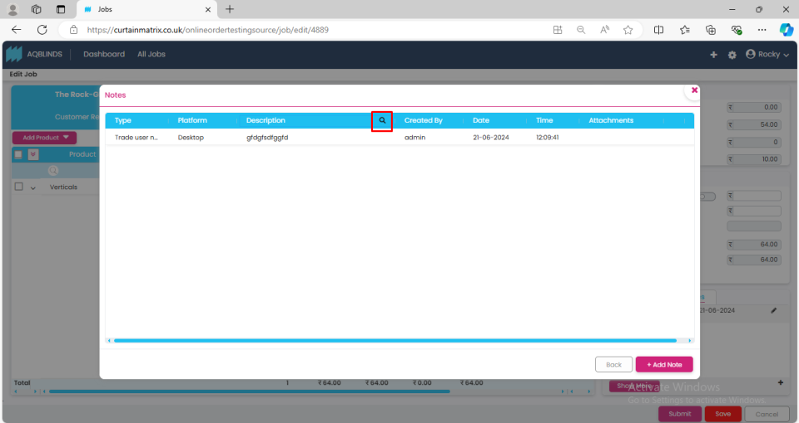
14. EMail tab missing on online ordering
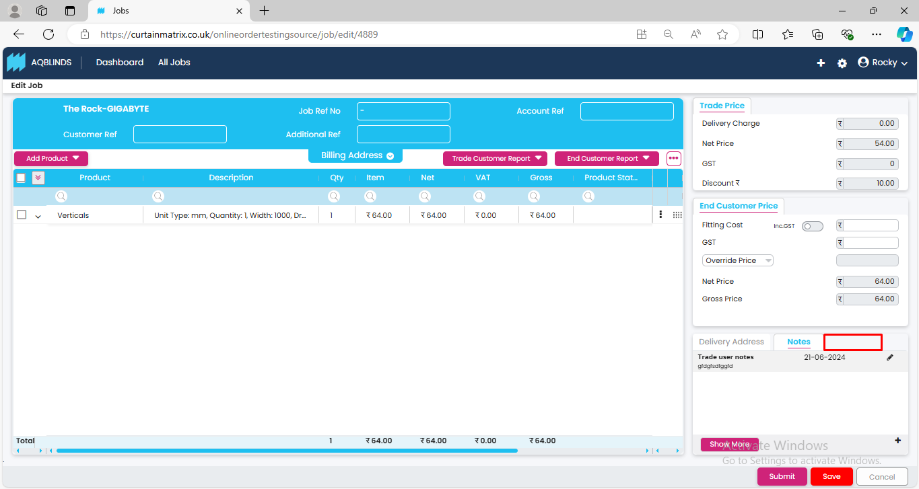
15.Attachment UI Issue online ordering
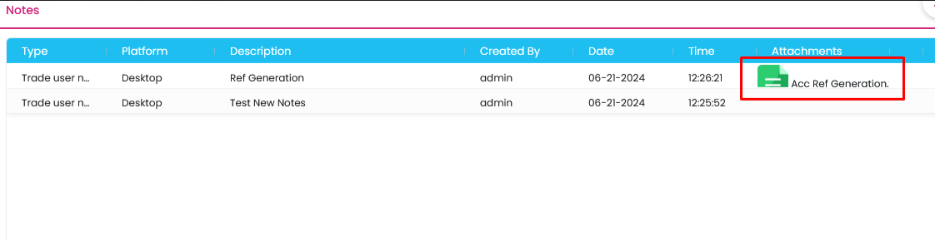
16.Email attachments UI issue
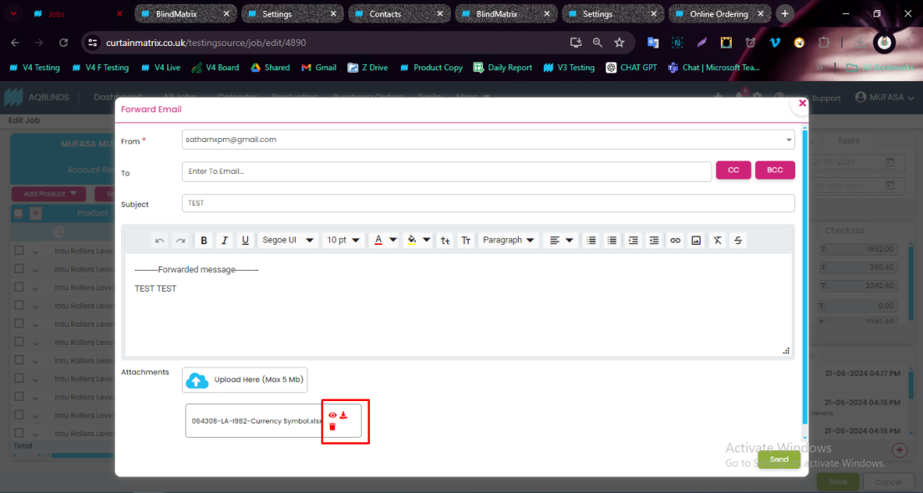
17.

