LA-I1636 changes
- The word description must contain the stating few words of the description if added in text format and also the name of the picture or video added
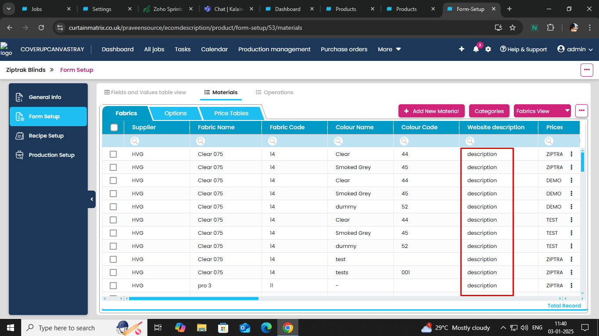

- In other attributes option must contain a attribute for ecommerce description
