BUGS – CASE LA-I729
- there is an extra log button at the form type page and it is not working ( what is the functionality of this log button)
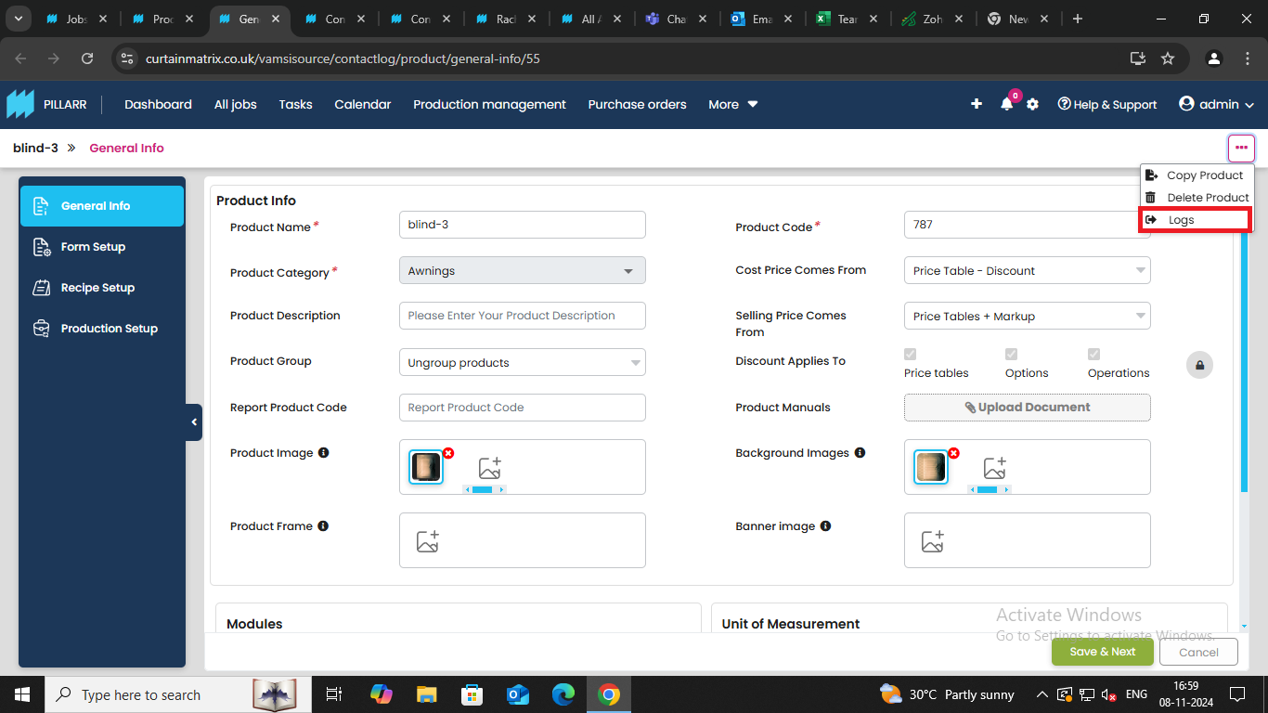

- in product log when we click the date search tab the date pop is not same as in the version v4 it is same as v3 version
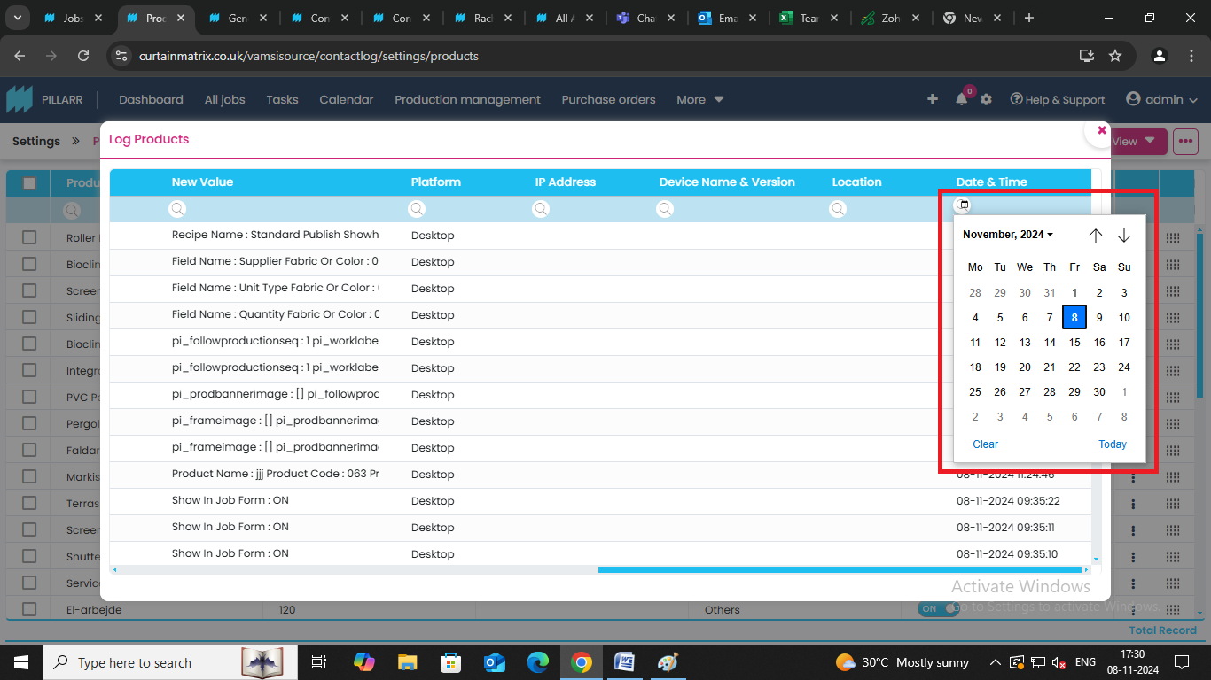
- when the vale is changed it does not show the correct previous value and the changed value
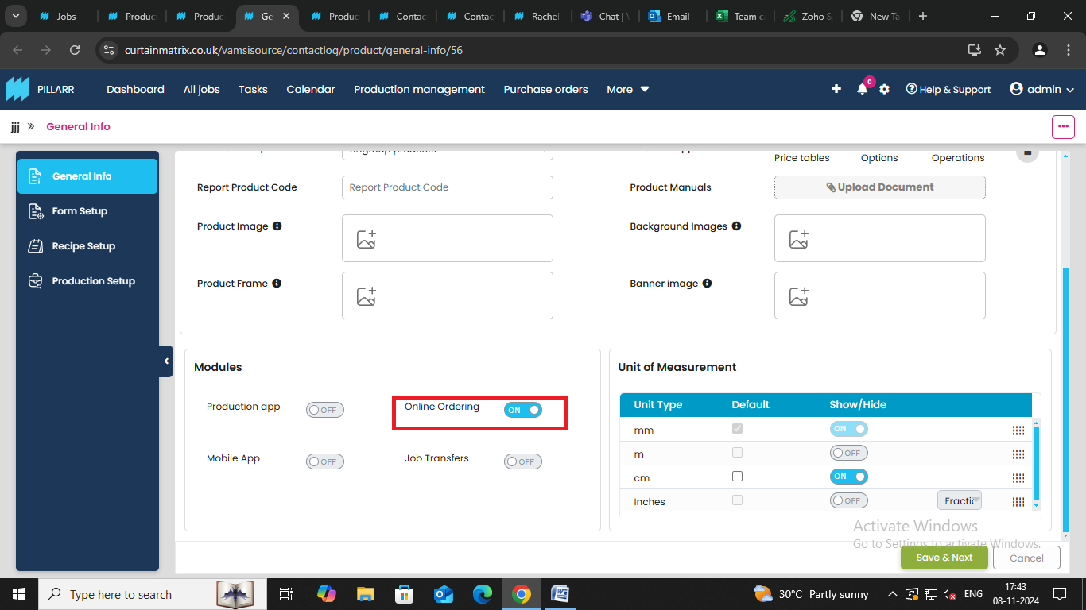

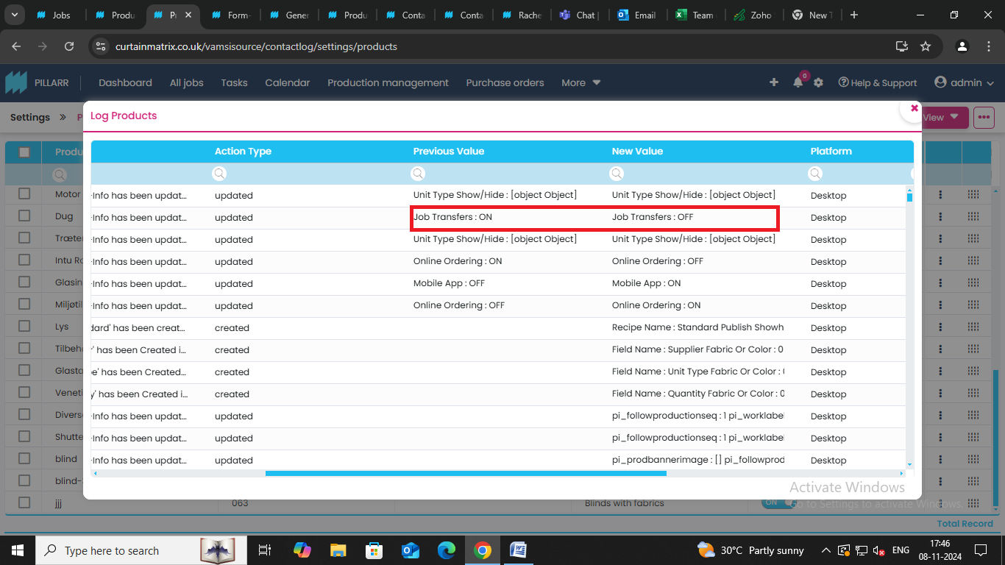

- the changes done in the unit of measurement is also not reflecting the correct value in the product log page
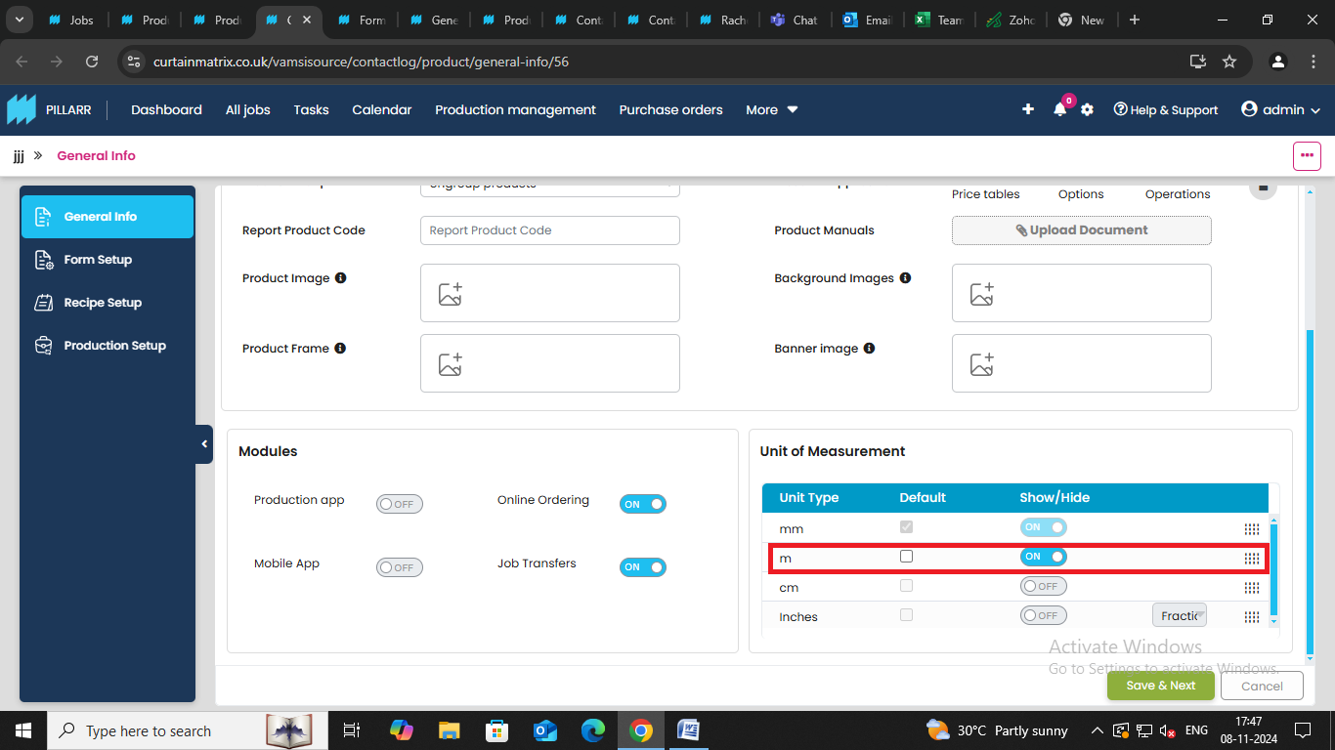

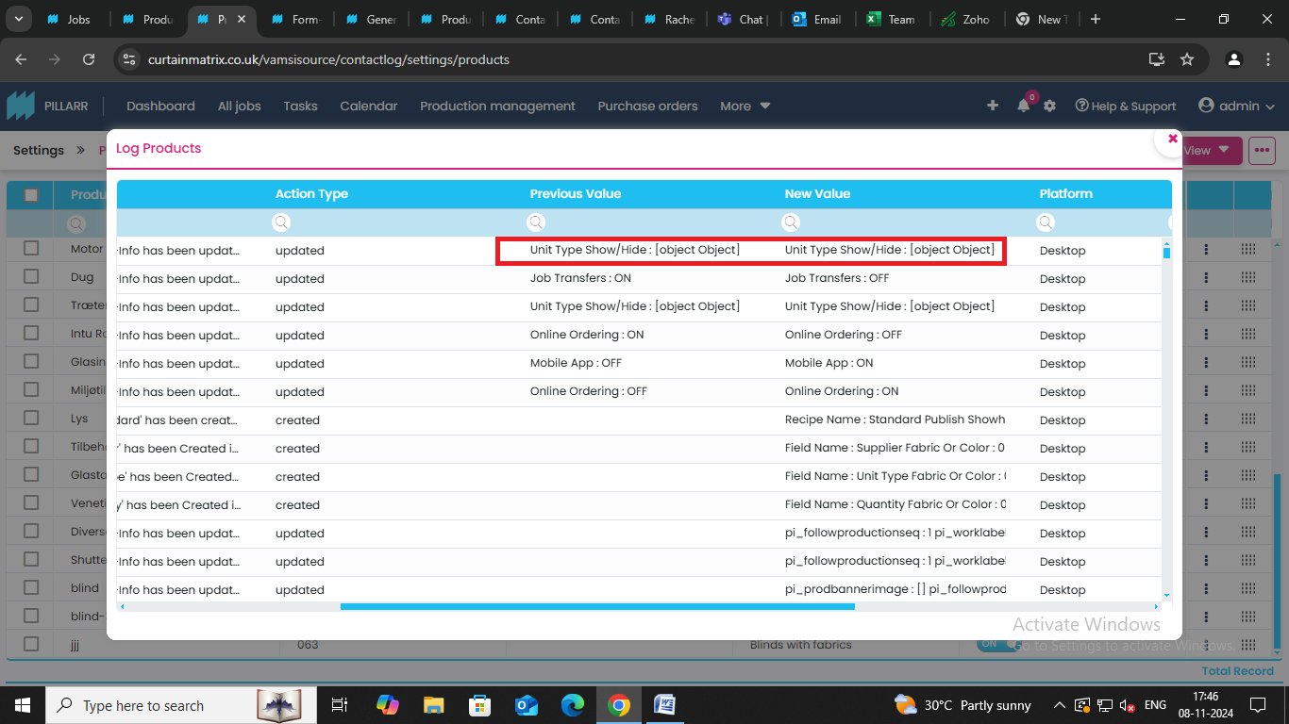
5 when the options in the discount applies to field is checked or unchecked it gets updated in the log but it gets updated in the backend code format (please work on this as the customer cannot understand this format )
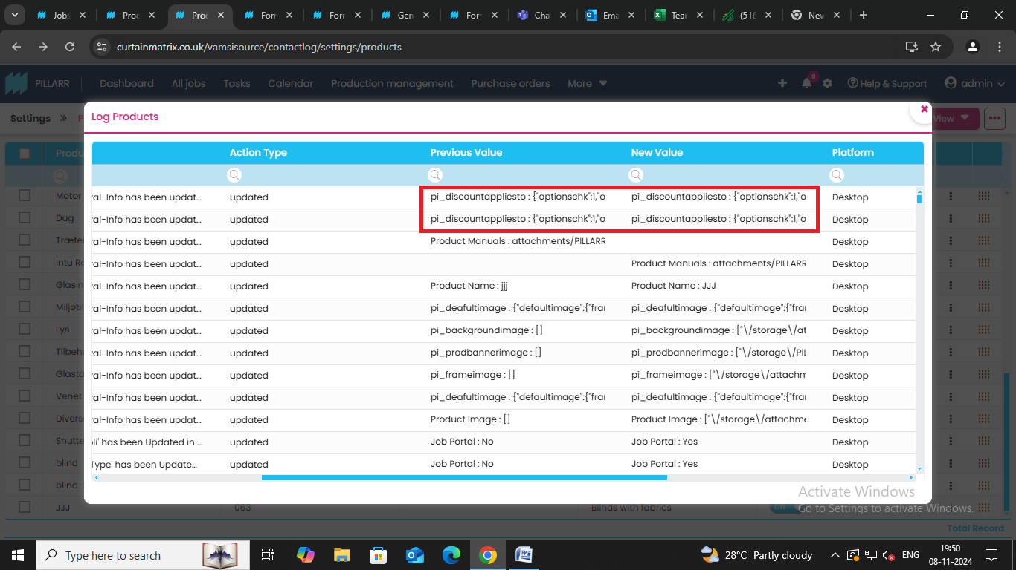

- when the pictures are being uploaded in the product page after saving the image in the log when we check the previous value and the new value it shows the path or the link of the image
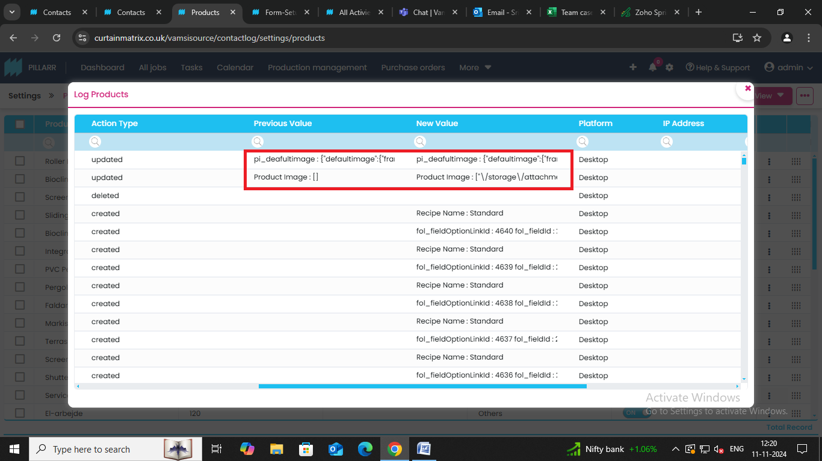
- when a contact number is added to the contact it shows the number with the key word /code ({"Default Contact":0,"cci_smsrandomverify":"cdd2d25d"}) please check it
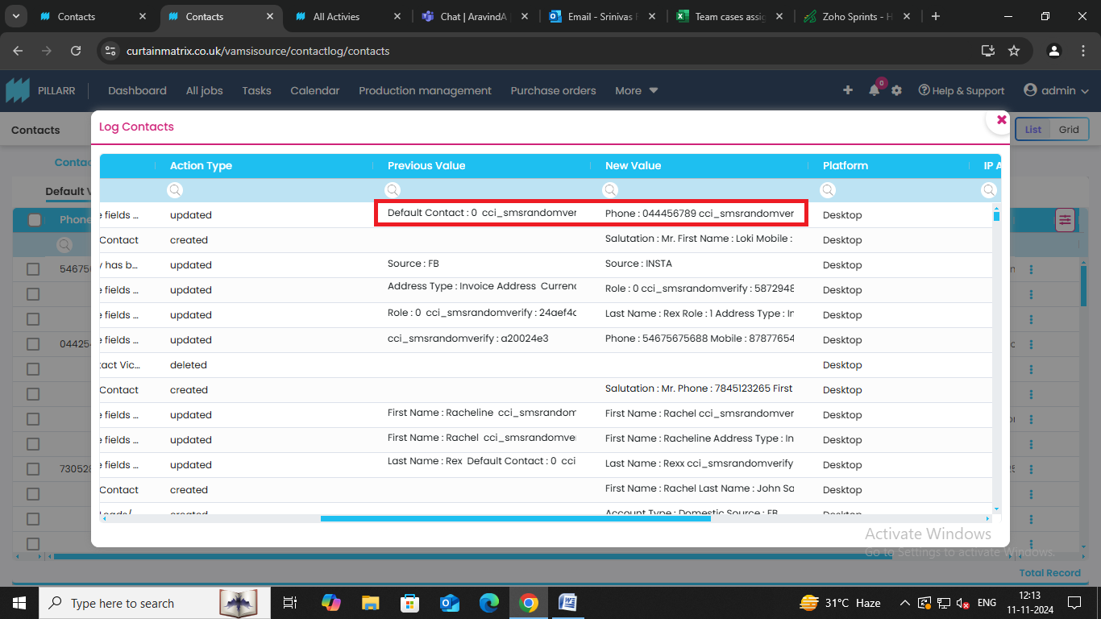

- in production setup in production formulas when all the formulas are turned on or off it does not show the exact value in the log
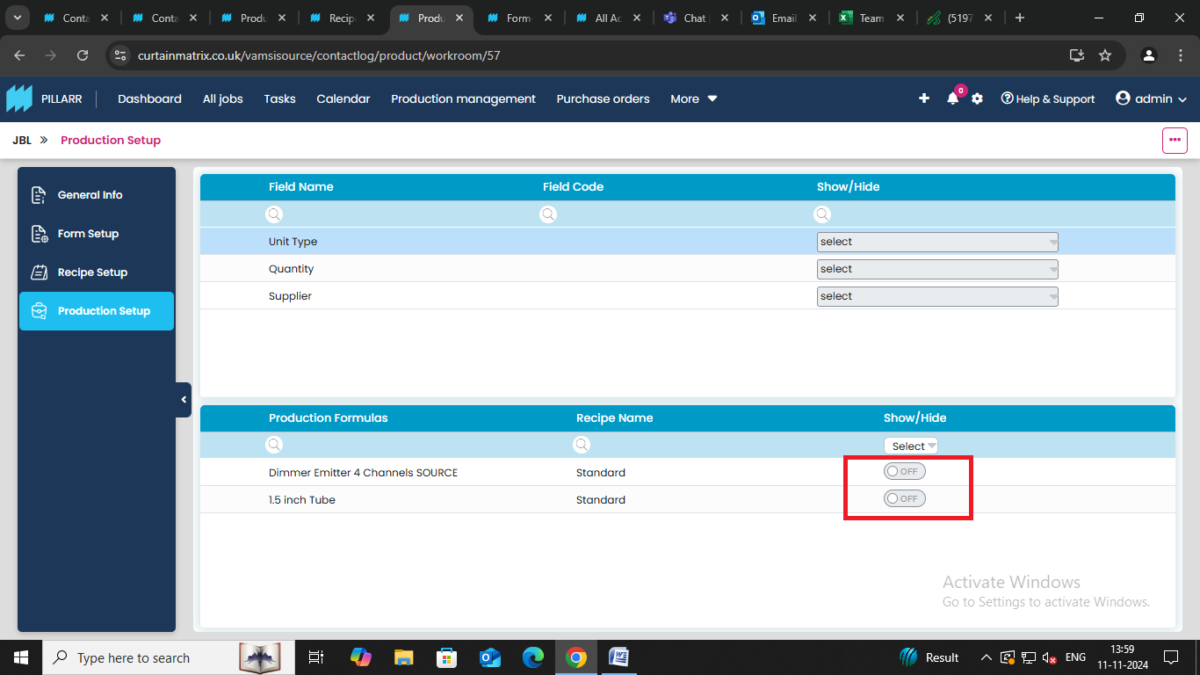
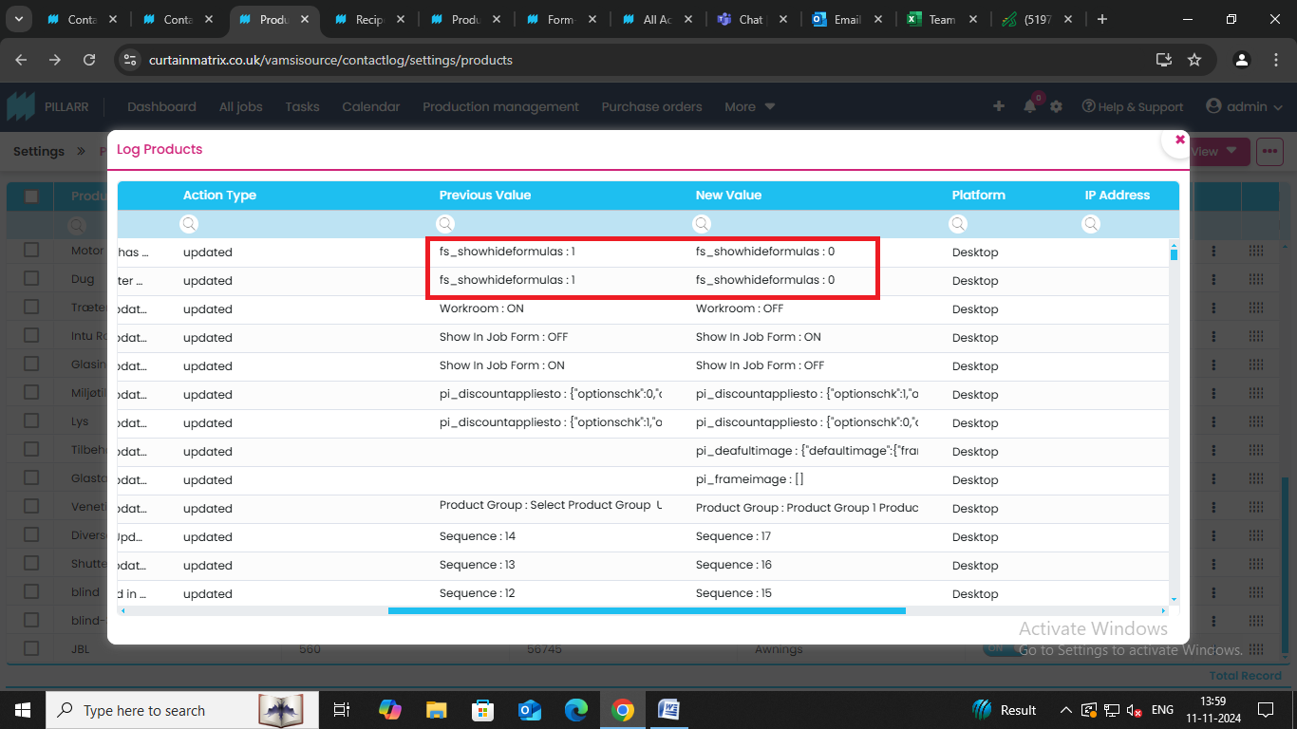

- when we add a document in the general info of the product after saving in the log it does not show the appropriate info in the log it shows the pathway
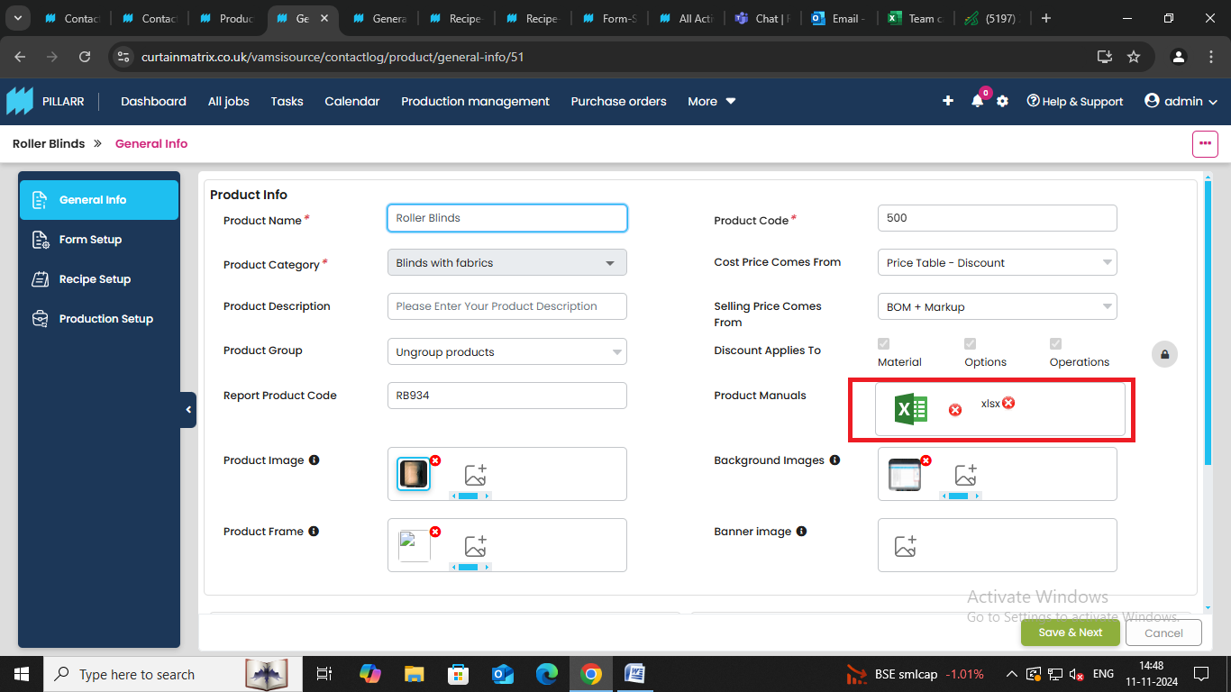
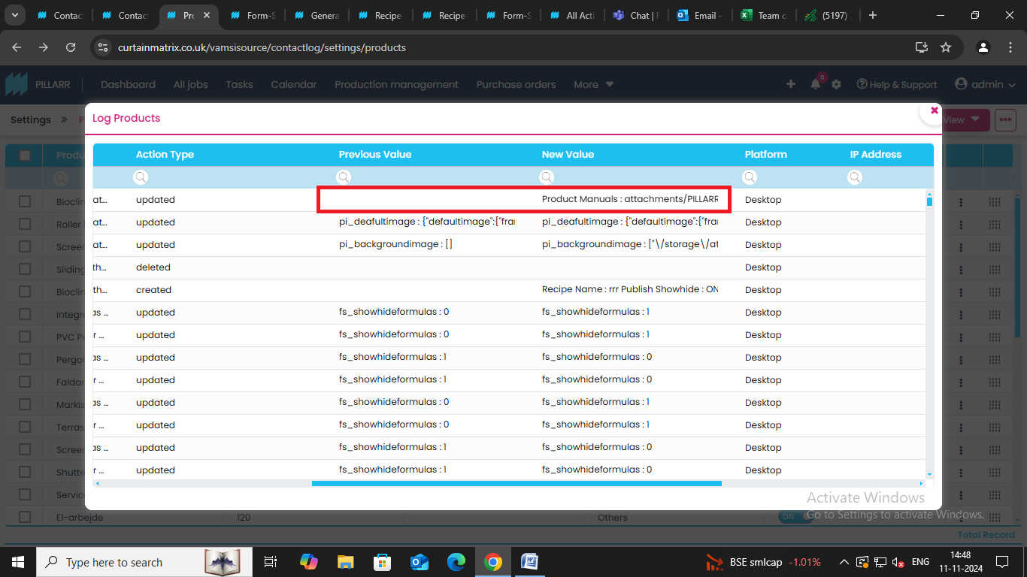

- the previous value and the new value are interchanged when the cost price is changed
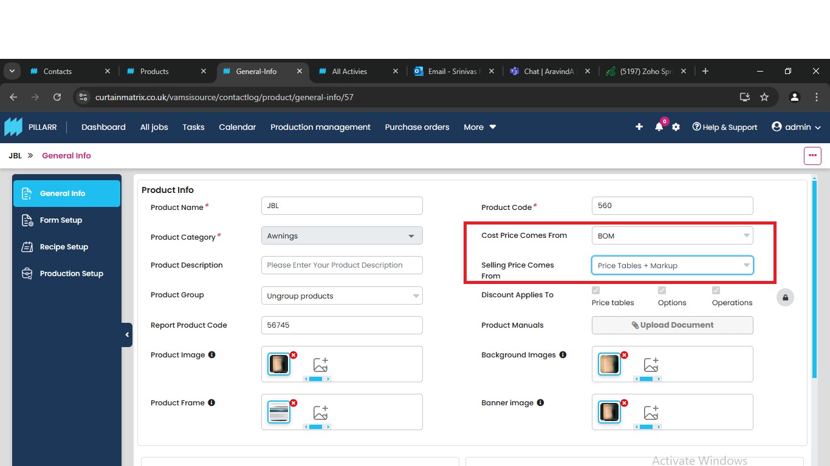

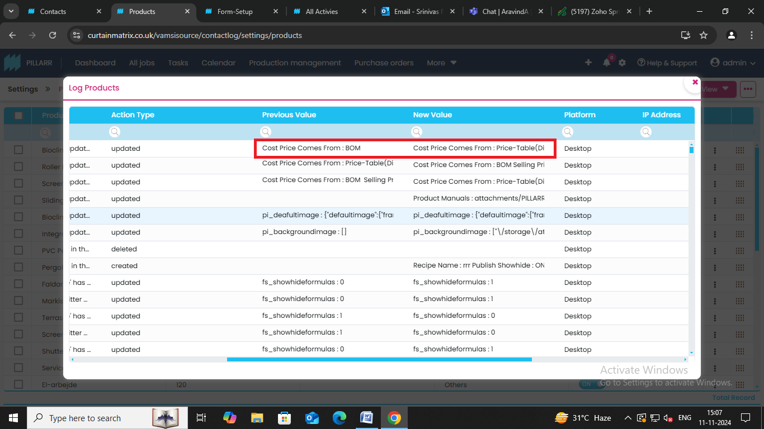

- in the create contact page after updating the settings in other setup in the contact info page after saving when we check the log it doesn’t show the correct value
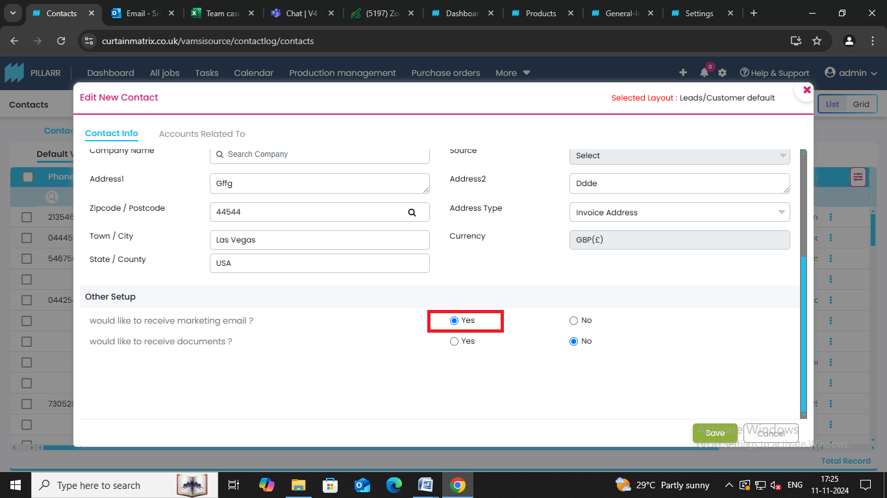

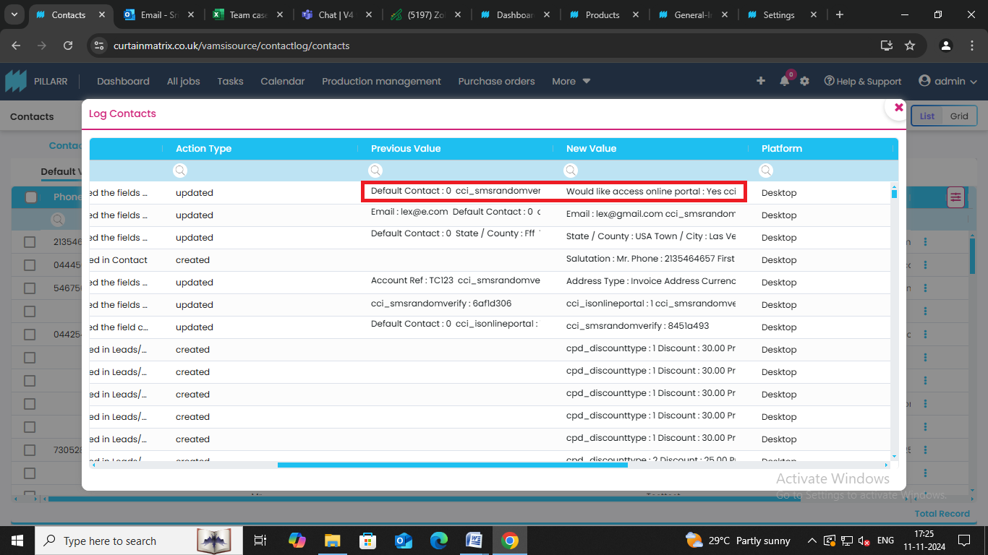

- when the last name is changed in the contact page in log it shows extra un related information kindly check towards it
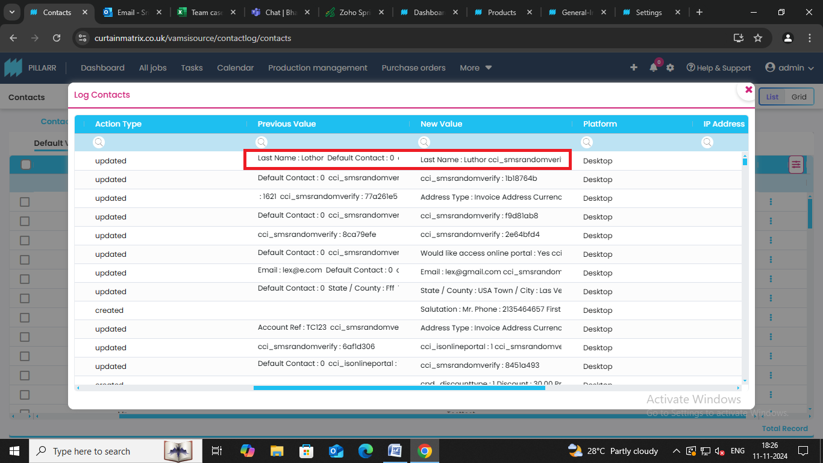

- there is no space between contact and info in the notification kindly change it
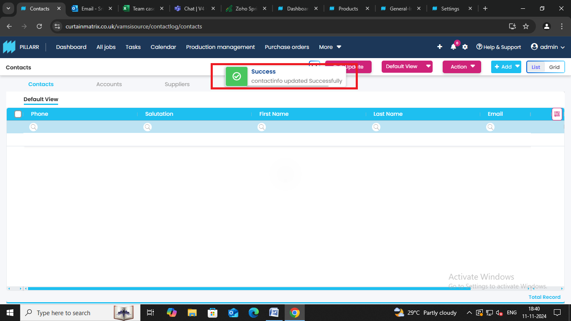

- don’t know what this means it is included in all the fields which are being edited
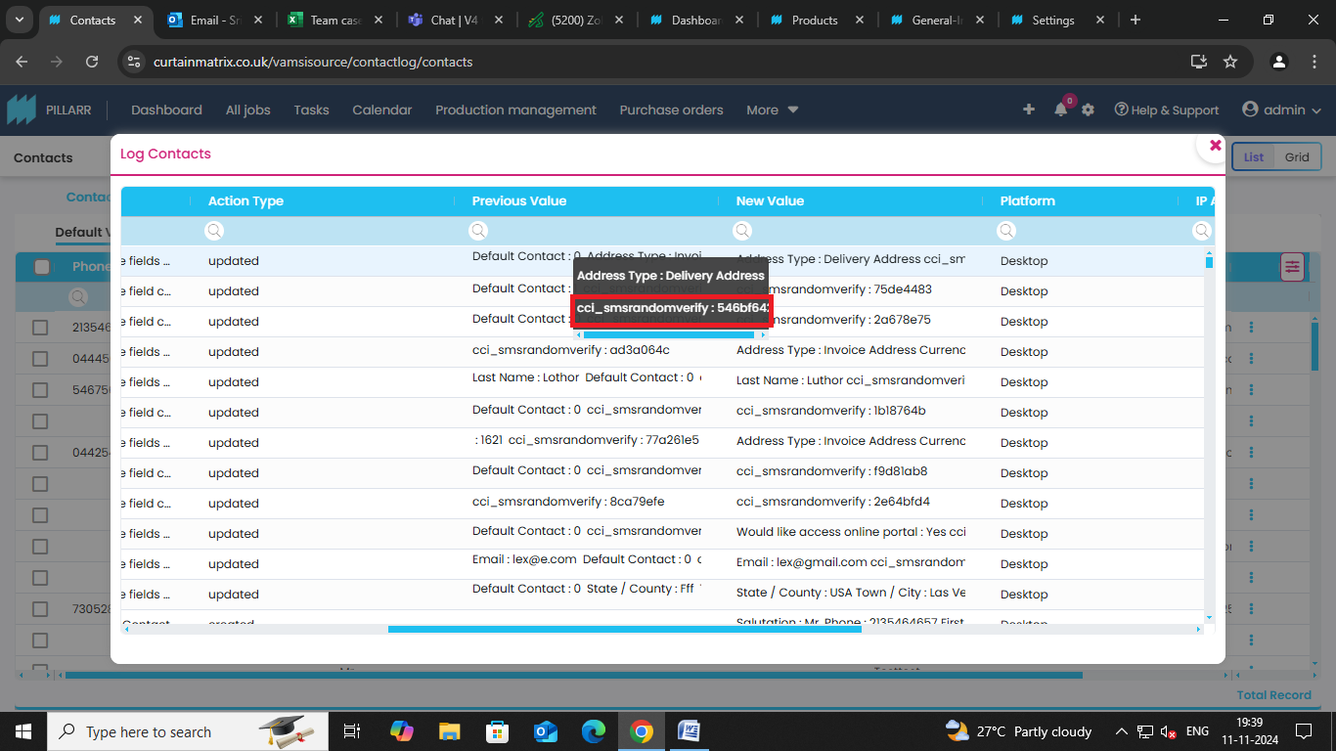

- when a new price table is created it does not register in the log but it is getting noted once a price table is deleted ( as in the below image in the log the created price table LKG i9s not recorded but the deletion of table ARM is recorded in log )
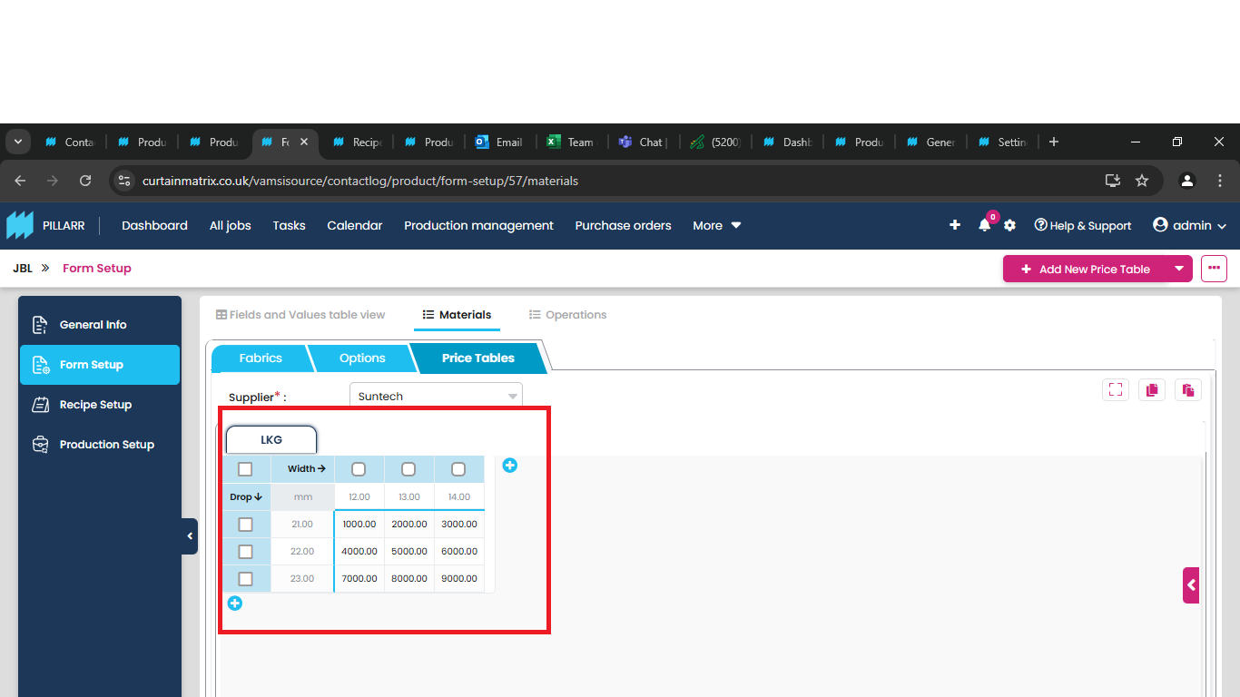

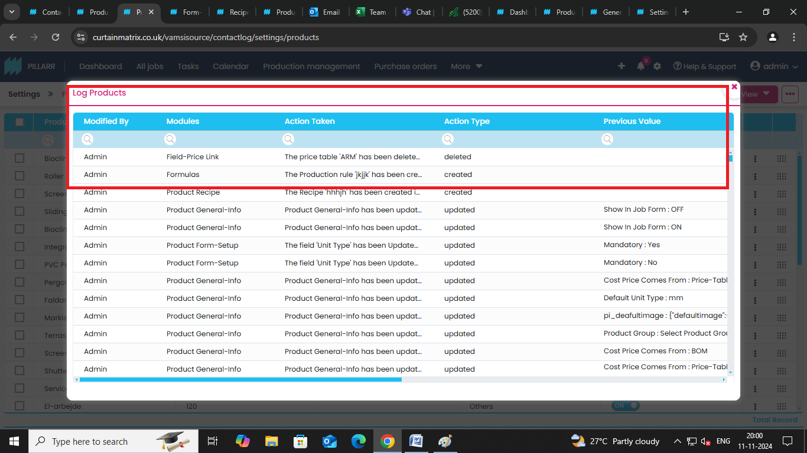
- when a new field is created in form setup it is not registered in log ( a new field called no is created but it’s not registered in the log )
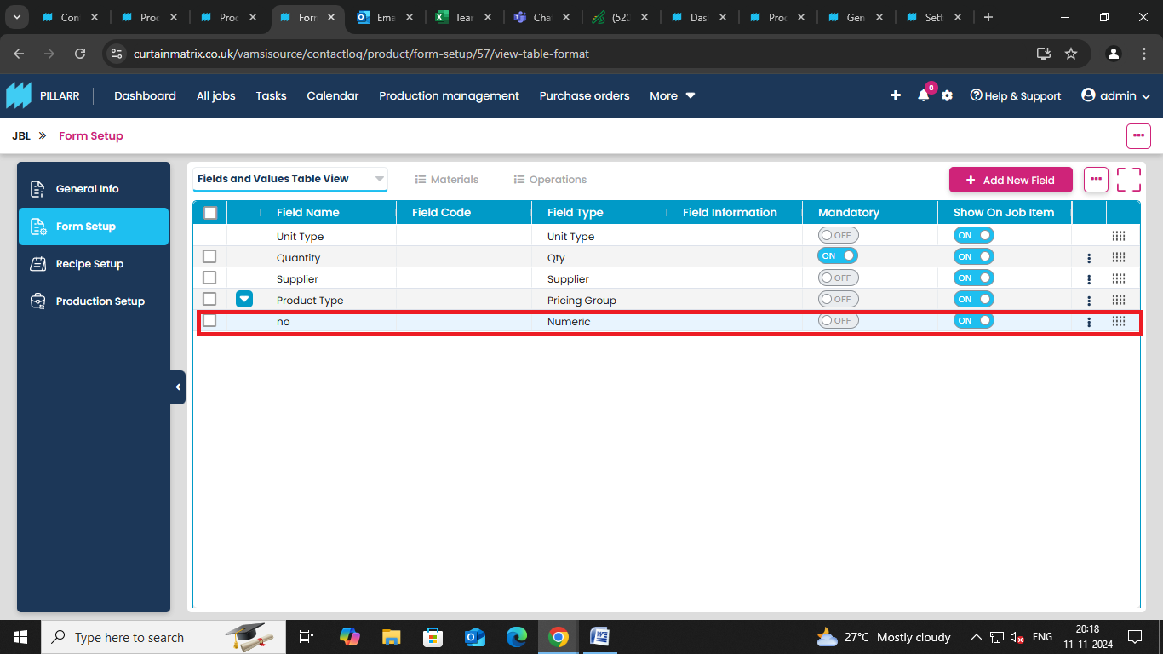

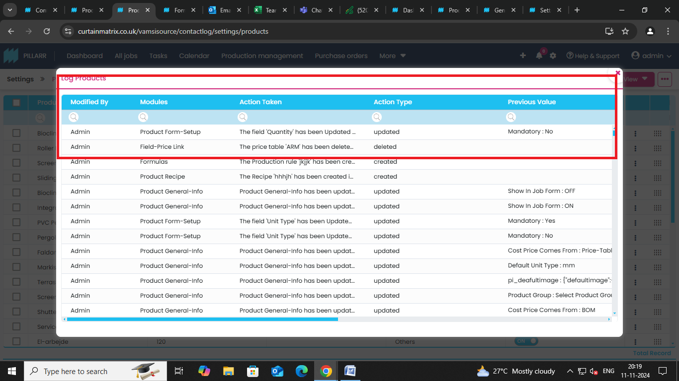

- when we update the two columns at the same time in the log it shows the discount update not the correct value
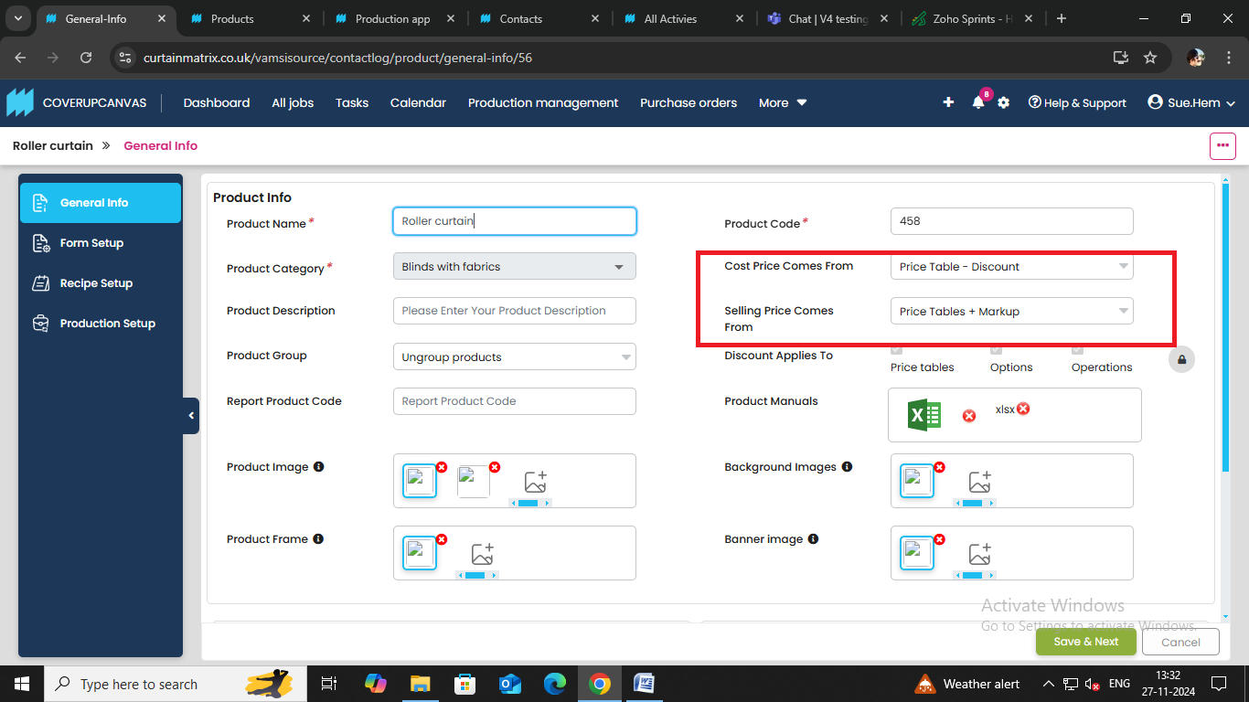
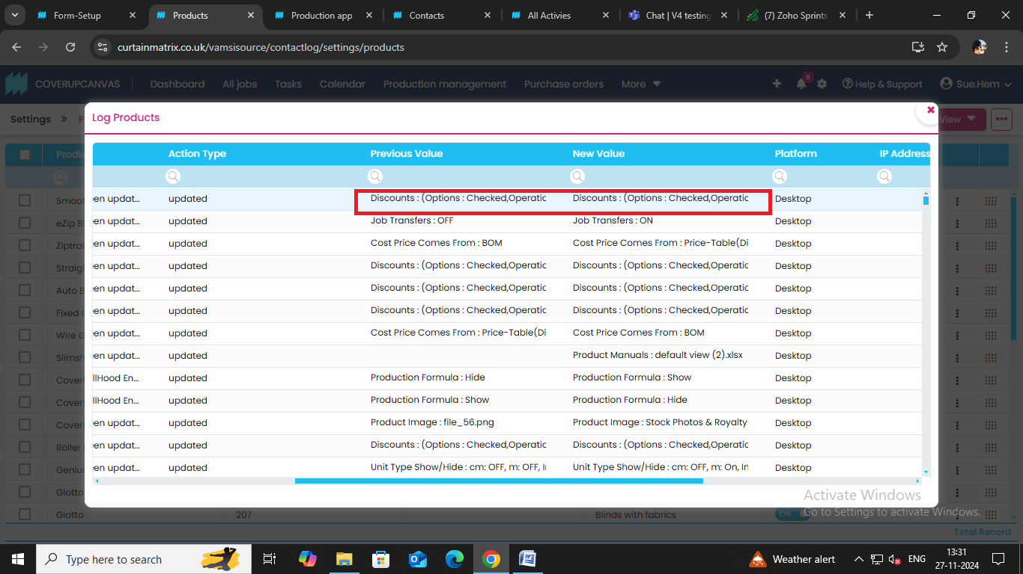

18) please see through this additional values
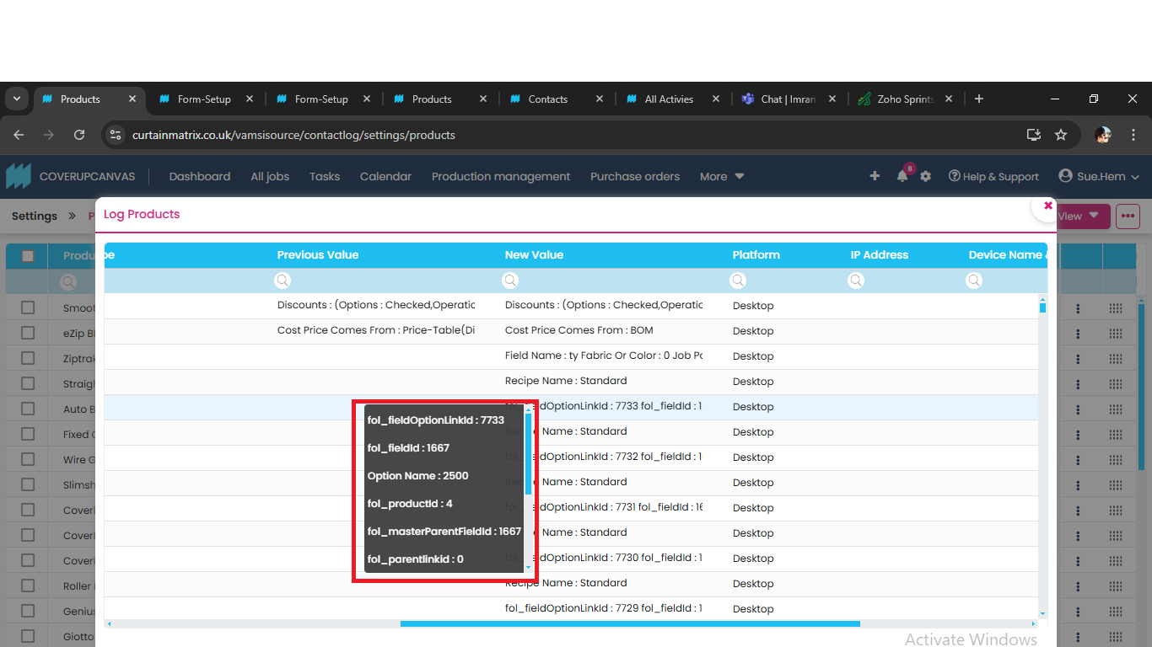

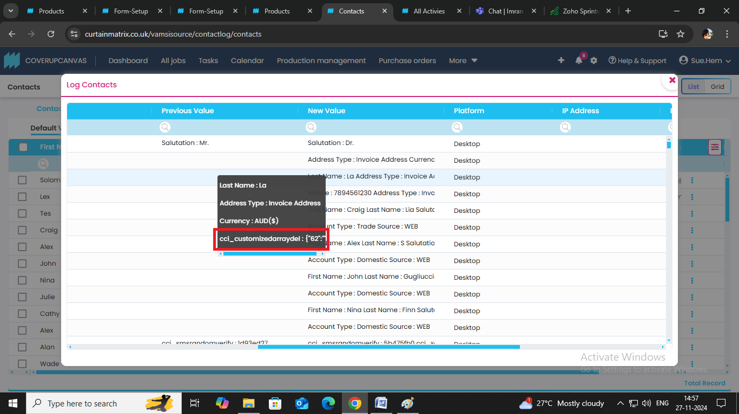

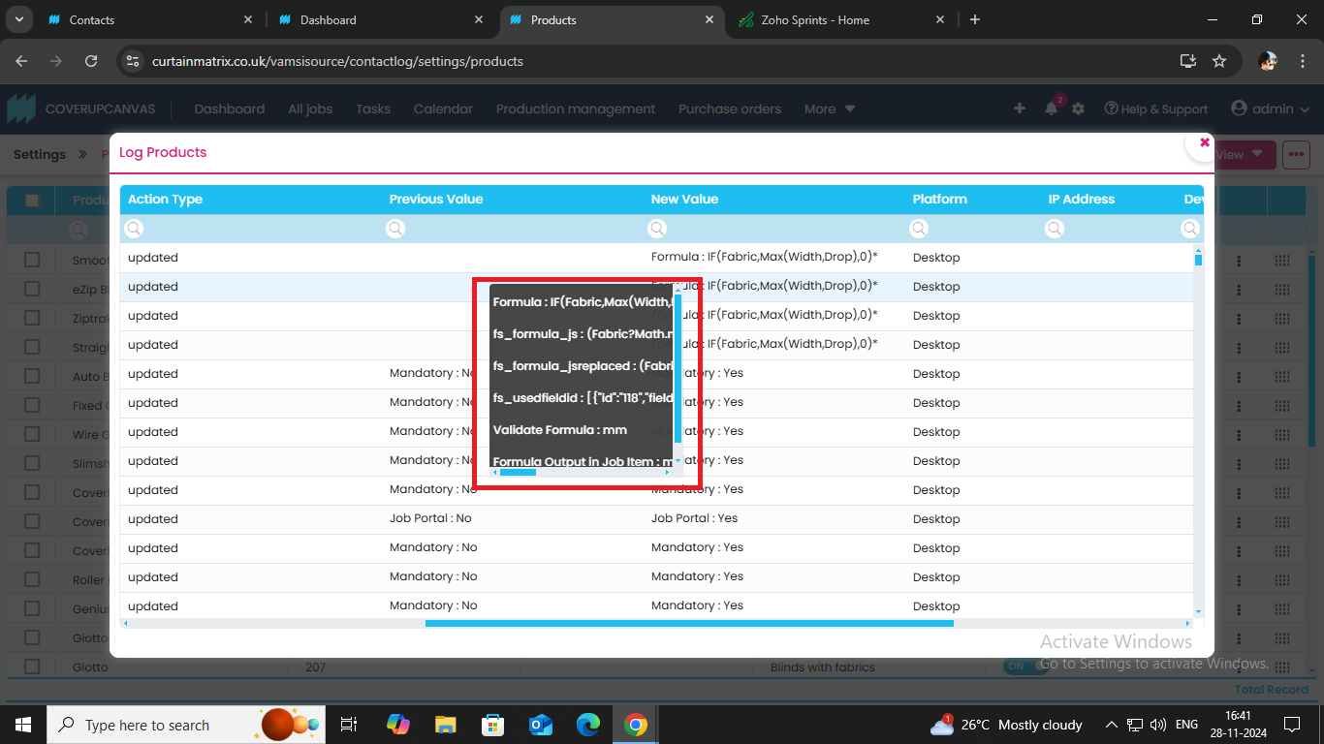

In all logs when the image is added its showing the backend value
