17 Berkeley Street Fabric Replacement Site Visit Report

We could not carry out the fabric replacement as the motor had sheered its cable and so no point replacing fabric as would only have to remove fabric again to replace the broken motor.

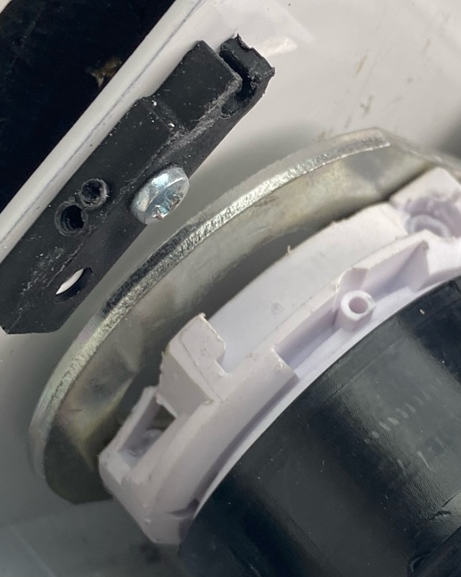
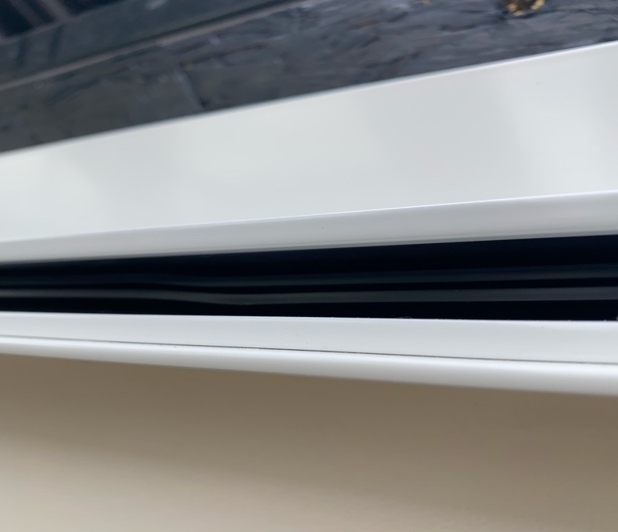
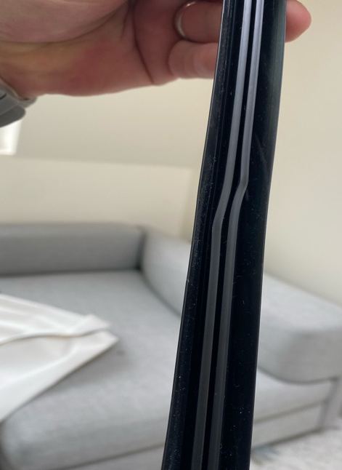
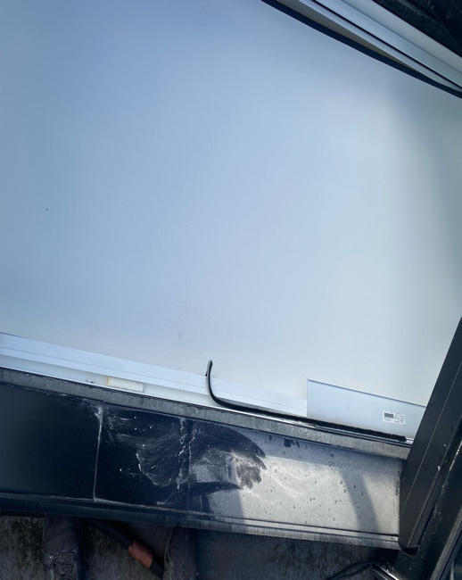
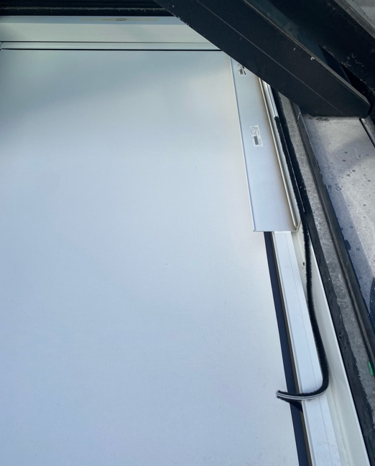
On first inspection the blind zip had come out of the tracks on both sides and was not operating (client assured it was working a few months ago when last run), went on the roof to look down through the opening skylight and found that there was a 3” roller head wedged down the side of the track forcing the side track to bend in and on the opposite side track the inner section was bent and misshaped, on closer inspection the whole system had no fixings in and was just sitting on top of the shelving and sitting on top of the track itself was the motor end casing which indicates someone had tried to have a look at it and not put the system back together again.
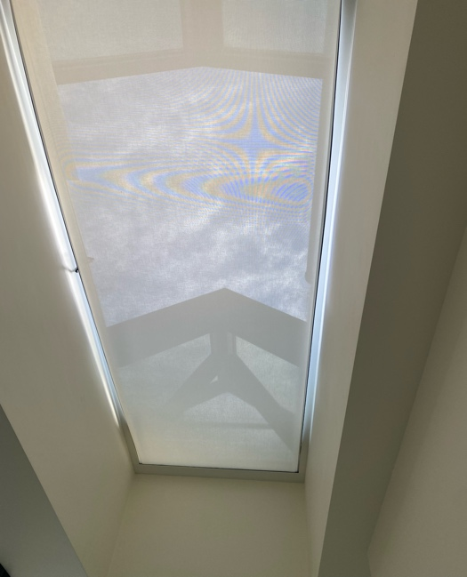

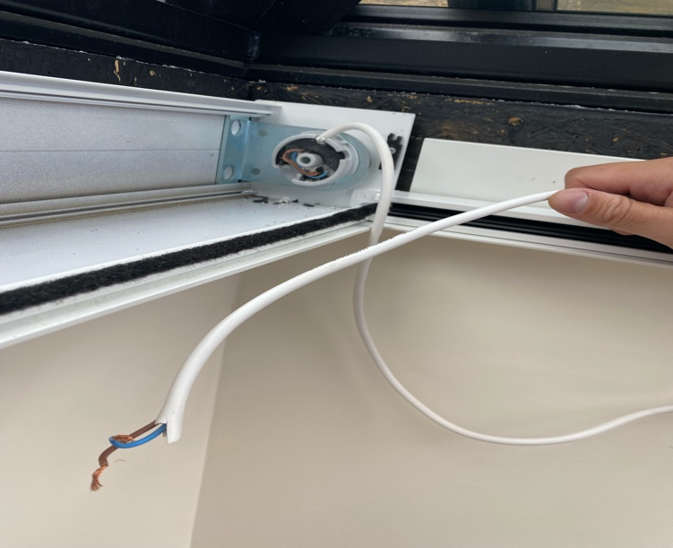
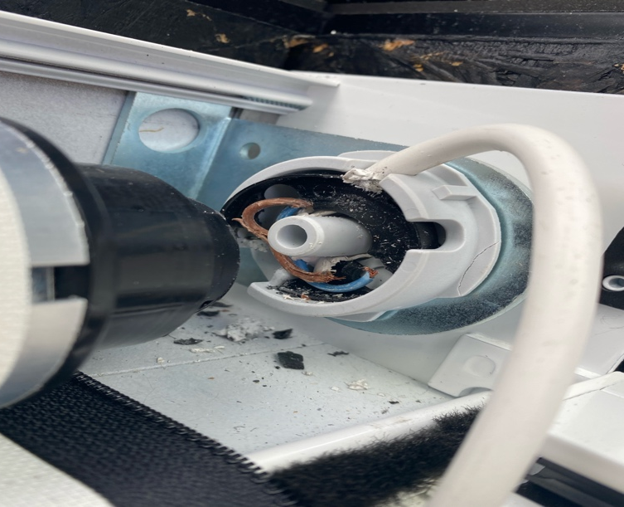
Once we had released the tension on the system and inspected the rest of the blind it became clear that the system had somehow gotten jabbed and had torn the cables from the motor. The idle end also had no fixing pin in it.

As there was nothing, we could do without a new motor we reinstalled the sheer fabric back into the zip at the clients’ request, to do this we had to remove the motor collar inside the tube to allow it to run freely, this will need to be reinstalled once the new motor arrives.

We believe the fact the system was not screw in through the side channels thus allowing the roller head to somehow get down the side of the system (don’t know how or why) is the root cause of the blind coming out of the zip and the motor sheering its cable, when the blind was retracting the hembar would of got stuck and the motor carried on pulling until it slipped in its bracket and sheered the cable. It does look as if after the motor broke someone has been tampering with it otherwise, we can’t see how the blind have ended up in the closed position.

To fix the system you need
- A new motor
- Motor collar inside tube needs fixing in place again
- New side channel inserts
- Fabric still needs changing to blackout
- Fix the system correctly through the side channels
- New idle end drop in pin
- We would also advise to replace any of the plastic components that fix the blind to the brackets as we can’t guarantee they have not been damaged when the motor broke

If you require any more information, please don’t hesitate to reach out to us.

Kind Regards,

Oliver Levy
Director

