Client and Order ID | 27405 DONALD
Room/ Position | Bedroom
Item
  Curtain Heading | Double pinch pleat curtains
  Unlined/ Lined/ Interlined | B/O lined
  Pair / Single and stack | Pair
  Quantity | 1
Fabric + quantity supplied | Morris &Co Kelmscott tree embroidery Woad/Rise 230343, Fabric width 137cm. Vertical Repeat: 76.5cm  16.0 metres
Lining | POS OWN
Interlining | N/A
Border fabric | N/A
Dimensions  Each curtain | 15cm Buckram
  Finished Width of each curtain inc. Overlaps & Returns | 122.5
  Pole length | 195cm
  Drop cm | 286cm
  Overlap | 7cm
  Return cm | 13cm
  No of Drops cm/ Railroaded | 2 widths in each curtain
  Border cm / Trim  Hem/ Leading edge | N/A
Date Required | W/C 27/04/2026

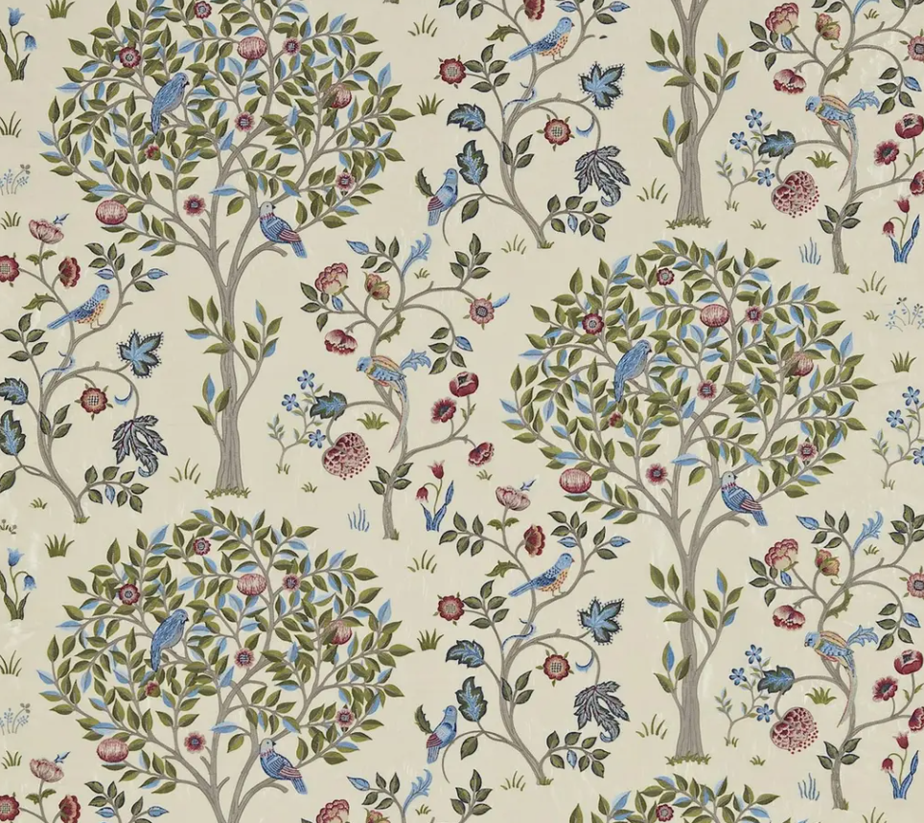

Morris &Co Kelmscott tree embroidery Woad/Rise 230343, Fabric width 137cm. Vertical Repeat: 76.5cm

