

10 March 2026

To: ABDUL
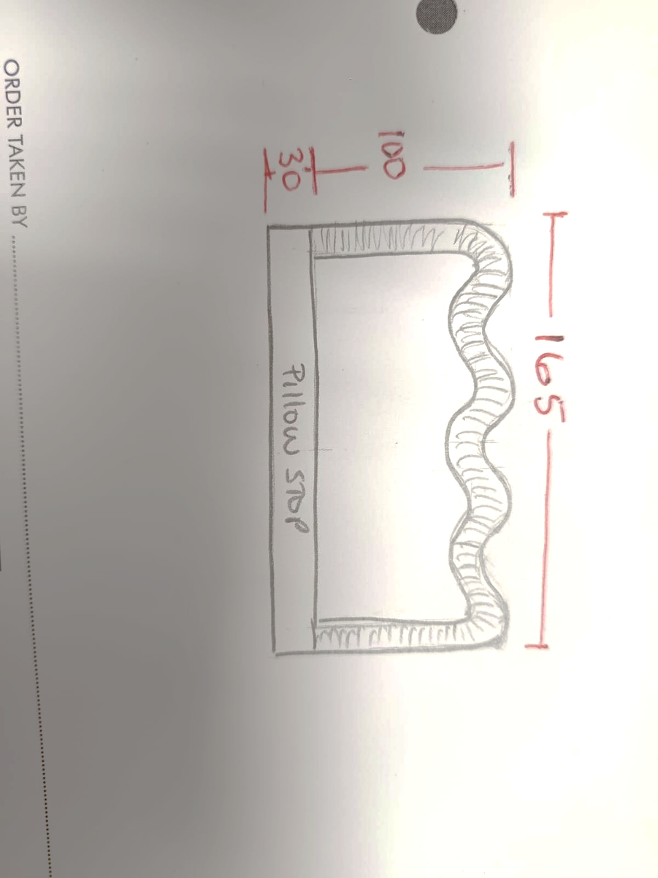
Order No: 27407 BEV & MALCOLM

X1 King Size Scallop top headboard with Rouched boarder

30cm Pillow stop

Fabric: ROMO FARO MARSALA V3570/04

