MANUFACTURERS OF QUALITY CUSTOM MADE CURTAINS, PELMETS AND BLINDS
DATE  02/06/2025 |  | COMPANY  POSNER INTERIORS |  |  |  | CUSTOMER  27029 EVANS |  |  | ORDER  REFERENCE MASTER BED
CONTACT NAME |  | FABRIC DETAILS  Jane Churchill Sunstone Blue J0208-07 |  |  |  | FABRIC WIDTH  136 cm |  | REPEAT  8cm vertical |  | QTY |  | RAILROAD
COLOUR OF LINING IS IVORY OR ALMOND |  | PC PREMIUM LINING |  | PC STANDARD LINING |  | PC BLACKOUT  LINING | POSN OWN | PC INTERLINING |  | PC SATIN FLEECE LINING
TRIM / BRAID / BORDER |  |  | BORDER SIZE |  | TOP |  | BOTTOM |  | LEADING  EDGE |  | RTN  EDGE
MEASUREMENTS MUST BE IN METRIC |  |  | ITEM 1 | ITEM 2 | ITEM 3 | ADDITIONAL INFORMATION  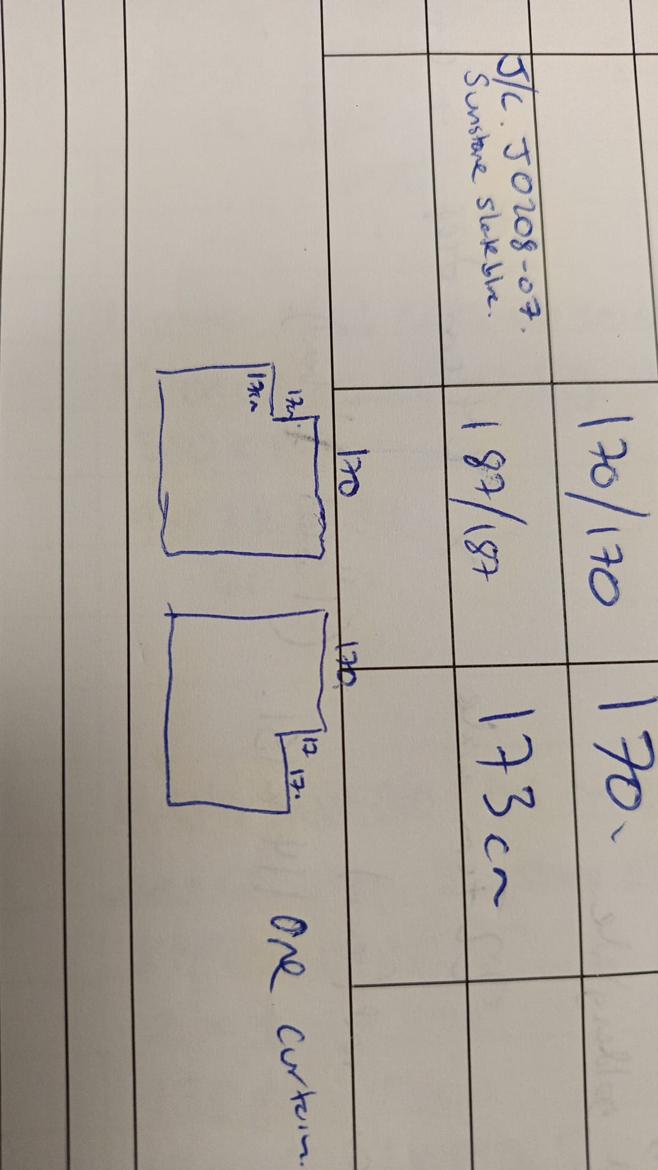  PLEASE CREATE CUT OUT FOR CURTAIN TO FIT AROUND BEAM  17cm x 17cm
PAIR |  |  | X
SINGLE | LH | RH
WIDTHS PER CURTAIN |  |  | 3.5
OVERALL DROP |  |  | 173 cm
HOOK HEIGHT/EYE DROP
TRACK SIZE |  |  | 374 cm
OVERLAPS & RETURNS |  |  | 8cm each
INTERLINED - HANDSEWN
LINED - HANDSEWN |  |  | X
LINED - MACHINE
HEADING PENCIL
HEADING TRIPLE PINCH |  |  | X
HEADING DOUBLE PINCH |  |  |  |  |  | DEPTH OF BUCKRAM  15cm
SINGLE PLEAT & CARTRIDGE PLEAT (CIRCUMFERENCE OF PLEAT IN CM) |  |  |  | 7.6 | 10.2 | 12.7 | 15.3
CARTRIDGE FILLED OR UNFILLED |  | F | UF
HEADING WAVE | 80MM | 60MM
INVISIBLE WAVE | 80MM | 60MM
THIS ORDER INCLUDES ON A SEPARATE SHEET  (Please tick appropriate box) |  |  |  | CURTAINS | X | BLINDS
Premierchoice Ltd, 3 Algores Way, Weasenham Lane, Wisbech, Cambs, PE13 2TQ. Email: orders@premierchoice.co.uk

