POCHETINO GLASS ROOM

GLASS ROOM:
Replaced faulty light bar receiver.
Had to trace wiring and disconnect in order to remove light bar because the Sotezza is in the way.
Also had to remove several lights because low voltage and mains cables are ran under the lights.
New LED receiver replaced and programmed in (Darren fortunately had one on his van).
Replaced light bar and re wired everything.
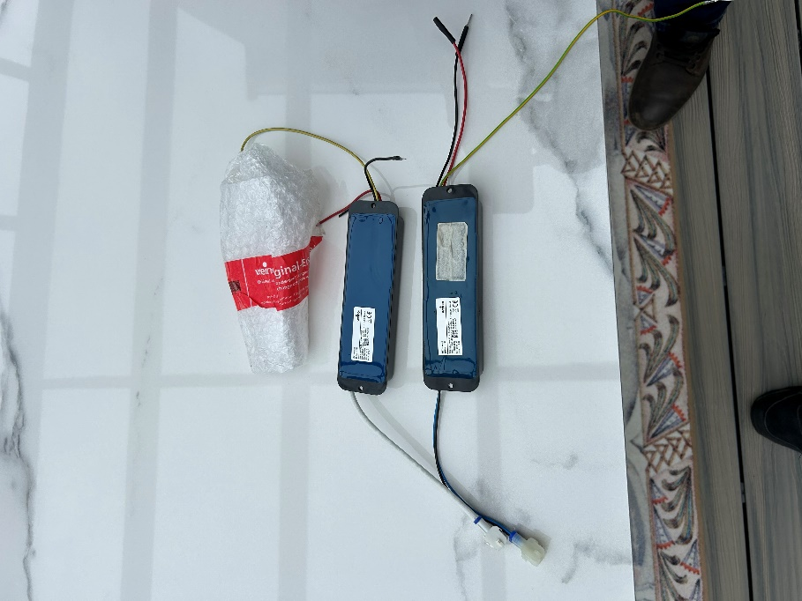
DECKING:
Re Decking, there were several boards loose on the front step section.
I took these up repositioned fixings and glued the boards down for extra stability.
I checked the whole room and tightened screws wherever needed.
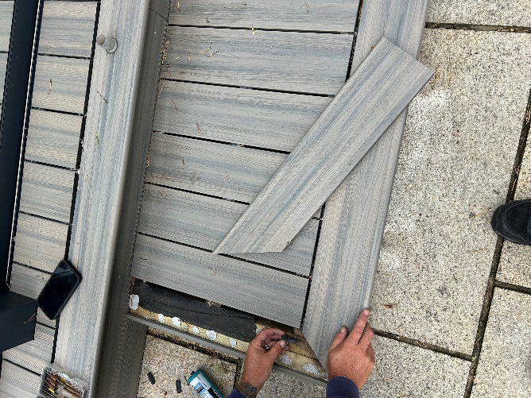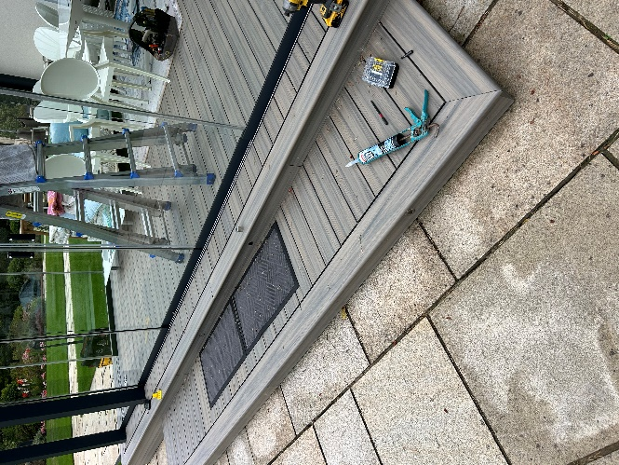

PLINTH LIGHTING:
Re Plinth lighting, a couple of lights appear to have ‘burned’ out.
I couldn’t trace any power, so I think the fault is with the supply. This will need an electrician to look at and possibly replace the fittings.
They said that they have been having issues with some of the other garden lights going off so maybe it’s related!
The work we carried out inside the glass room is all ok and tested.

