Blind Worksheet
House of Mulholland Workroom
Studio 4, 6-10 Central Parade, 137 Hoe street, London, E17 4RT
info@houseofmulholland.co.uk 07942 282777
Client and Order ID | 26640 Sinnamon
Room/ Position | Master bed Ensuite Left
Item
  Blind Stack / Waterfall | Waterfall
  Unlined/ Lined/ Interlined | Unlined
  Returns Y/N | Yes
  Quantity | 1
Fabric + quantity supplied | Casamance Petale 4418 06 81  Wide Width 2 Mtrs ordered – 1 mtrs for each
Lining | none
Interlining
Border fabric
Dimensions  Each curtain
  Width cm | 905
  Drop cm | 1750
  Overlap
  No of Rods | No rods - unstructured
  No of Cords | 2
  Border cm / Trim
  Sides / Bottom
  Drops per blind | 1
Date Required | As soon as possible
Notes
Motorised headrail 0.5cm small than blind to allow for returns see image

Blind Worksheet
House of Mulholland Workroom
Studio 4, 6-10 Central Parade, 137 Hoe street, London, E17 4RT
info@houseofmulholland.co.uk 07942 282777
Client and Order ID | 26640 Sinnamon
Room/ Position | Master bed Ensuite Right
Item
  Blind Stack / Waterfall | Waterfall
  Unlined/ Lined/ Interlined | Unlined
  Returns Y/N | Yes
  Quantity | 1
Fabric + quantity supplied | Casamance Petale 4418 06 81  Wide Width 2 Mtrs ordered – 1 mtr for each
Lining | none
Interlining
Border fabric
Dimensions  Each curtain
  Width cm | 1210
  Drop cm | 1750
  Overlap
  No of Rods | No rods - unstructured
  No of Cords | 3
  Border cm / Trim
  Sides / Bottom
  Drops per blind | 1
Date Required | As soon as possible
Notes
Motorised headrail 0.5cm small than blind to allow for returns see image

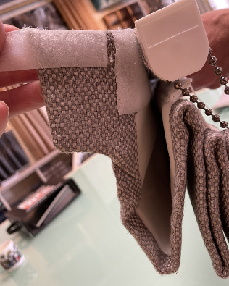
– please make headrail side covers

