

24 May 2024

To: Patricia
Order No: 26621 BERNICE VIRBY ROSS – NORTON FOLGATE
WORKSHEET 4 OF 4

BAY 4: X3 FLAT PANELS ROD POCKETS IN TOP AND BOTTOM

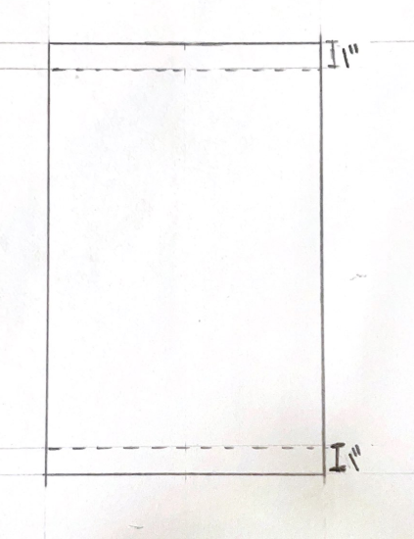
Please make the slots 1”

FINISHED PANEL SIZES:

LEFT: 110cm x 152.5cm
MIDDLE: 112cm X 152.5cm
RIGHT: 110cm X 152.5cm

