

03 June 2024

To: Premier Choice
Order No: 26652 BYLETT
LOUNGE BLACKUT CURTAIN

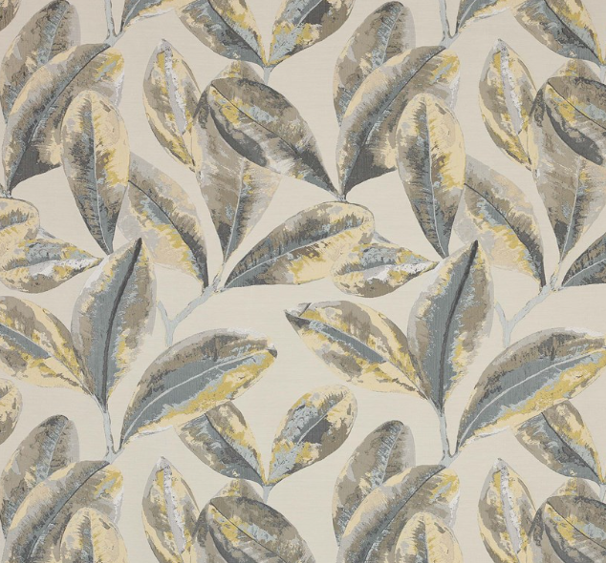
To alter heading to 80mm wave and alter drop.

Track size: 314cm.

Glider count: 42

New Drop: 247.5cm
ORIGINAL ORDER 26301 BYLETT

