QUOTATION:
QUOTE REF : |  | 47292 |  | Designer : | Paul
DATE : |  | 17/10/19 |  | Advisor : | Michelle
CUSTOMER : |  | Robin Saxby
ADDRESS : |  | Unity Building  Chapel Street  L3 9AG |  | DELIVERY :  (if different)
Mobile Tel : |  | 07917 801386 |  | Home / Work Tel :
QTY | LOCATION |  | Description |  |  |  | PRICE (£)
1 | En Suite |  | Material:  Java  Tilt Option:  Silent Tilt  Louvre Size:  76mm  Paint / Finish:  Pure White |  |  |  | £580
1 | Bathroom |  |  |  |  |  | £1245
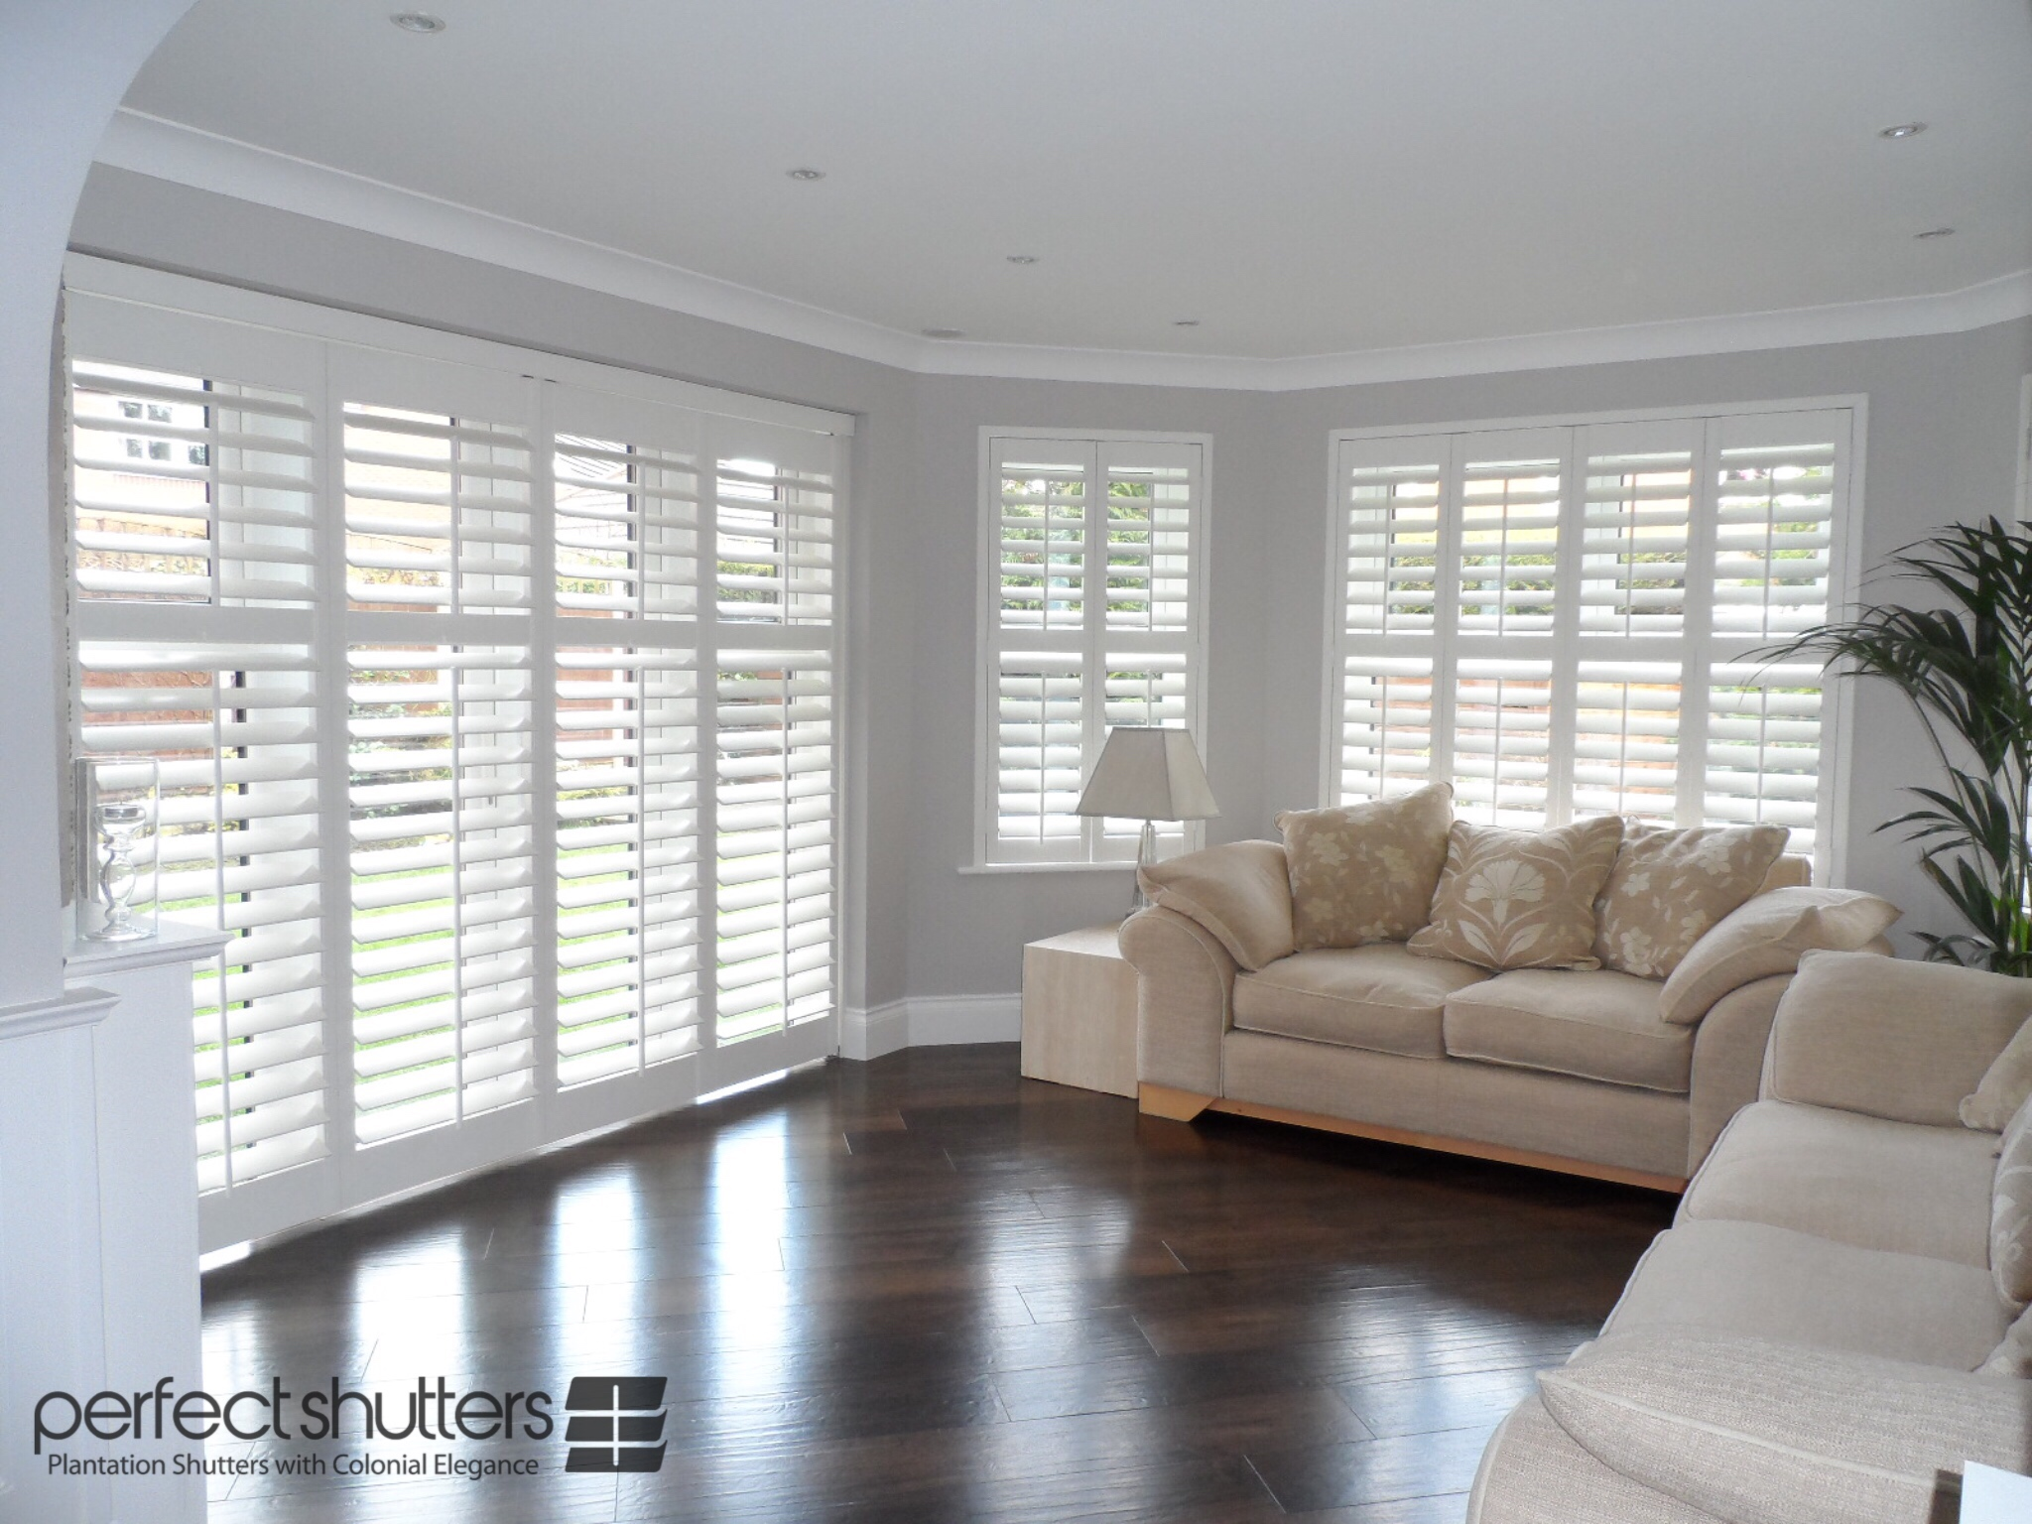 |  |  | Net total |  |  |  | £1925
 |  |  | Vat @ 20% |  |  |  | £385
 |  |  | Total Amount Payable |  |  |  | £2310
 |  |  | Deposit Required |  |  |  | tbc
 |  |  | Cash, cheques and All Major debit / credit cards accepted.
Notes :  Delivery is approximately 10 - 12 weeks, subject to complexity of design and shipping. |  |  |  |  |  | 

Prices are based on full project. Individual windows ordered separately may be subject to additional price changes.

TO DISCUSS ANY DETAILS OR PLACE YOUR ORDER / PAY DEPOSIT, PLEASE CALL 0151 724 1100

