YOUR QUOTATION
QUOTE REF |  | CONTACT INFO
DATE | 21.04.23
CUSTOMER
MOBILE / TEL |  | SALES DESIGNER: Kelly
ADDRESS: 12 Forest Drive Sale |  | SALES DESIGNER: Kelly
DESCRIPTION | NOTES | LOCATION | QTY | PRICE (£)
Faux Wood Ven Blinds in Pure White |  |  | 6 | 697
  Lounge
  Front small room
  Front right
  Bathroom
  Back Bed
  Ensuite
No tapes
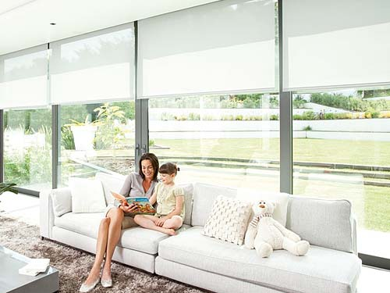 |  | BLINDS TOTAL |  | 697
 |  | SURVEY & INSTALLATION |  | 0
 |  | TOTAL AMOUNT PAYABLE |  | 697
 |  | DEPOSIT REQUIRED |  | 349
 | Cash, Cheques and All Major Debit / Credit Cards Accepted
NOTES  Delivery approximately 2-4 weeks. Subject to complexity of design. |  |  | 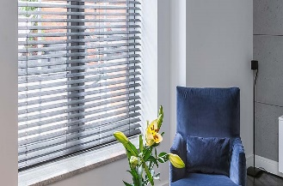

Prices are based on full project. Individual windows ordered separately may be subject to additional price changes.

TO DISCUSS ANY DETAILS OR PLACE YOUR ORDER / PAY DEPOSIT, PLEASE CALL 0151 298 2000

