YOUR QUOTATION
QUOTE REF | 75731 | CONTACT INFO
DATE | 14.11.2022 | SHOWROOM ADVISOR:
CUSTOMER | Patrick Malone | SHOWROOM ADVISOR:
MOBILE / TEL | 07518 458787 | SALES DESIGNER: Jack
ADDRESS: 6 Thetford Close |  | SALES DESIGNER: Jack
DESCRIPTION | NOTES | LOCATION | QTY | PRICE (£)
Perfect Fit Aluminium Slats |  | Bi-Fold 1 | 3 | £150 Each
Perfect Fit Aluminium Slats |  | Bi-Fold 2 | 3 | £150 Each
Should you wish to upgrade ………
 |  | BLINDS TOTAL |  | £900
 |  | Discount |  | 25%
 |  | TOTAL AMOUNT PAYABLE |  | £900
 |  | DEPOSIT REQUIRED |  | £450
 | Cash, Cheques and All Major Debit / Credit Cards Accepted
NOTES  Delivery approximately 2-4 weeks. Subject to complexity of design. |  |  | 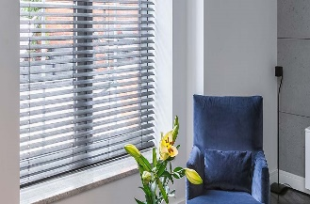

Prices are based on full project. Individual windows ordered separately may be subject to additional price changes.

TO DISCUSS ANY DETAILS OR PLACE YOUR ORDER / PAY DEPOSIT, PLEASE CALL 0151 298 2000

