YOUR QUOTATION
QUOTE REF | 70726 | CONTACT INFO
DATE | 07.06.2022 | SHOWROOM ADVISOR: Jack
CUSTOMER | Johnathan Gittins | SHOWROOM ADVISOR: Jack
MOBILE / TEL | 07752 750734 | SALES DESIGNER:
ADDRESS: 1 Cambridge Road |  | SALES DESIGNER:
DESCRIPTION | NOTES | LOCATION | QTY | PRICE (£)
White Venetians |  | Bedroom 1 Perfect Fit roller | 1 | £270
White Venetians |  | Bedroom 2 (Sons) Perfect Fit roller | 1 | £200
Perfect Fit Blinds |  | Master Bedroom – Motorised Roller | 1 | £530
Pleated Blinds
Should you wish to upgrade ………

 |  | TOTAL AMOUNT PAYABLE |  | 1000
 |  | DEPOSIT REQUIRED |  | £500
 | Cash, Cheques and All Major Debit / Credit Cards Accepted
NOTES  Delivery approximately 2-4 weeks. Subject to complexity of design. |  |  | 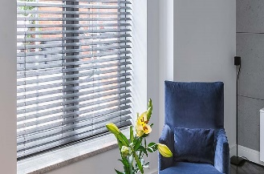

Prices are based on full project. Individual windows ordered separately may be subject to additional price changes.

TO DISCUSS ANY DETAILS OR PLACE YOUR ORDER / PAY DEPOSIT, PLEASE CALL 0151 298 2000

