YOUR QUOTATION
QUOTE REF | 68018 | CONTACT INFO
DATE | 24/06/2022 | SHOWROOM ADVISOR:  HELEN
CUSTOMER | Lyme Community Primary School | SHOWROOM ADVISOR:  HELEN
MOBILE / TEL | 01744 678351 | SALES DESIGNER:  CHRIS
ADDRESS: Newton Le Willows WA12 9HD |  | SALES DESIGNER:  CHRIS
DESCRIPTION |  | LOCATION & PRODUCT | QTY | PRICE (£)
Supply & Install

Supply & Install |  | Reception - 1 vertical 1 Roller - Beige | 2 | 195
Supply & Install |  | Staff Room – Verticals - Beige | 2 | 295
Supply & Install |  | Head Teachers Office – Verticals - Beige | 1 | 145
Supply & Install |  | Sports Hall Doors – Roller Polaris Grey | 2 | 225
Supply & Install |  | Sports Hall Windows - Roller Polaris Grey | 6 | 875
Supply & Install |  | Hallway Large – Roller – Polaris Grey | 2 | 210
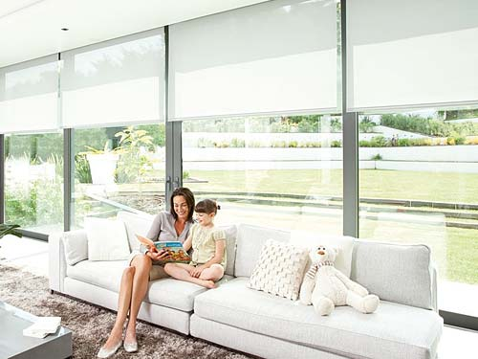 |  | BLINDS TOTAL |  | £1945
 |  | Motors x 6 |  | 750
 |  | TOTAL AMOUNT PAYABLE |  | £2695
 |  | DEPOSIT REQUIRED |  | £1350
 | Cash and All Major Debit / Credit Cards Accepted
NOTES  Deposit Outstanding – £1350  Fitting date booked for 21st July - |  |  | 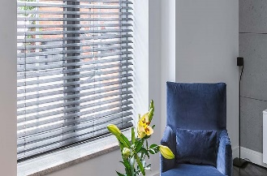

Prices are based on full project. Individual windows ordered separately may be subject to additional price changes.

TO DISCUSS ANY DETAILS OR PLACE YOUR ORDER / PAY DEPOSIT, PLEASE CALL 0151 525 0050.

