YOUR QUOTATION
QUOTE REF | 47761 | CONTACT INFO
DATE | 11th November 2019 | SHOWROOM ADVISOR: Karen
CUSTOMER | Steve Moore | SHOWROOM ADVISOR: Karen
MOBILE / TEL | 07786 727012 | SALES DESIGNER: Paul
ADDRESS: 5 Shireburn Road, Formby L37 1LR. |  | SALES DESIGNER: Paul
DESCRIPTION | NOTES | LOCATION | QTY | PRICE (£)
 | 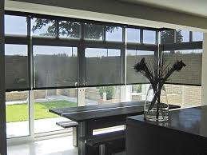
 |  | Kitchen L & R | 2 | £295
3 or 5% Quad in Chalk |  | Patio L & R | 2 | £710
3 or 5% Quad in Chalk |  | Utility | 1 | £190
Should you wish to upgrade ………
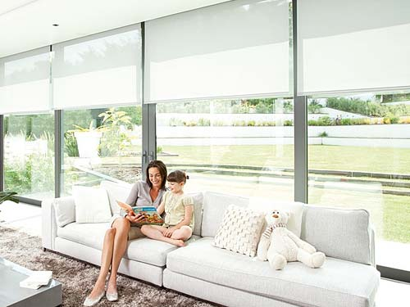 |  | BLINDS TOTAL |  | £1195
 |  | SURVEY & INSTALLATION |  | INC
 |  | TOTAL AMOUNT PAYABLE |  | £1195
 |  | DEPOSIT REQUIRED |  | £400
 | Cash, Cheques and All Major Debit / Credit Cards Accepted
NOTES  Delivery approximately 2-4 weeks. Subject to complexity of design. |  |  | 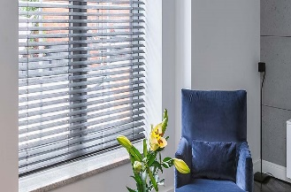

Prices are based on full project. Individual windows ordered separately may be subject to additional price changes.

TO DISCUSS ANY DETAILS OR PLACE YOUR ORDER / PAY DEPOSIT, PLEASE CALL 0151 298 2000

