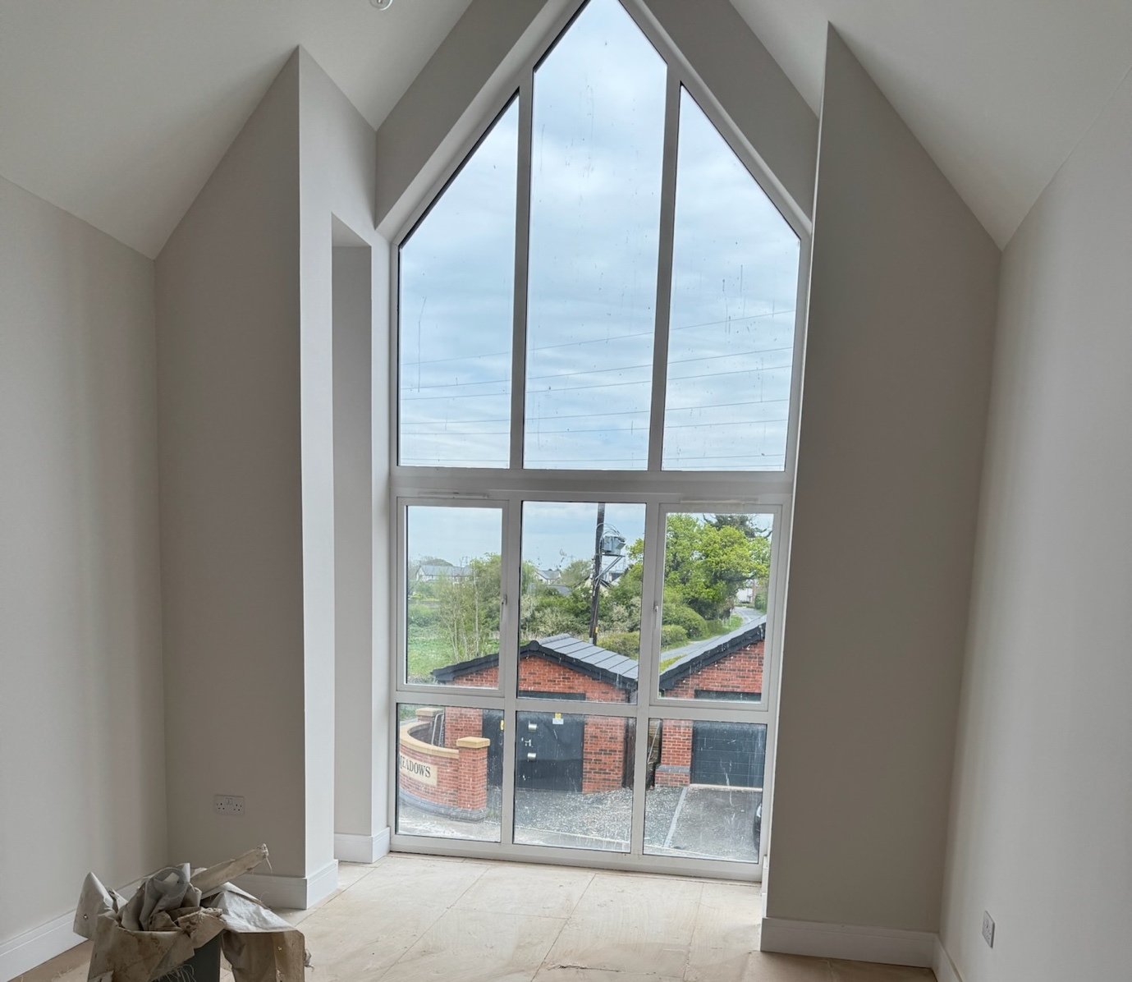

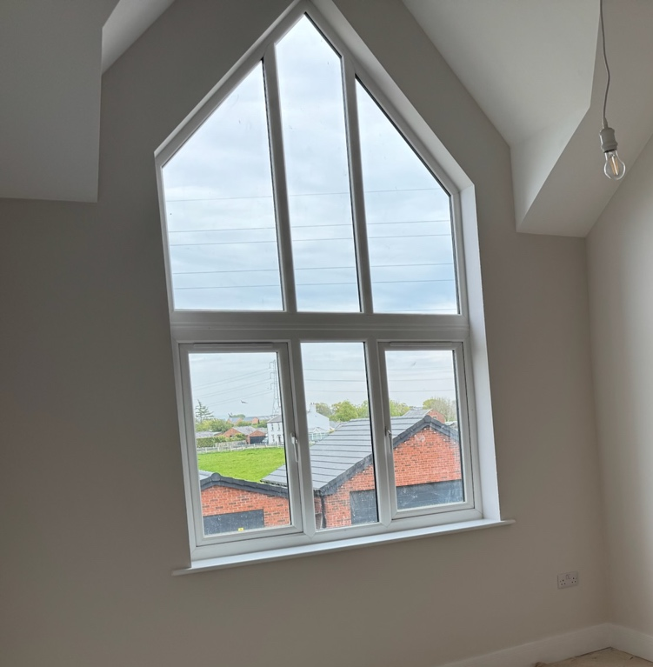

Plus 2 rectangular side windows 490 x 3260mm
4640mm
3260 mm
2150 mm
2170 mm

1997mm
1620 mm
2993mm

