PORTRAIT AND LANDSCAP VIEW ISSUES
- In the calendar, when switching the full view tab from Portrait to Landscape, blank space is displayed.(IOS – only)

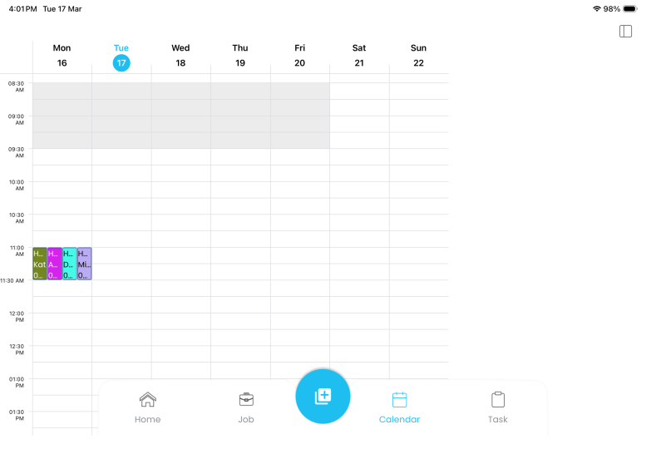

- On iOS, the three-dot options are hidden behind the menu bar in landscape mode. When switching from landscape to portrait, an empty space is displayed.
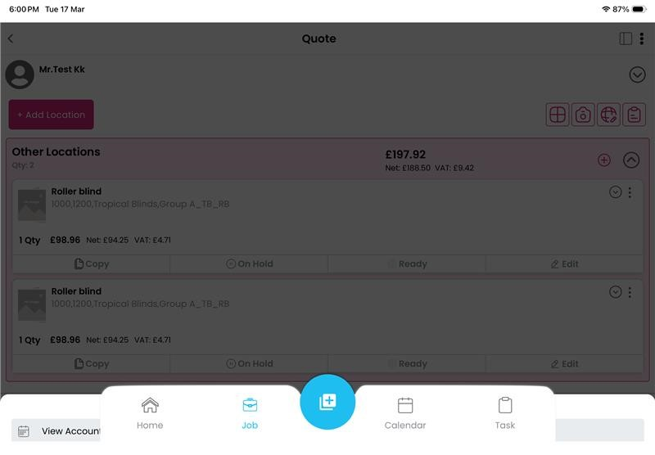

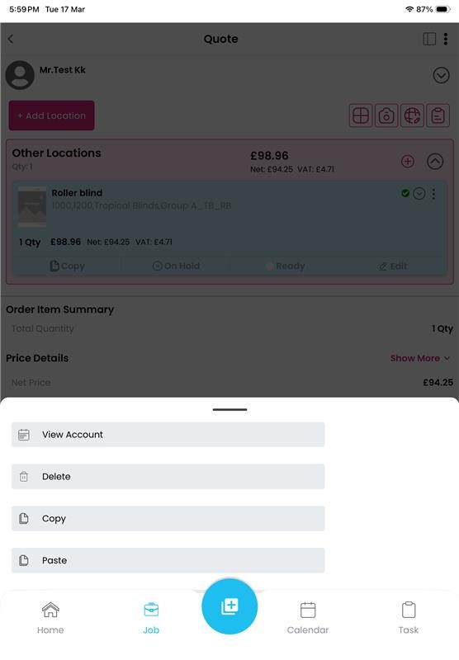

- On initial loading, when switching the tab to portrait or landscape, a blank space is displayed.
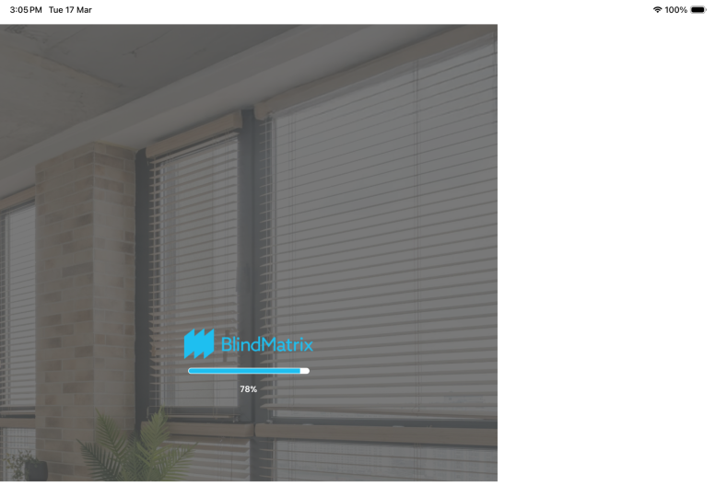

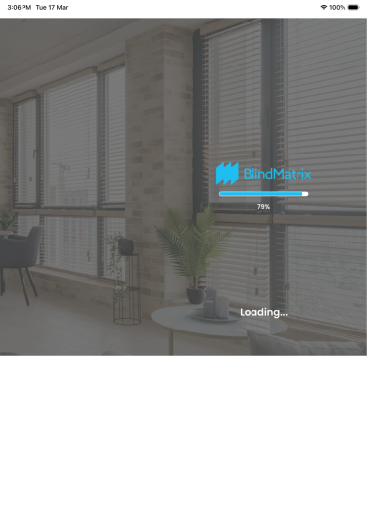

- More option and Save button not available.(IOS only)
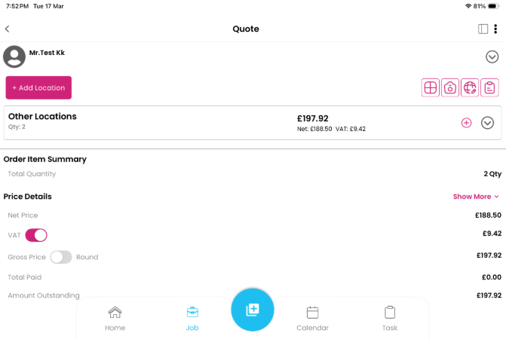

- Side menu overlap (Android only)
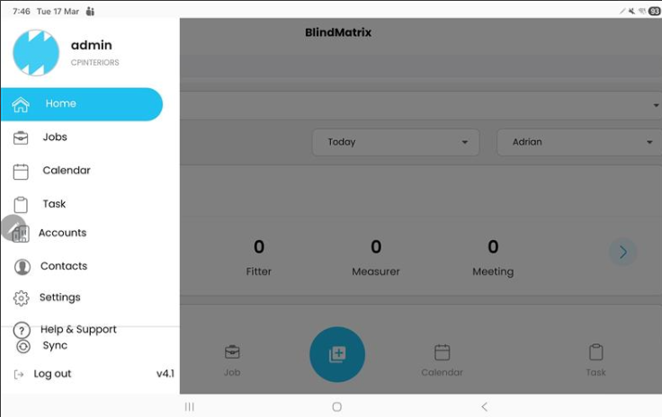
6. The appointment got hidden in landscape.
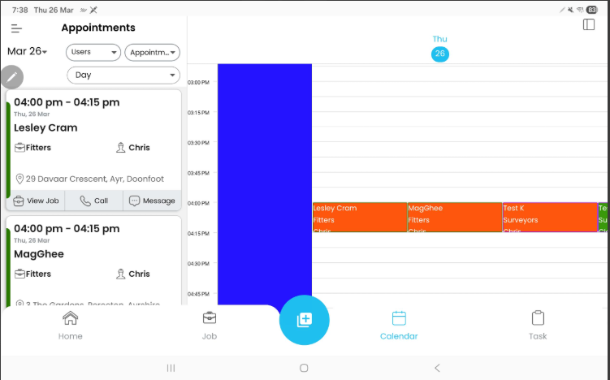
7. When switching from portrait to landscape mode in week view, the dates are getting hidden
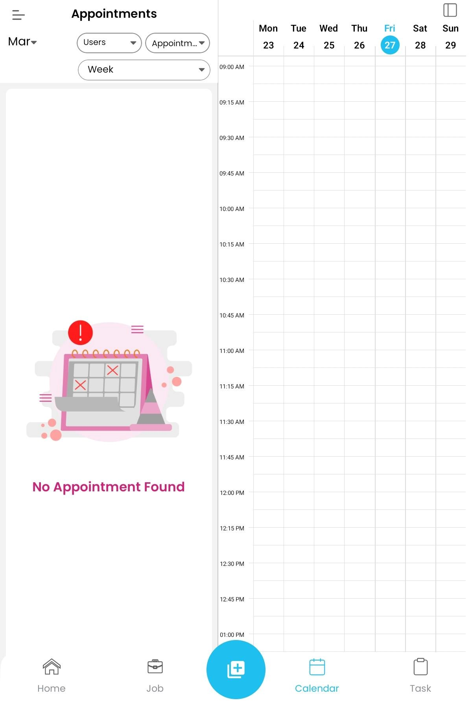

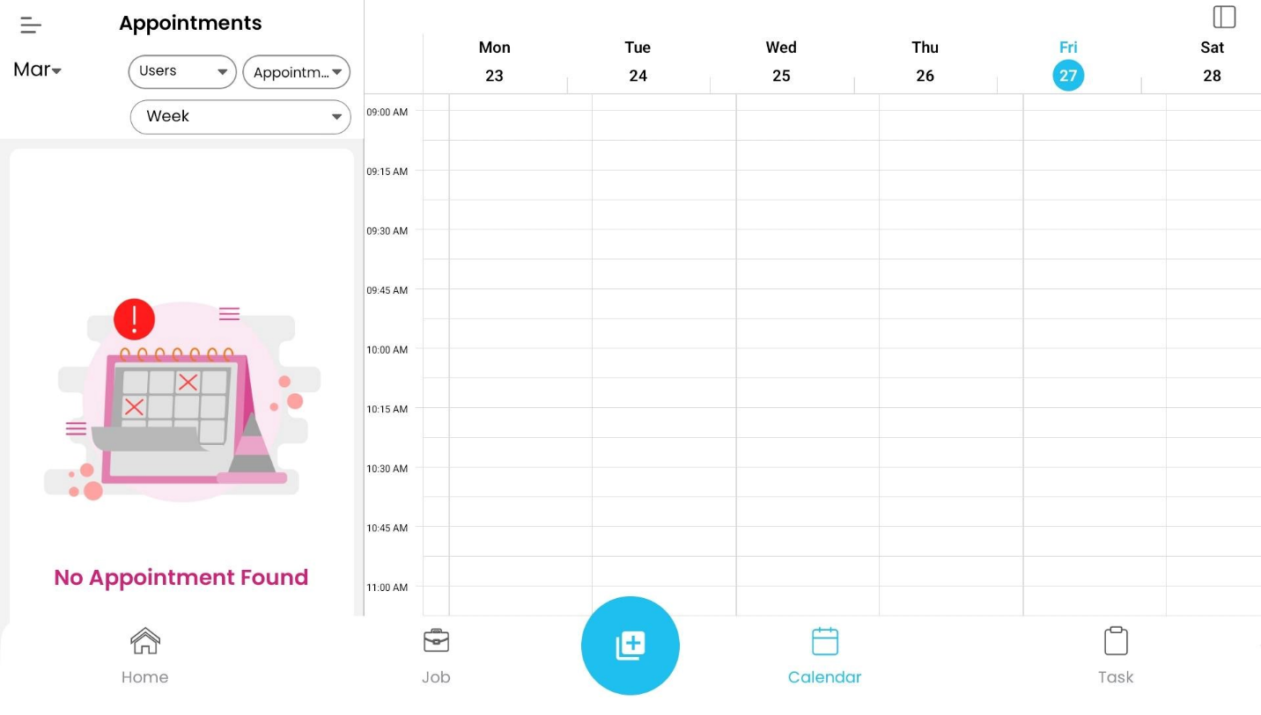
8. When switching from landscape to portrait mode, the week changes to the next or previous week automatically.
