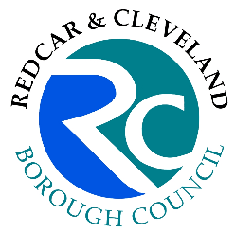
Purchase Requisition
Redcar & Cleveland Borough Council
Facilities Management
South Tees Business Centre Puddlers Road
South Bank
Middlesbrough, TS6 6TL

Requisition No Date
RCPS00003066 19/09/2023 15:25

To Supplier / Subcontractor

MARSKE FUNISHINGS - MARSKE FUNISHINGS
21 The Wynd, Marske-by-the-Sea, TS11 7LD

Project Name / Location
REDCAR COMMUNITY HEART

Request No
DLO00013033
Description of Materials / Services Required

The roller blind in the Registrars office (Room3) is broken a cord issue

Value of Materials / Works £ 0.00

Requestor  Help Desk | Contact Details

For Office Use Only

10613-R2004 - R&M Property Services

