Good Morning

I hope you are well.

I am not sure if you can assist at all, one of our landlords are having new windows fitted at their above property at the end of this month. They have asked if you would be able to provide some quotations for the following options she has detailed below. Please let me know what further information you would need and if it would be easier for you to visit the property before or after the new windows are installed:

Downstairs lounge
- The blinds were previously screwed into the wood in the window – please do not screw the blinds back into the new windows
- Could the existing blinds be safely screwed into the ceiling of the window – or would it be unsafe and cause a leak as it is a flat roof
- If no, could a curtain rail be installed as per the picture below where the blue line is – preferably black curtain rod and white/cream curtains
- If no, what could the other options be

Upstairs bedroom
- The existing fabric curtain was screwed into the wood in the window – please do not screw the fabric curtain back into the new windows
- Can a curtain be hung from a curtain rail installed as per the picture below blue line – or would it be unsafe as the walls either side of the window are too thin
- If yes preferably a black curtain rail and white/cream curtains
- If no, what could the other options be

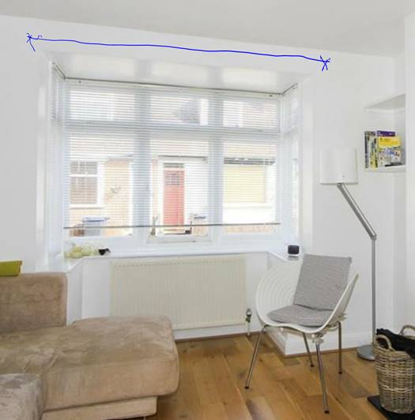

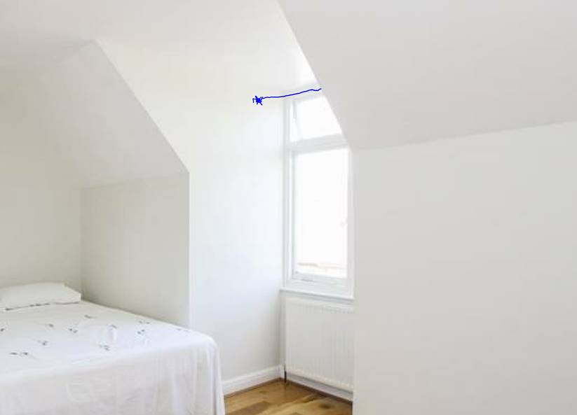

I look forward to hearing from you in due course.

Kind Regards
Shauna


  Shauna Sullivan​​
  Property Manager
  t: 01227 278 232 | | | o: 01227 266 441
  e: Shauna.Sullivan@christopherhodgson.co.uk | | | w: christopherhodgson.co.uk
  a: | 95-97 Tankerton Road, Whitstable, CT5 2AJ

