Le Breton Curtain Spec March 26
Roman blinds to use Stabbing stitches – not machined across face.
Master Bedroom |  | 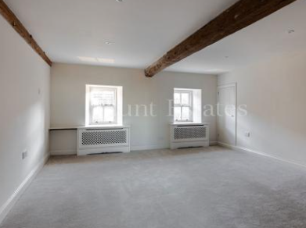
To cut, make and fit 2 Roman blinds to be fitted as high as possible and to drop to the radiator case. To be the width of the radiator case. To be interlined in Venus dim out and lined in off white sateen. | Using: Linwood Kala Aloe | 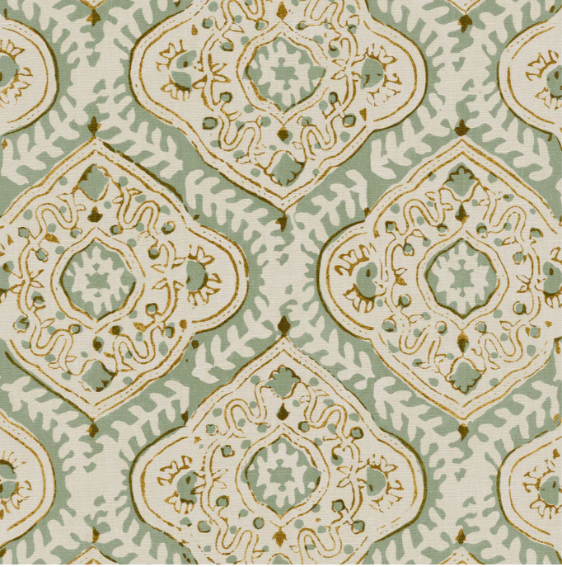
Master Bathroom  To cut, make and fit 2no [?] Roman blinds to fit as high as possible and to fall to the sill. | Using: Ian Sanderson Dulcie Thyme | 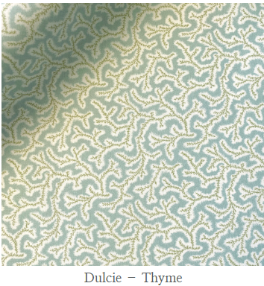

Bedroom 2 |  | 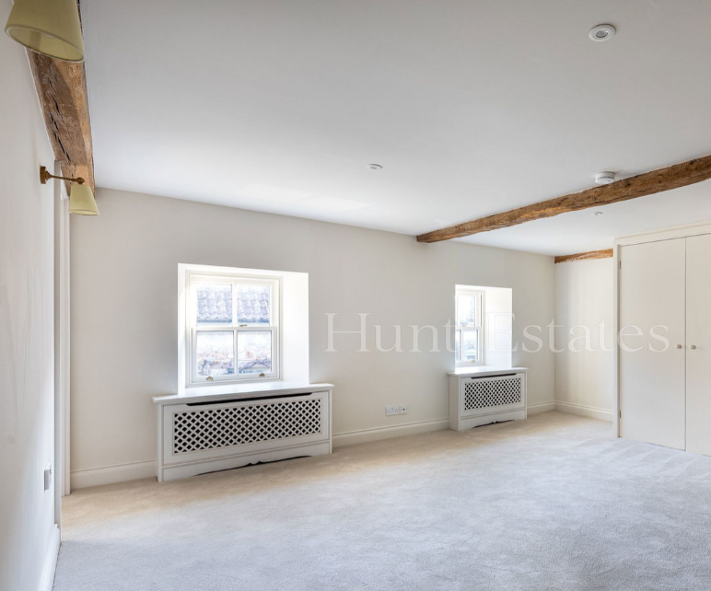
To cut, make and fit 2 Roman blinds to be fitted as high as possible and to drop to the radiator case. To be the width of the radiator case. To be interlined in Venus dim out and lined in off white sateen.
Using | Linwood Hester Pink Green  LF2234C/002 Pink Green | 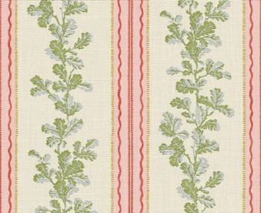
Bathroom 2 Blind | Ian Sanderson | 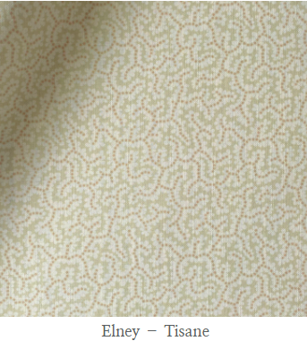

Yellow Room |  |  | 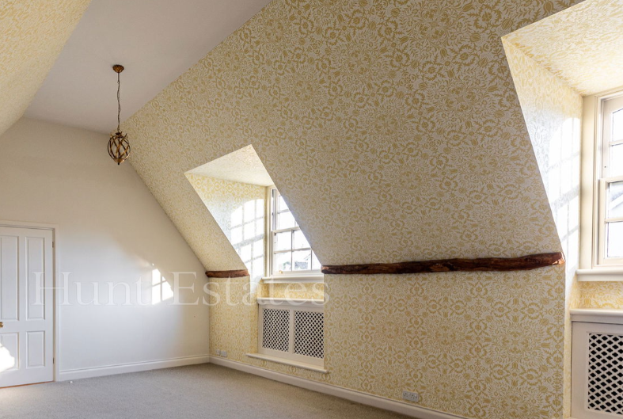
Cottage curtains on short antiqued brass arms. To be self lined and interlined in Venus dim out. To fall to the radiator base top. |  |  | 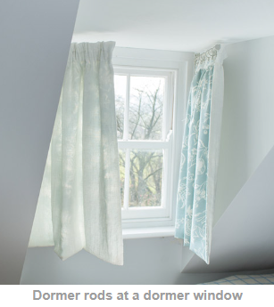
Using | Linwood |  | 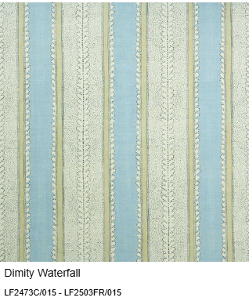  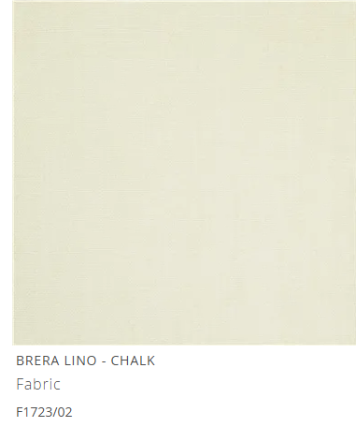
Bathroom off Yellow Room
 |  |  |  | 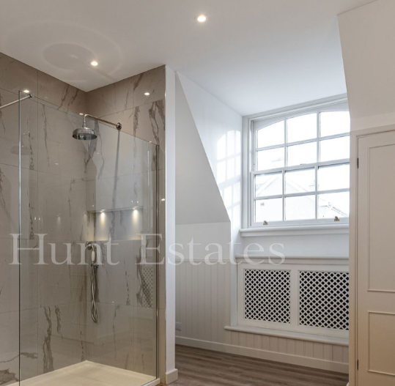
To cut, make and fit Roman blind to fit as high as possible and to fall to the sill.  Unlined? |  | Linwood |  | 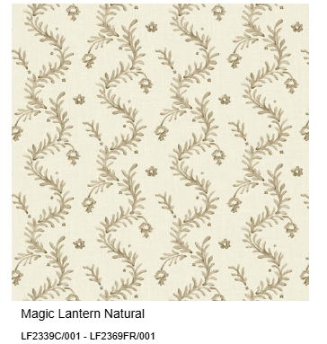

Black out Velux blinds. |  | 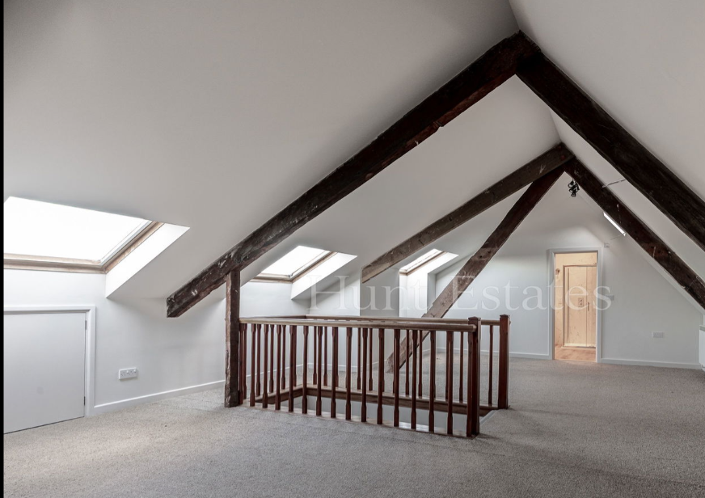

Family Bathroom |  | 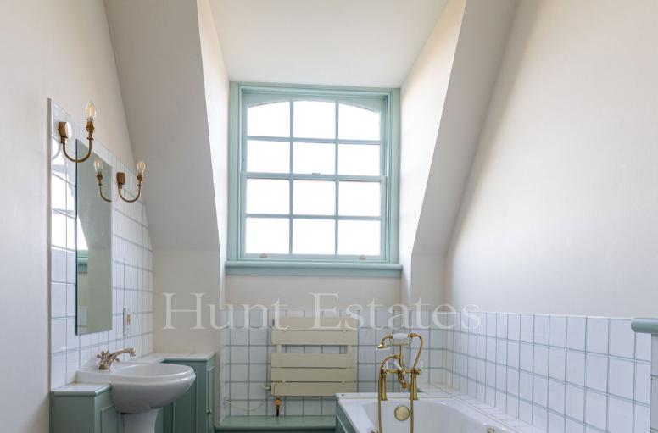
To cut, make and fit Roman blind to fit as high as possible and to fall to the sill.  Unlined? | Linwood | 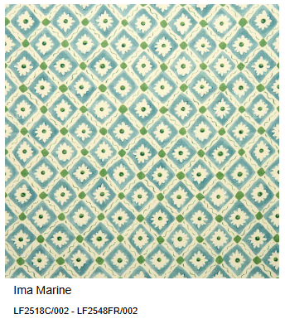

WC - |  | 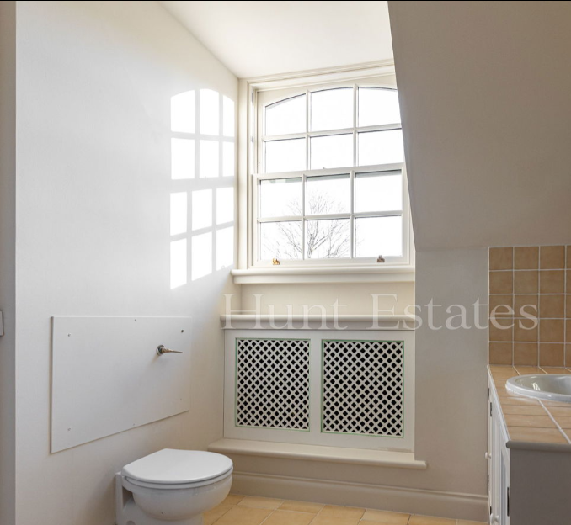
To cut, make and fit Roman blind to fit as high as possible and to fall to the sill. | Linwood | 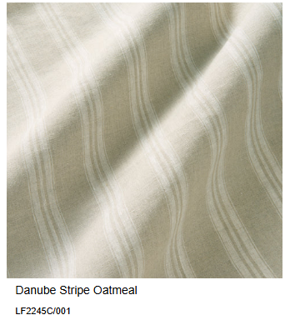

Bedroom 3 next to Bathroom |  | 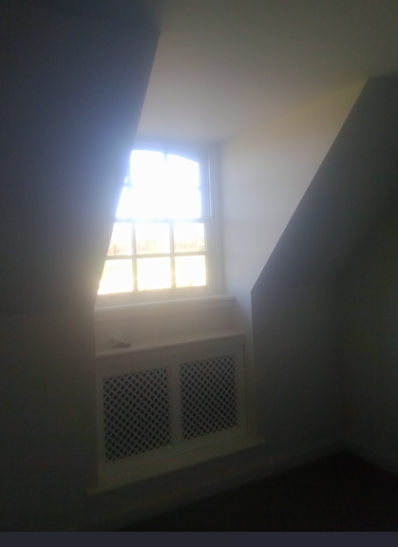
To cut, make and fit Roman blind to fit as high as possible and to fall to the sill. Interlined in Venus Dim out. Lined in off white Sateen | Linwood | 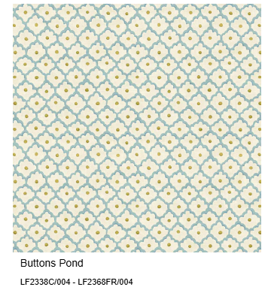
Bedroom 4 next to bathroom |  | 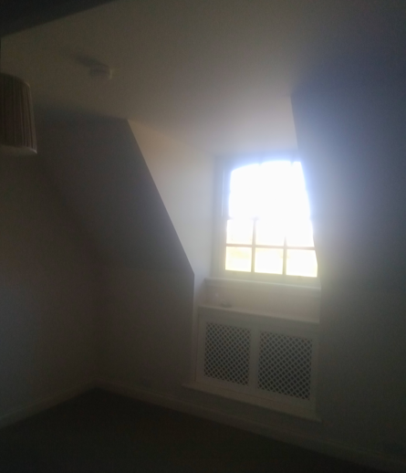
To cut, make and fit Roman blind to fit as high as possible and to fall to the sill. Interlined in Venus Dim out. Lined in off white Sateen |  | 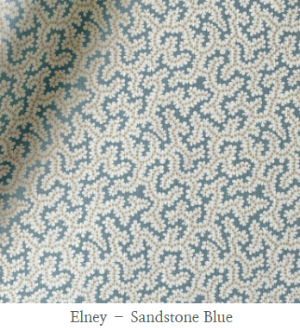
Or |  | 