
QUOTE
To: |  |  |  |  |  |  |  |  |  |  | Job Number: |  | SO16365 |  |  | Quote Date: |  |  | Tuesday 10 Dec 2024
Mrs. Elaine Walker  Le Grouet  Mont Du Grouet  Corbiere  St Brelade |  |  |  |  |  |  |  |  |  |  | Customer Reference: |  |  |  |  | Deposit required: |  |  |  |  |  | ₤ 8,694.00
 |  |  |  |  |  |  |  |  |  |  | Renson Aero |  |  |  |  | Your Contact: |  |  |  |  | Rachel
Our Price Promise to you
We are so confident our pricing is competitive, that we will beat any written quotation for equivalent product by 5%
To supply and fit unless otherwise stated.
Location |  |  | Product |  |  |  |  | Description |  |  |  |  |  |  |  |  |  |  |  | Qty |  |  | Price
 |  |  |  | Bladed Roof Systems |  |  |  |  | Renson Aero, bladed roof system with electrical rotating louvres, powder coated in a RAL colour TBC, including water drainage and rain sensor. Minimalist design for subtle integration. Matches all architectural styles. Somfy IO operation with remote control. 4.2m x 5.5m |  |  |  |  |  |  |  |  |  |  | 1 |  |  | £ 20,700.00
 |  |  |  |  |  |  |  |  | electrical works not included,
 |  |  |  | Optional Upgrade |  |  |  |  | Lineo LED in roof louvres, warm white £2640.00. |  |  |  |  |  |  |  |  |  |  | 3
 |  |  |  | Optional Upgrade |  |  |  |  | UpDown Led to x 4 sides. RGB lighting up, warm white down £6108.00. |  |  |  |  |  |  |  |  |  |  | 4
 |  |  |  | Optional Upgrade |  |  |  |  | Protecto Profile. Offers protection from wind, drizzle and snow which is likely to enter the patio cover between the blades and the frame £1725.00 |  |  |  |  |  |  |  |  |  |  | 2
 |  |  |  | Optional Upgrade |  |  |  |  | Tahoma Switch smart home hub to operate louvres via mobile, tablet and voice-controlled devices £275.00. |  |  |  |  |  |  |  |  |  |  | 1
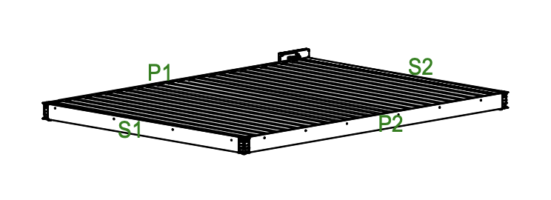
Terms: |  | 40% deposit due with order, 40% on delivery & final 20% on completion
 |  |  |  |  |  |  |  |  |  |  |  |  |  |  |  |  | Subtotal |  |  |  |  |  | £ 20,700.00
** To go ahead with this quote please make deposit payment. To pay by card call us on 01534 768141 **
 |  |  |  |  |  |  |  |  |  |  |  |  |  |  |  |  | GST |  |  |  |  |  | £ 1,035.00
 |  |  |  |  |  |  |  |  |  |  |  |  |  |  |  |  | Total |  |  |  |  |  | £ 21,735.00
Direct Deposit - Sort Code: 60-12-03 Account: 66577772
 |  |  |  |  |  |  |  |  |  |  |  |  |  |  |  |  | Paid amount |  |  |  |  |  | £ 0.00
If you have any queries please call us on 01534 768141 or visit our showroom Rue des Pres Trading Estate St Saviour |  |  |  |  |  |  |  |  |  |  |  |  |  |  |  |  | Total amount |  |  |  |  |  | £ 21,735.00
** For Our Terms & Conditions of Sale please go to www.cpinteriors.je **
Please note: This quotation is only valid for acceptance for 7 days. Our estimate does not include any electrical work or additional carpentry work to install the above unless otherwise specified. Please note there is a handling charge on customer own fabric of £7.50 per metre. Due to high costs of labour, pre-arranged missed fitting appointments will be charged on a time-wasted basis. Settlement is due on completion of works and an administration charge of £25 will be added per month if unpaid within 30 days. We reserve the right to charge for design, advice and liaison work carried out should an order not be placed. Goods remain the property of CP Interiors until full settlement is received. Should payment not be received we reserve the right to attend premises during working hours to remove goods and not be required to make good. Our full terms and conditions apply and are available on request.

