 |  |  |  |  |  |  |  |  |  |  | 
Mrs. Lorrain Morvan

Shorepark West
Rue De La Haule
 |  |  |  |  |  |  |  |  |  | Date |  | Reference |  |  |  |  | Your Contact
 |  |  |  |  |  |  |  |  |  | 16-08-2024 |  | SO16056 |  |  |  |  | Leeana
 |  |  |  |  |  |  |  |  |  | Customer Ref.
Quote
Our Price Promise to you
We are so confident our pricing is competitive, that we will beat any written quotation for equivalent product by 5%
Supply & Fit/Supply Only
 |  |  |  |  | Description |  |  |  |  |  |  |  |  |  |  | QTY |  |  |  | Price
Location
 |  |  |  |  | Awning / Canopy, Weinor Smaila electrically operated awning with full cassette and vibration sensor, powder coated in one of the standard colours and with one of the Weinor My Collections 2 acrylic fabrics .  Includes remote control |  |  |  |  |  |  |  |  |  |  | 1
 |  |  |  |  | Awning / Canopy, Size 4.75m wide x 3m projection |  |  |  |  |  |  |  |  |  |  | 1
 |  |  |  |  | Awning / Canopy, Size 5.5m wide x 3m projection |  |  |  |  |  |  |  |  |  |  | 1
 |  |  |  |  | Awning / Canopy, Size 5m wide x 3m projection |  |  |  |  |  |  |  |  |  |  | 2
 |  |  |  |  | . wiring not included,
 |  |  |  |  | 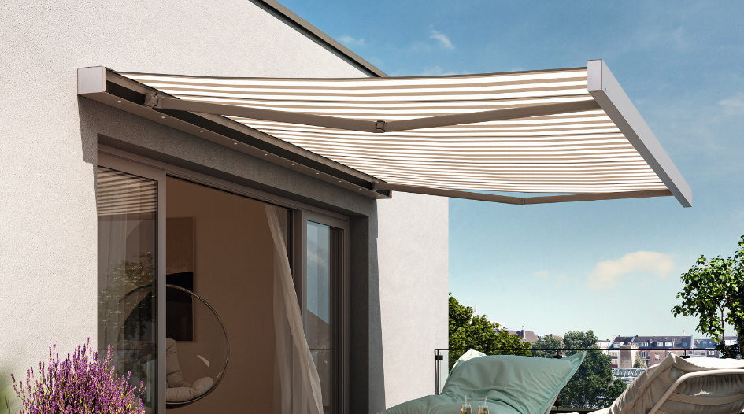
Terms :
 |  | 40% deposit due with order, 40% on delivery & final 20% on completion |  |  |  |  |  |  |  |  |  |  |  |  | Subtotal : |  |  |  | £ 22,097.00
BACS Payment |  |  |  |  |  |  |  |  | Phone and Card Payment
Bank:  Sort Code:  Account No: |  |  | NatWest  60 12 03  66577772 |  |  |  |  |  | Payment can be made in person or by phone.  If phone, please call us on 01534 768141 and have your card details ready.  Note, we do not accept American Express or Cheque payments.
 |  |  |  |  |  |  |  |  |  |  |  |  |  |  | GST : |  |  |  | £ 1,104.85
 |  |  |  |  |  |  |  |  |  |  |  |  |  |  | Total : |  |  |  | £ 23,201.85
Carpet Protection (C.I) Ltd T/A CP Interiors
Please note: This quotation is only valid for acceptance for 7 days. Our estimate does not include any electrical work or additional carpentry work to install the above unless otherwise specified. Please note there is a handling charge on customer own fabric of £5 per metre. Due to high costs of labour, pre-arranged missed fitting appointments will be charged on a time-wasted basis. Settlement is due on completion of works and an administration charge of £25 will be added per month if unpaid within 30 days. We reserve the right to charge for design, advice and liaison work carried out should an order not be placed. Goods remain the property of CP Interiors until full settlement is received. Should payment not be received we reserve the right to attend premises during working hours to remove goods and not be required to make good. Our full terms and conditions apply and are available on request.

