 |  |  |  |  |  |  |  |  |  |  |  |  |  |  |  |  | 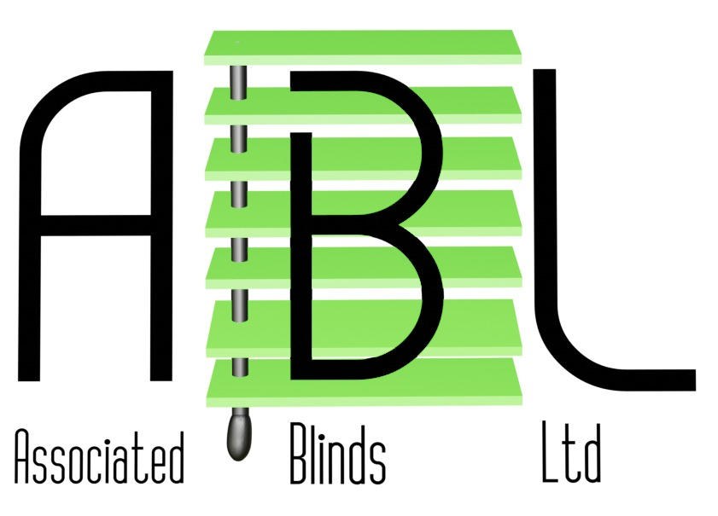
 |  |  |  |  |  |  |  | BLINDS, CURTAINS & SUN AWNINGS
 |  |  |  |  |  |  | MANUFACTURERS OF ALL TYPES OF WINDOW BLINDS
Quotation
To : |  |  |  | CP Interiors  Unit 28, L'Avenue Le Bas, La Rue Des Pres Trading Estate  St. Saviour  Jersey  JE2 7QN |  |  |  |  |  |  |  |  |  |  | Job Reference
 |  |  |  |  |  |  |  |  |  |  |  |  |  |  | Quotation Ref . |  |  | AB12166
 |  |  |  |  |  |  |  |  |  |  |  |  |  |  | Date |  |  | 10-10-2023
 |  |  | Dear . Rachel Allo
 |  |  | Further to our visit we have pleasure enclosing our Quotation Details for Blinds as discussed.
Description |  |  |  |  |  |  |  |  |  |  |  |  |  |  |  | Qty |  | Price |  |  |  |  |  | Amount
 |  | To Supply 2 Roof Light Direct Blinds Luna Ivory, Pleated Motorised Blackout, CR08 blinds |  |  |  |  |  |  |  |  |  |  |  |  |  | 2 |  | 300.86 |  |  |  |  |  | 601.72
 |  | To Supply 2 Roof Light Direct Blinds 2 x Transformers |  |  |  |  |  |  |  |  |  |  |  |  |  | 2 |  | 146.37 |  |  |  |  |  | 292.74
 |  | To Supply 1 Postage and Packaging |  |  |  |  |  |  |  |  |  |  |  |  |  | 1 |  | 32.00 |  |  |  |  |  | 32.00
WARNING |  |  |  |  |  |  |  |  |  |  |  |  |  |  |  |  |  | Delivery |  |  |  |  |  |  | 0.00
Buyers and users of blinds should be aware of the hazard posed by cords and loop chains to children. Looped cords of all types are a strangulation hazard to children. To avoid strangulation and entanglement keep all blind cords out of reach of children. Always check regularly that cords do not pose a danger to children. Please ensure all users of these blinds are made aware of this. |  |  |  |  |  |  |  |  |  |  |  |  |  |  |  |  |  | SubTotal |  |  |  |  |  |  | 926.46
 |  |  |  |  |  |  |  |  |  |  |  |  |  |  |  |  |  | Vat |  |  |  |  |  |  | 0.00
 |  |  |  |  |  |  |  |  |  |  |  |  |  |  |  |  |  | Total |  |  |  |  |  |  | 926.46
We accept all major credit debit cards etc.,
 |  |  |  |  |  |  |  |  |  |  |  |  |  |  |  |  |  |  |  |  | Page |  |  |  | 1 of 1
I trust our quotation is acceptable but if you require any information please do not hesitate to contact us. |  |  |  |  |  |  |  |  |  |  |  |  |  |  |  |  |  |  |  |  |  |  |  |  | 1 of 1
BACS Details |  |  |  |  |  | Account Name  Account No  Sort Code |  |  | : Associated Blinds Ltd.  : 42909007  : 60-24-60 |  |  | NatWest Bank,  12-23 High Street,  Witney,  Oxon OX28 6HW
Unit 3a Glenmore Business Centre, Range Road, Windrush Park, Witney, Oxfordshire, OX29 0AA, Phone: 01993 774446
Email: sales@associatedblinds.co.uk, Website: www.associatedblinds.co.uk
Vat No. 663-6874-92 | Company Registration: 3300284 | Registered Address: 13-15 High Street, Witney, Oxfordshire, OX28 6HW

