
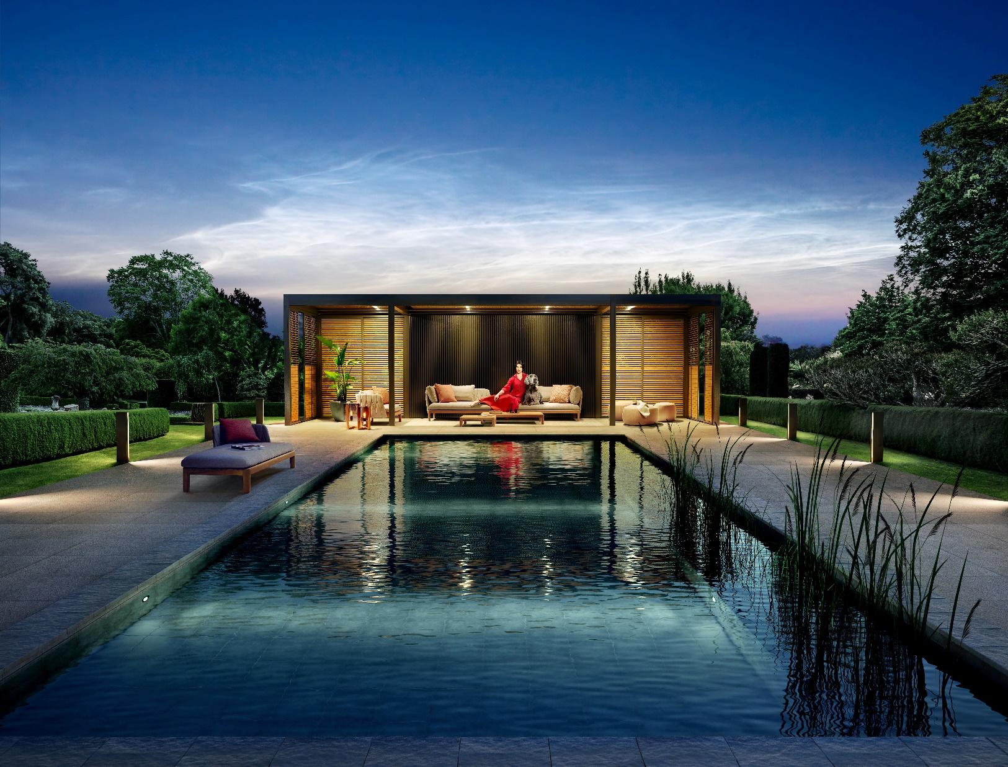
Renson Outdoor
WHERE MAGIC HAPPENS



CP Interiors
Rue des Pres. Tr. Est. 28
JE2 7QN Jersey

10/03/2022
Ref: BAXTER SO12949 SMALLER_SO12949

Sales Quote
Project | Quote reference | RIO ID | Document ID
BAXTER SO12949 SMALLER | BAXTER SO12949 SMALLER_SO12949 | AA00103592 | 20034464

Sales quote content
Quote details 4
1 - Algarve 4
Price breakdown 4
Configuration details 5
Extra documentation 11
Warranty conditions & tips 11

Notes

Quote details

1 - Algarve

Price breakdown
Description | Quantity | Unit price | Total
Algarve Single unit, 5.5m x 4.2m with 4 posts | 1x |  | 27,214.00 GBP
Glass sliding panels | 2x |  | 17,822.00 GBP
3 Lineo Led | 1x |  | 3,214.00 GBP
UpDown Led : 2x Up RGB + Down White | 1x |  | 4,552.00 GBP
Total (excl. GST) |  |  | 52,802.00 GBP

Configuration details
STRUCTURE
Type
Algarve structure | Single
Roof design | ‎‏Rotating blades
CONSTRUCTION
Dimensions
Span | 4200mm
Finishing of the fixed blades | Pivot on the mm / inch
Pivot | 5500mm
Passage height | 2200mm
Construction method
Span 1 | Freestanding
Span 2 | Freestanding
Pivot 1 | Full wall
Pivot 2 | Freestanding
Columns
Column 1A
Column type | Corner column
Column 1B
Column type | Corner column
Column 2A
Column type | Corner column
Column 2B
Column type | Corner column
SIDE INFILLS
Span 1 (S1)
Infill S1 | Yes
Infill S1 | Glass sliding panels
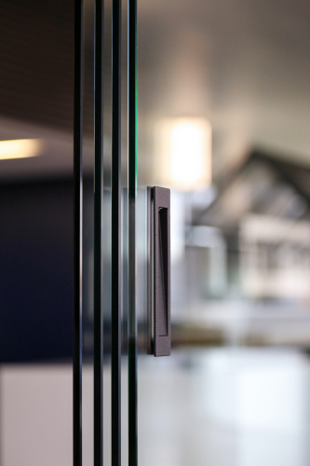 | Glass sliding panels
 | Fully transparent sliding panels
 | - Completely unobstructed outside view
 | - Protection from cold, rain and wind
 | - Lockable
 | - Adds elegance to your patio cover
 | - Fitted with guiding castors for easy operation

Opening direction glass sliding panels | Sliding open from the middle
Span 2 (S2)
Infill S2 | Yes
Infill S2 | Glass sliding panels
Glass sliding panels
Fully transparent sliding panels
- Completely unobstructed outside view
- Protection from cold, rain and wind
- Lockable
- Adds elegance to your patio cover
- Fitted with guiding castors for easy operation

Opening direction glass sliding panels | Sliding open from the middle
Pivot 2 (P2)
Infill P2 | Yes
Infill P2 | Glass sliding panels
Glass sliding panels
Fully transparent sliding panels
- Completely unobstructed outside view
- Protection from cold, rain and wind
- Lockable
- Adds elegance to your patio cover
- Fitted with guiding castors for easy operation

Opening direction glass sliding panels | Sliding open from the middle
General specifications
Glass sliding panels
Glass included | Yes
Glass type | Clear glass
COMFORT
Lighting
Lineo LED (led blades) | Yes
Number of Lineo led | 3
Color Lineo led | Warm white
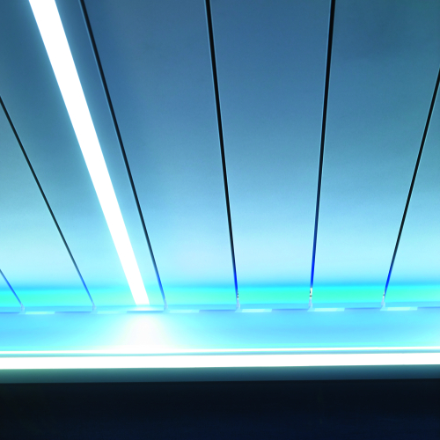 | LINEO LED
 | Integrated dimmable LED lighting in the blades with even distribution.
 | - The ideal basic lighting system
 | - Available in warm white and pure white
 | - Dimmable
 | - LED strip extends across the full length of the blade

UpDown LED | Yes
Sides with UpDown LED | P1, P2
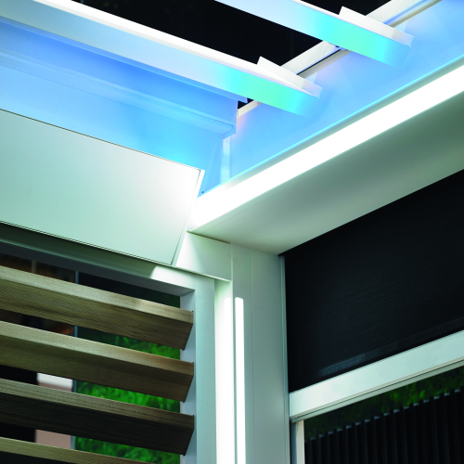 | Updown Led
 | Integrated dimmable LED lighting on the inside of the frame. Upwards and/or downwards for direct and/or indirect lighting.
 | - Basic lighting and ambient lighting combined in a single light fitting
 | - Available in warm white, pure white and/or RGB
 | - Dimmable
 | - High-quality IP65 LEDs

Color led 'UP' | RGB
Color led 'DOWN' | Warm white (3000 K)
Updown Led
Integrated dimmable LED lighting on the inside of the frame. Upwards and/or downwards for direct and/or indirect lighting.
- Basic lighting and ambient lighting combined in a single light fitting
- Available in warm white, pure white and/or RGB
- Dimmable
- High-quality IP65 LEDs

Comfort & Design
Lineo Heat | No
Protecto | Yes
Protecto side | P1, P2
Automation
Motor
Motor control | Somfy RTS
Transmitter | Yes
Transmitter | Telis 16 RTS Pure white
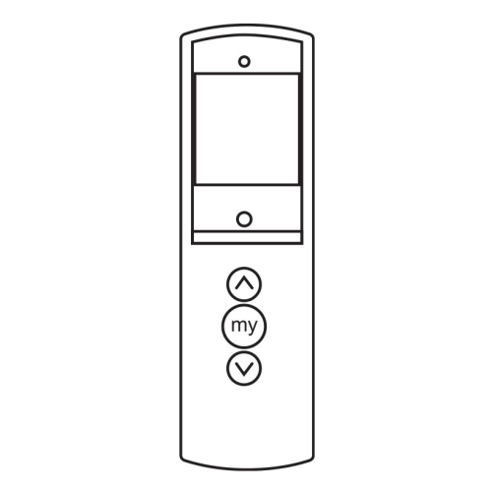 | Telis 16 RTS Pure
 | 16-channel transmitter (incl. support)

Sensors
Rain sensor | Yes
Rain sensor | Ceramic rain sensor 24V
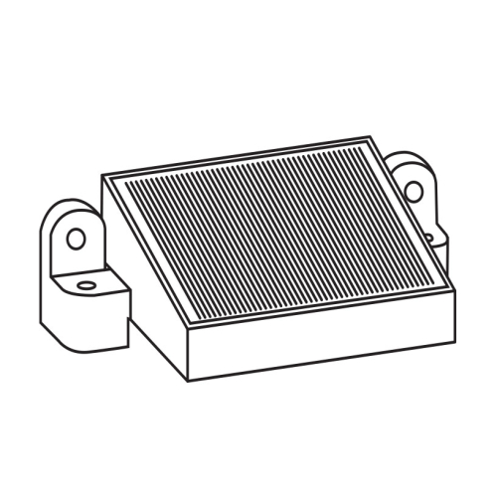 | Rain sensor kit
 | Ceramic rain sensor 24V 3M Outdoor

STYLING
Colors
Color type of the structure and the columns | Textured
Color type of blades | Same color as framework and columns
TECHNICAL SPECS
General
Blade rotation | Sunprotection
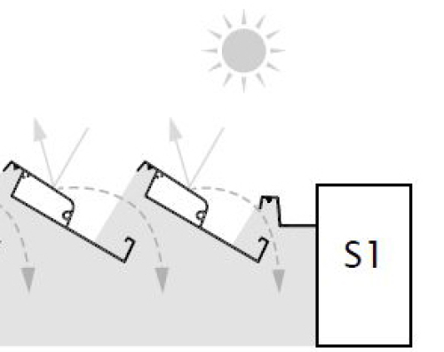 | Blade rotation - Sunprotection

Columns
Column 1A
Mounting base | Invisible reinforced
Water drainage in column | Yes
Direction of water drainage | Pivot
Column 1B
Mounting base | Invisible reinforced
Water drainage in column | Yes
Water drainage direction | Pivot
Column 2A
Mounting base | Invisible reinforced
Water drainage in column | Yes
Water drainage direction | Pivot
Column 2B
Mounting base | Invisible reinforced
Water drainage in column | Yes
Water drainage direction | Pivot

Extra documentation

Warranty conditions & tips
Guarantee *
  years  JAAR |   years  JAAR

 | Structural elements | Motors and electronic control | Coating gloss and colour | Coating adhesion | Fixscreen technology® (zips) | Crystal window in the full width
Camargue® | 10 years | 2 years | 5 years /  15 years* | 10 years** | 5 years | 2 years
Camargue® Skye | 10 years** | 2 years | 5 years /  15 years* | 10 years** | 5 years | 2 years
Algarve® Line | 10 years | 2 years | 5 years /  15 years* | 10 years** | 5 years | 2 years
Aero® Line | 10 years | 2 years | 5 years /  15 years* | 10 years** | 5 years | 2 years
Lapure® | 5 years | 2 years | 5 years /  15 years* | 10 years** | 5 years | 2 years
Façade elements | 5 years | 2 years | 5 years /  15 years* | 10 years** | - | -
Garden elements | 5 years | 2 years | 5 years /  15 years* | 10 years** | - | -
* Subject to registration and annual maintenance with the Renson® Maintenance Set
** In areas <500 m from a coastline: 5-year warranty on adhesion
*** 10-year warranty on the support structure and 5-year warranty on the mechanical parts
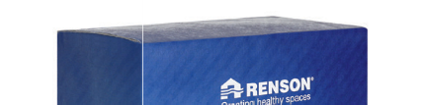
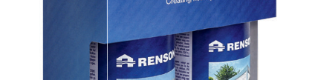
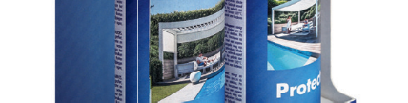
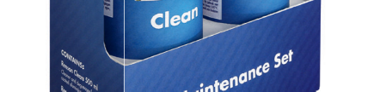
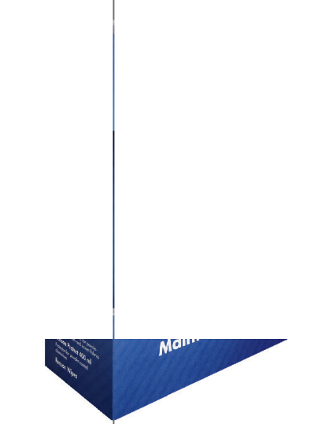
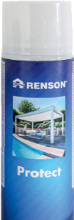
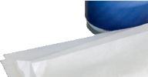
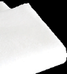

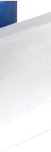
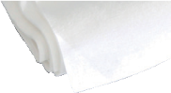
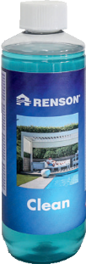

Register your patio cover within 15 days of installation and receive a

JAHRE
GARANTIE
http://www.renson-outdoor.com/GARANTIE
*A 5-year guarantee applies to the colour and gloss of the coating. If you register the patio cover and annually clean and protect it with the Renson Maintenance Set, you get an extended coating warranty of up to 15 years.

years
*

Guarantee
Maintenance
Easy maintenance with the Renson maintenance set
Your patio cover will be fully exposed to the elements for years - day in and day out. If you want to get the most out of your Renson® cover indefinitely, we recommend maintaining it regularly, i.e. once or twice a year. Regular maintenance will extend the lifespan of your cover. The following are important:
- The structure is made using powder coated aluminium. An annual cleaning with Renson Maintenance Set products will ensure that the intense colour is maintained for years, as well as providing extra protection from acid rain, sea air and UV radiation. For coastal or wooded areas, we recommend maintenance of your installations at least twice a year.
- The Renson 'Clean' is a concentrated product with strong cleaning and degreasing properties to deal with the most frequent kinds of natural filth, such as dust, oily precipitation, grease stains, moss, insect remains, etc.
This product cannot be compared to other cleaning products on the market. It sinks deeply and 'lifts out' the dirt. Renson 'Clean' can also be used to clean polyester roof fabrics and vertical fibreglass screen fabrics.
After cleaning, you must protect the aluminium structure with Renson 'Protect'. This leaves a protective film that allows the surface to be cleaned by simply wiping it down with a minimum amount of Renson 'Clean'. It also protects the aluminium from acid rain, sea air and UV radiation, and ensures the colour remains just as intense.
- Do not use either product in direct sunlight or in hot weather. The product's quick-drying action can leave stains on the structure or the fabric. Do not use corrosive or aggressive products, scouring pads or other scouring products. Do not use high-pressure equipment under any circumstances.
For more information about our outdoor products, you can consult our brochure.

