
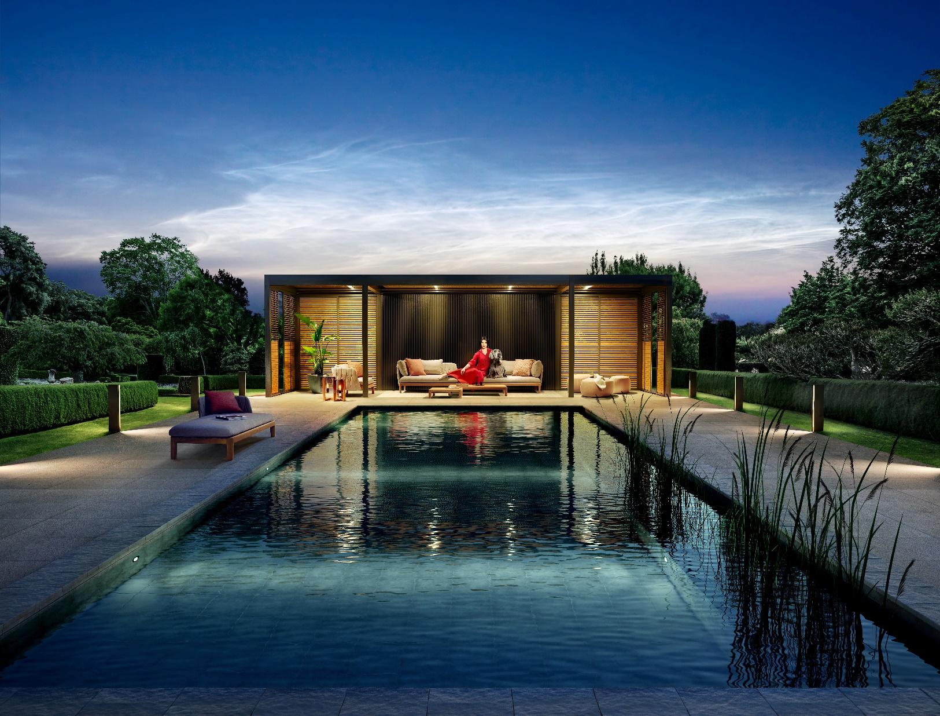
Renson Outdoor
WHERE MAGIC HAPPENS



CP Interiors
Rue des Pres. Tr. Est. 28
JE2 7QN Jersey

18/01/2022
Ref: MCLATCHIE SO12749_SO12749

Sales Quote
Project | Quote reference | RIO ID | Document ID
MCLATCHIE SO12749 | MCLATCHIE SO12749_SO12749 | AA00089464 | 20029909

Sales quote content
Quote details 4
1 - Camargue 4
Price breakdown 4
Configuration details 5
Extra documentation 11
Warranty conditions & tips 11

Notes

Quote details

1 - Camargue

Price breakdown
Description | Quantity | Unit price | Total
Renson Camargue, including Protecto, Rain Sensor,  Telis 16 RTS Pure transmitter | 1x | 28,311.00 GBP | 28,311.00 GBP
Optional Extras
Integrated Fixscreen S1 Doorway, Serge Fabric SC0207 | 1x | 2,072.00 GBP | 2,072.00 GBP
Integrated Fixscreen S1, Serge Fabric SC0207 | 1x | 2,372.00 GBP | 2,372.00 GBP
Integrated Fixscreen P1 & P2, Serge Fabric SC0207 | 2x | 3,875.00 GBP | 7,750.00 GBP
3 Lineo Led | 1x | 3,010.00 GBP | 3,010.00 GBP
UpDown Led : 2x Up RGB + Down White | 1x | 4,259.00 GBP | 4,259.00 GBP
Total (excl. GST) |  |  | 47,774.00 GBP

Configuration details
STRUCTURE
Type
Camargue structure | Single
1.1 - Camargue
CONSTRUCTION
Dimensions
Span C1 | 3500mm
Pivot C1 | 5000mm
Passage height | 2400mm
Construction method
Span 1 | Freestanding
Span 2 | Full wall
Pivot 1 | Freestanding
Pivot 2 | Freestanding
Columns
Column 1A
Column type | Corner column
Column 1B
Column type | Corner column
Column 2A
Column type | Corner column
Column 2B
Column type | Corner column
Intermediate columns
Intermediate column S1 | Yes
Position intermediate column S1 | 1200mm
SIDE INFILLS
Span 1 (S1)
Infill to the left of the intermediate column/ shifted column | Yes
Infill S1 - left | Fixscreen
 | 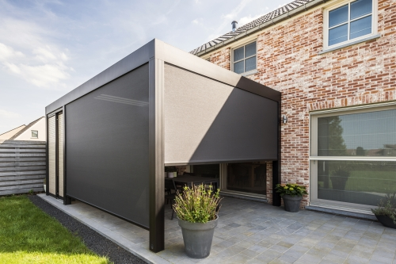 | Integrated Fixscreen for Camargue & Camargue Skye
 |  | Integrated into the cover profile
 |  | - Minimal design
 |  | - Screen box hidden in the cover’s support structure
 |  | - Side channels integrated into columns (Camargue, Camargue Skye)
 |  | - Can be seamlessly integrated even after first installation
 |  | - High wind resistance

Infill to the right of the intermediate column/ shifted column | Yes
Infill S1 - right | Fixscreen
Integrated Fixscreen for Camargue & Camargue Skye
Integrated into the cover profile
- Minimal design
- Screen box hidden in the cover’s support structure
- Side channels integrated into columns (Camargue, Camargue Skye)
- Can be seamlessly integrated even after first installation
- High wind resistance

Pivot 1 (P1)
Infill P1 | Yes
Infill P1 | Fixscreen
Integrated Fixscreen for Camargue & Camargue Skye
Integrated into the cover profile
- Minimal design
- Screen box hidden in the cover’s support structure
- Side channels integrated into columns (Camargue, Camargue Skye)
- Can be seamlessly integrated even after first installation
- High wind resistance

Pivot 2 (P2)
Infill P2 | Yes
Infill P2 | Fixscreen
Integrated Fixscreen for Camargue & Camargue Skye
Integrated into the cover profile
- Minimal design
- Screen box hidden in the cover’s support structure
- Side channels integrated into columns (Camargue, Camargue Skye)
- Can be seamlessly integrated even after first installation
- High wind resistance

COMFORT
Lighting
Lineo Led (led blades) | Yes
Number of Lineo led | 3
Color of Lineo led | Warm white
 | 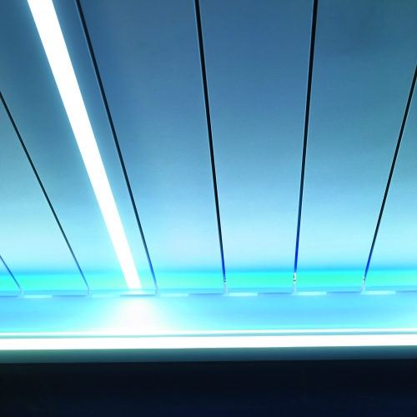 | LINEO LED
 |  | Integrated dimmable LED lighting in the blades with even distribution.
 |  | - The ideal basic lighting system
 |  | - Available in warm white and pure white
 |  | - Dimmable
 |  | - LED strip extends across the full length of the blade

Updown led | Yes
Sides with UpDown LED | Pivot 1, Pivot 2
Color led 'UP' | RGB
Color led 'DOWN' | Warm white
 | 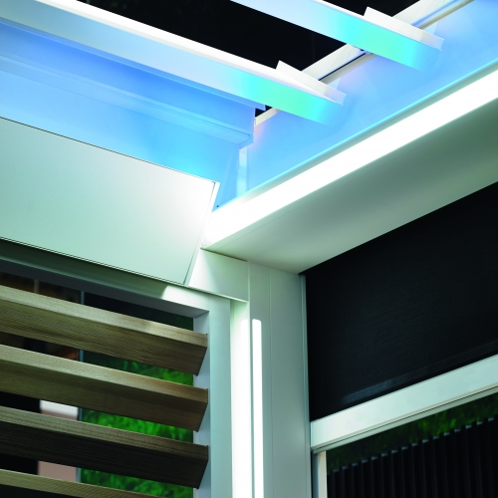 | Updown Led
 |  | Integrated dimmable LED lighting on the inside of the frame. Upwards and/or downwards for direct and/or indirect lighting.
 |  | - Basic lighting and ambient lighting combined in a single light fitting
 |  | - Available in warm white, pure white and/or RGB
 |  | - Dimmable
 |  | - High-quality IP65 LEDs

Colomno led | No
Comfort & Design
Protecto | Yes
Position | P1, P2
 | 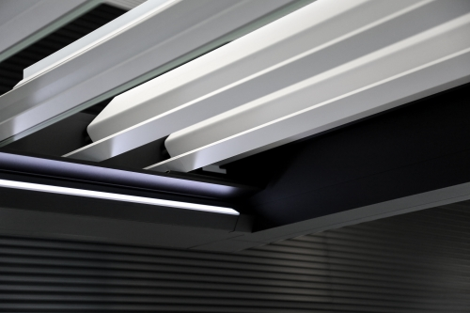 | Protecto Camargue
 |  | - Protection from wind, drifting rain, and snow between the gutter and the blades
 |  | - Maintains continuous contact with the blades thanks to an concealed hinge system
 |  | - Coated in the colour of the frame and columns
 |  | - Back orders are possible for already installed covers

Automation
Motor control | Somfy RTS
Transmitter | Yes
Transmitter | Telis 16 RTS Pure white
 | 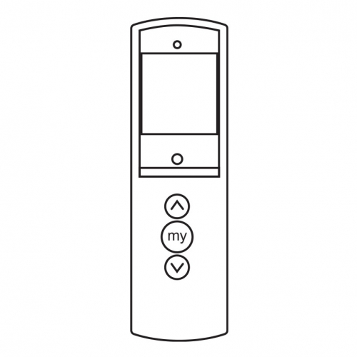 | Telis 16 RTS Pure
 |  | 16-channel transmitter (incl. support)

Rain sensor | Yes
Rain sensor | Ceramic rain sensor 24V
 | 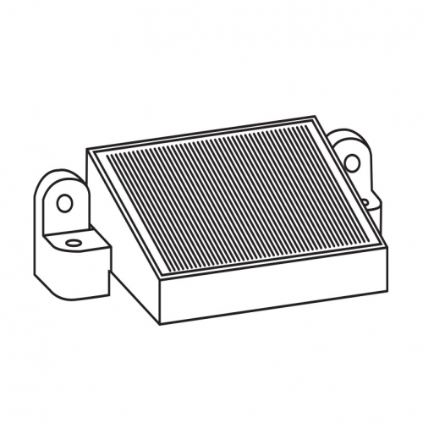 | Rain sensor kit
 |  | Ceramic rain sensor 24V 3M Outdoor

STYLING
Colors
Color structure and columns
Color type of frame and columns | Textured
Color of frame and columns | 029/10674 - TIGER BEL9010 FINE TEXTURE
Color of blades
Color blades | Same color as framework and columns
Type of fabrics
Fixscreen
Type of fabric Fixscreen/Linarte-Canvas | Fibreglass fabric Sergé
Fabric code Fixscreen | GV-0207 - FG-SC0207 WHITE-PEARL
TECHNICAL SPECS
General
Blade rotation | Sunprotection
 | 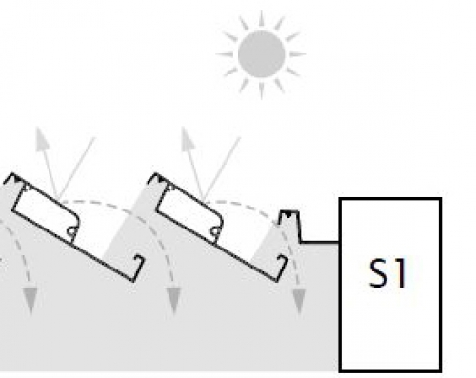 | Blade rotation - Sunprotection

Columns
Column 1A
Mounting base | Invisible reinforced
Water drainage | Yes
Direction of water drainage | Pivot
Column 1B
Mounting base | Invisible reinforced
Water drainage | Yes
Water drainage direction | Pivot
Column 2A
Mounting base | Invisible reinforced
Water drainage | Yes
Water drainage direction | Pivot
Column 2B
Mounting base | Invisible reinforced
Water drainage | Yes
Water drainage direction | Pivot
Intermediate columns
Mounting bases needed | Yes
Intermediate column S1
Mounting base | Invisible reinforced

Extra documentation

Warranty conditions & tips
Guarantee *
  years  JAAR |   years  JAAR

 | Structural elements | Motors and electronic control | Coating gloss and colour | Coating adhesion | Fixscreen technology® (zips) | Crystal window in the full width
Camargue® | 10 years | 2 years | 5 years /  15 years* | 10 years** | 5 years | 2 years
Camargue® Skye | 10 years** | 2 years | 5 years /  15 years* | 10 years** | 5 years | 2 years
Algarve® Line | 10 years | 2 years | 5 years /  15 years* | 10 years** | 5 years | 2 years
Aero® Line | 10 years | 2 years | 5 years /  15 years* | 10 years** | 5 years | 2 years
Lapure® | 5 years | 2 years | 5 years /  15 years* | 10 years** | 5 years | 2 years
Façade elements | 5 years | 2 years | 5 years /  15 years* | 10 years** | - | -
Garden elements | 5 years | 2 years | 5 years /  15 years* | 10 years** | - | -
* Subject to registration and annual maintenance with the Renson® Maintenance Set
** In areas <500 m from a coastline: 5-year warranty on adhesion
*** 10-year warranty on the support structure and 5-year warranty on the mechanical parts
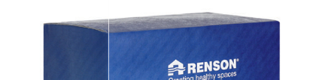
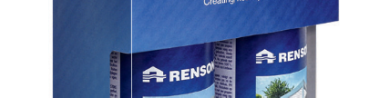
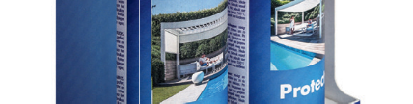
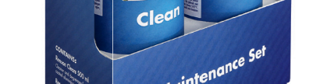
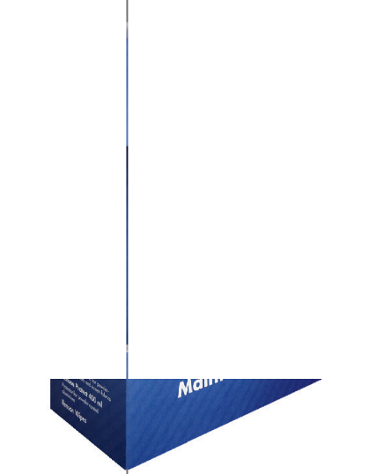
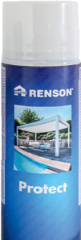
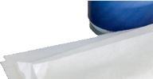
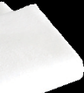

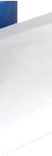
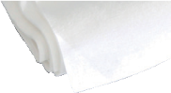
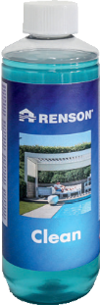

Register your patio cover within 15 days of installation and receive a

JAHRE
GARANTIE
http://www.renson-outdoor.com/GARANTIE
*A 5-year guarantee applies to the colour and gloss of the coating. If you register the patio cover and annually clean and protect it with the Renson Maintenance Set, you get an extended coating warranty of up to 15 years.

years
*

Guarantee
Maintenance
Easy maintenance with the Renson maintenance set
Your patio cover will be fully exposed to the elements for years - day in and day out. If you want to get the most out of your Renson® cover indefinitely, we recommend maintaining it regularly, i.e. once or twice a year. Regular maintenance will extend the lifespan of your cover. The following are important:
- The structure is made using powder coated aluminium. An annual cleaning with Renson Maintenance Set products will ensure that the intense colour is maintained for years, as well as providing extra protection from acid rain, sea air and UV radiation. For coastal or wooded areas, we recommend maintenance of your installations at least twice a year.
- The Renson 'Clean' is a concentrated product with strong cleaning and degreasing properties to deal with the most frequent kinds of natural filth, such as dust, oily precipitation, grease stains, moss, insect remains, etc.
This product cannot be compared to other cleaning products on the market. It sinks deeply and 'lifts out' the dirt. Renson 'Clean' can also be used to clean polyester roof fabrics and vertical fibreglass screen fabrics.
After cleaning, you must protect the aluminium structure with Renson 'Protect'. This leaves a protective film that allows the surface to be cleaned by simply wiping it down with a minimum amount of Renson 'Clean'. It also protects the aluminium from acid rain, sea air and UV radiation, and ensures the colour remains just as intense.
- Do not use either product in direct sunlight or in hot weather. The product's quick-drying action can leave stains on the structure or the fabric. Do not use corrosive or aggressive products, scouring pads or other scouring products. Do not use high-pressure equipment under any circumstances.
For more information about our outdoor products, you can consult our brochure.

