C P Interiors, Rue Des Pres Trading Estate, St Saviour Jersey |  |  |  |  |  |  |  | 02.11.2021
 |  |  |  |  |  |  |  | reference:
 |  |  |  |  |  |  |  | Hern
Item | Quantity |  | Product
1 | 1,00 |  | w17 easy - the full glass sliding door
 |  |  | type of floor rail: flat floor rail with drainage holes (for outside)
 |  |  | Selection of leaves + tracks: 4-track with 8 leaves (lock plate version)
 |  |  | Direction of opening: sliding to the left and the right
 |  |  | Glazing: 10 mm toughened safety glass, clear
 |  |  | Soft-Closing-System: Soft-Closing-System standard
 |  |  | handling: handle bar standard
 |  |  | side of the handling: handling on both sides
 |  |  | leaf actuator: leaf actuator opening and closing in sliding direction
 |  |  | Locking mechanism on inside, on bottom glass retainer profile: Locking mechanism supplied loose, freely positionable
 |  |  | extra operation for the endleaf: handle bar standard
 |  |  | lock inside for endleaf: installed Active door locks on the inside
 |  |  | Height of knob From bottom edge of guide track (mm): 1050 mm
 |  |  | Basic colour: RAL 1001 Beige
 |  |  | Installation multi-colour: multicoloured
 |  |  | color of guide profile above: WT029/10797 Approx. RAL 9010
 |  |  | Colour of wall connection rubber: WT029/10797 Approx. RAL 9010
 |  |  | wall connection profile left: yes
 |  |  | wall connection profile right: yes
 |  |  | brush seal: 6 x Brush profile transparent for 10 mm glass, length 2800 mm
 |  |  | gap seal: 2 x Spaltdichtungen für 10 mm Glas, Länge 2500 mm
 |  |  | with threshold profile: on both sides positioned threshold profile
Item | Quantity |  | Product
 |  |  | 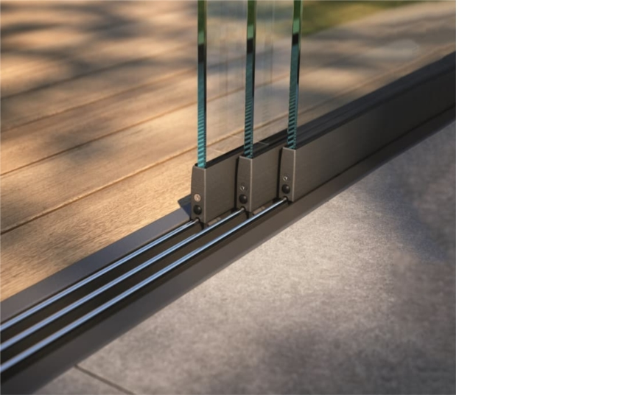
 |  |  | 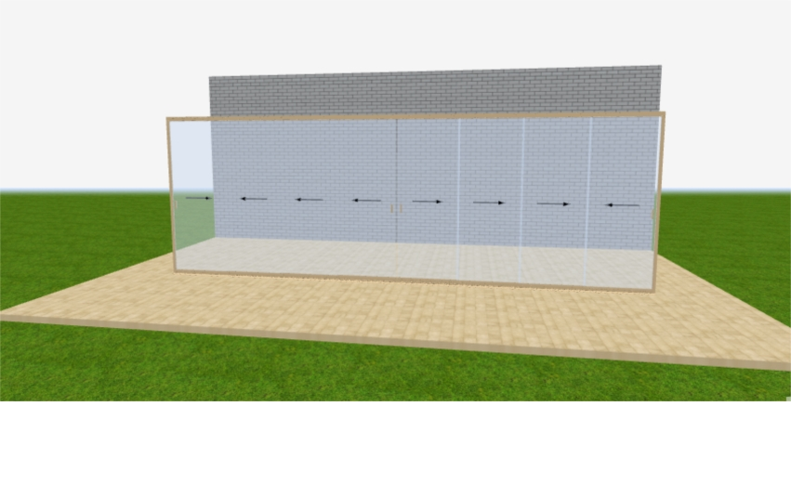
 |  |  | front view
 |  |  | 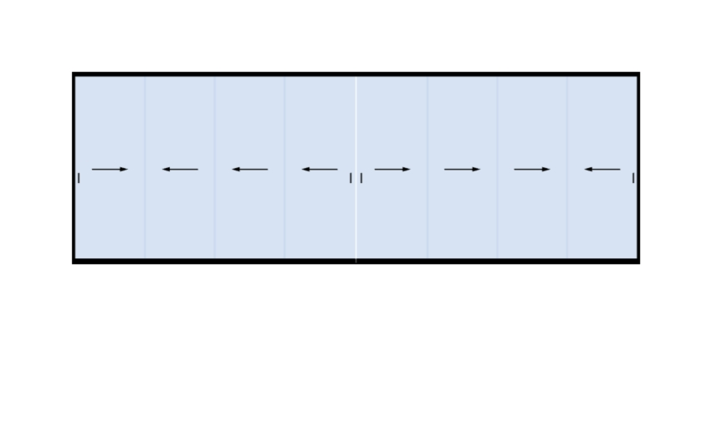
2 | 1,00 |  | GE SUPER LITE w50-c
 |  |  | Frame profile: blind frame section 35 w50-c
 |  |  | Number of vertical glass panels: one-piece
 |  |  | Prepared for: prepared for 10mm (for cold use)
 |  |  | Basic colour: RAL 1001 Beige
 |  |  | gap seal: Without gap seal

