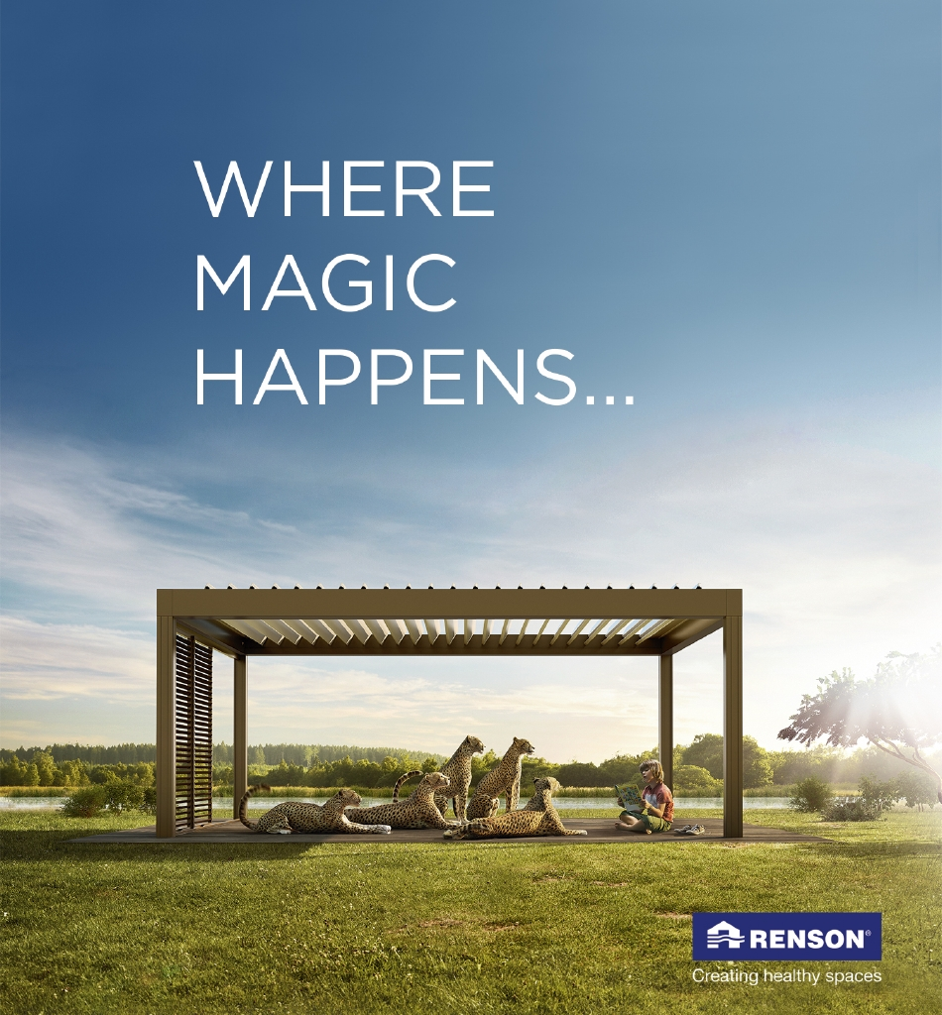
Document: 20/100584/0 CP Interiors
Reference: SO10556 Morin 28 Rue des Pres. Tr. Est.
Contact: JE2 7QN Jersey
Tel.1534768141

Thank you for your interest in the Renson Outdoor products.
We offer you a personalized quote.
For more information, visit the website at this link.

Camargue

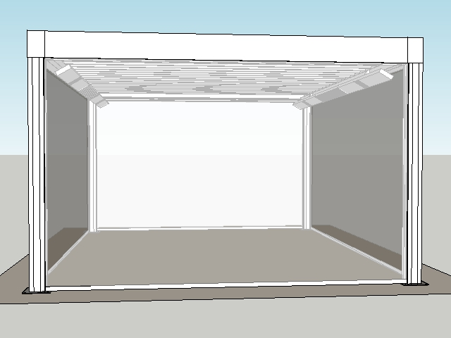

Your product features

Base structure

Product type  Camargue® Single-part |  | 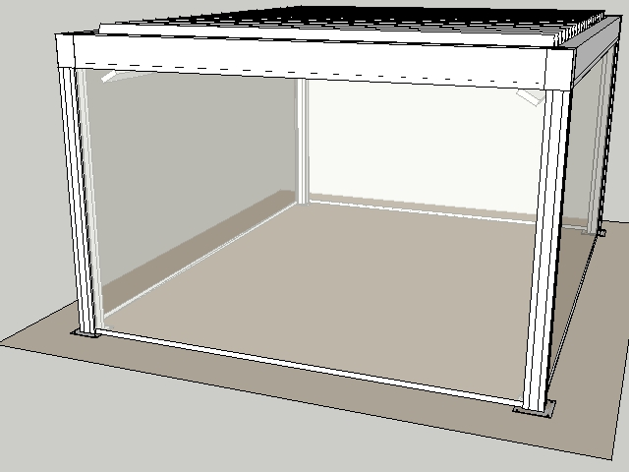
Dimension Span
4000 mm
Dimension Pivot
5000 mm
Passage height
2300 mm
Colour frame and columns
Quotation TOP RAL - Textured colours
Col lam
Quotation TOP RAL - Textured colours
Motor-side 1
P1
Blade rotation 1
Sunprotection

Your product options

Beam Heat  The comfort in your terrace covering is increased even more thanks to the design beam with an integrated heating system.  The heating system uses a short-wave infrared transmitter that can be screened using a heat-resistant, black, ceramic glass plate.  The Beam can also be equipped with weather-resistant, 4-ohm speakers. | 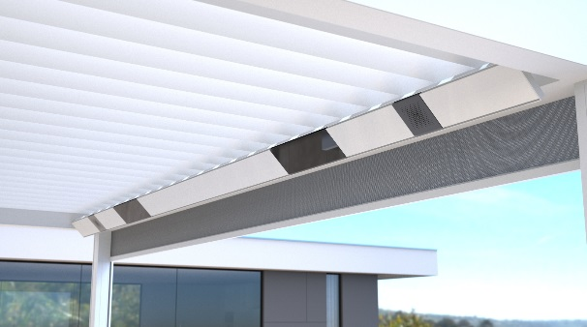

UpDown LED  Integrated LED lighting on the inside of the frame. Fitted with upwards and downwards lighting.  This lets you create indirect and/or direct atmospheric lighting.  A total of two UpDown LED lighting modules can be installed per roof section.  The LEDs are dimmable.  Up lighting is available in:  - warm white (3000 K): perfect for creating ambiance, cosy gatherings, etc.  - pure white (5000 K): perfect for reading, etc.  - RGB: perfect for creating the right ambiance  Down lighting is available in:  - warm white (3000 K): perfect for creating ambiance, cosy gatherings, etc.  - pure white (5000 K): perfect for reading, etc. | 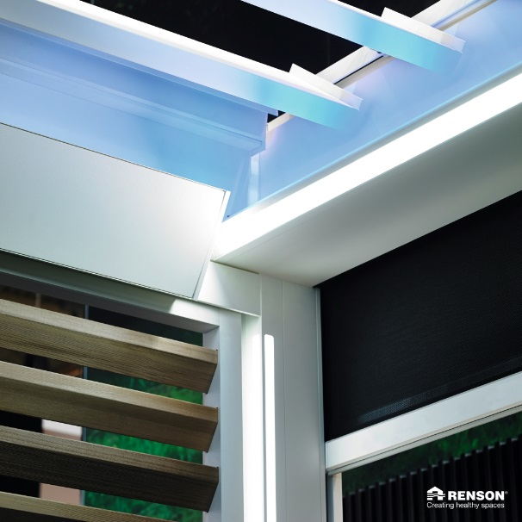

Lineo LED  Integrated LED lighting in the blades ensures even distribution without visible bright spots thanks to high-quality LEDs (180 per metre).  The LEDs are dimmable.  Available in  - warm white (3000 K): perfect for creating ambiance, cosy gatherings, etc.  - pure white (5000 K): perfect for reading, etc. | 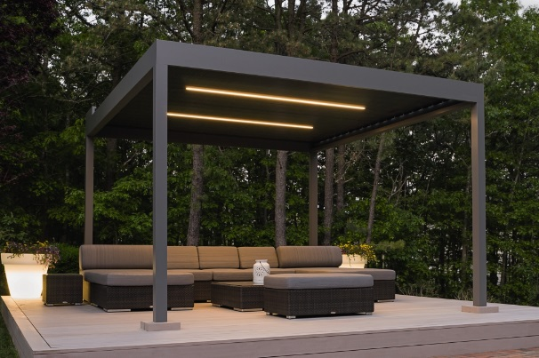

Integrated Fixscreen®  Integrated Fixscreens come in 50 colours, allowing you to customise your terrace covering and create the atmosphere you desire.  The terrace covering’s frame profiles are developed in such a way that the bottom bar is aesthetically hidden away in the box when the screen is raised.  Perfect integration into the frame and column, even after installation. | 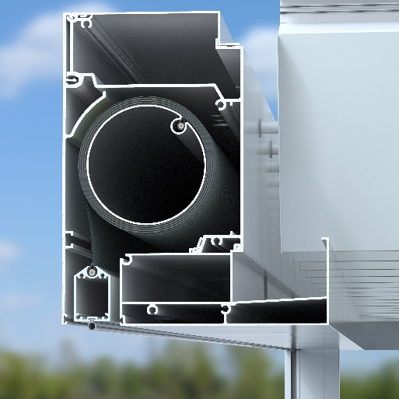

TOTAL (Gross price excl. GST) £38,851.00

Ordersignature
Done in two copies of which each party acknowledges having received one copy.
Signed: Date:

Vendor: Customer:

