
Document: 20/093650/0 CP Interiors
Reference: SO10496 Pipon 28 Rue des Pres. Tr. Est.
Contact: Jersey, JE2 7QN
Tel.1534768141

Thank you for your interest in the Renson Outdoor products.
We offer you a personalized quote.
For more information, visit the website at this link.

Camargue

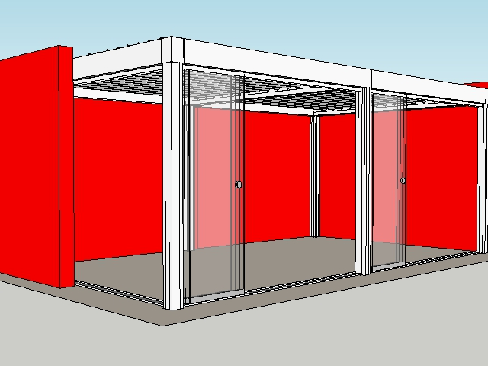

Your product features

Base structure

Product type  Camargue® 2-parts - Coupled at pivot side |  | 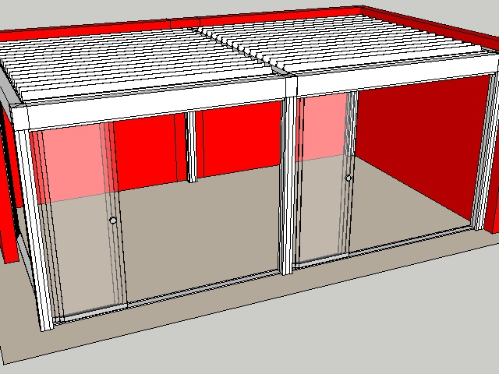
Dimension Span
3500 mm
Dimension Pivot
4000 mm
Span 2
3.500
Pivot 2
4.000
Passage height
2600 mm
Colour frame and columns
Quotation TOP RAL - Textured colours
Col lam
Quotation TOP RAL - Textured colours
Motor-side 1
Coupling bar (P2)
Motor-side 2
Coupling bar (P1)
Blade rotation 1
Sunprotection
Blade rotation 2
Sunprotection

Your offer.

Document: | 20/093650/0
Reference: | SO10496 Pipon
Contact:
Billing address: |  | Placement address
Town: |  | Town
E-mail:
Phone:
CAM2 Camargue® 2-parts - Coupled at pivot side
- Seaside Quality A
- Colour blades: OFF-TOPS Frame : OFF-TOPS
- OFF-TOPS - Quotation TOP RAL - Textured colours
- Passage height 2600 mm

TOTAL (Excluding GST) £42,531.00

Ordersignature
Done in two copies of which each party acknowledges having received one copy.
Signed: Date:

Vendor: Customer:

