
Document: 20/093262/0 CP Interiors
Reference: SO10440 28 Rue des Pres. Tr. Est.
Contact: Jersey, JE2 7QN
Tel.1534768141

Thank you for your interest in the Renson Outdoor products.
We offer you a personalized quote.
For more information, visit the website at this link.

Camargue

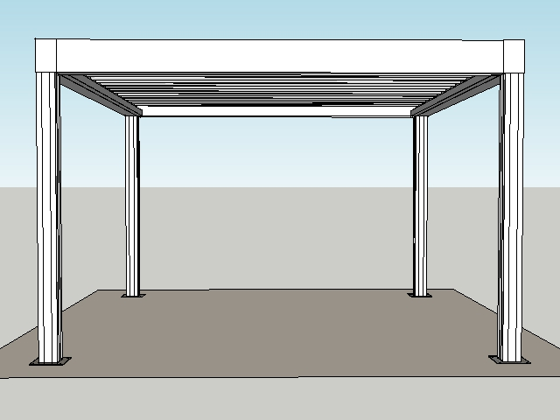

Your product features

Base structure

Product type  Camargue® Single-part |  | 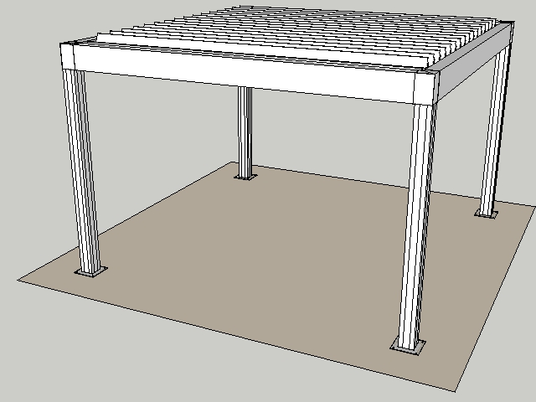
Dimension Span
3900 mm
Dimension Pivot
4000 mm
Passage height
2330 mm
Colour frame and columns
Quotation TOP RAL - Textured colours
Col lam
Quotation TOP RAL - Textured colours
Motor-side 1
P1
Blade rotation 1
Sunprotection

Thank you for your interest in the Renson Outdoor products.
We offer you a personalized quote.
For more information, visit the website at this link.

Fixscreen® 150 EVO MS1 Freestanding
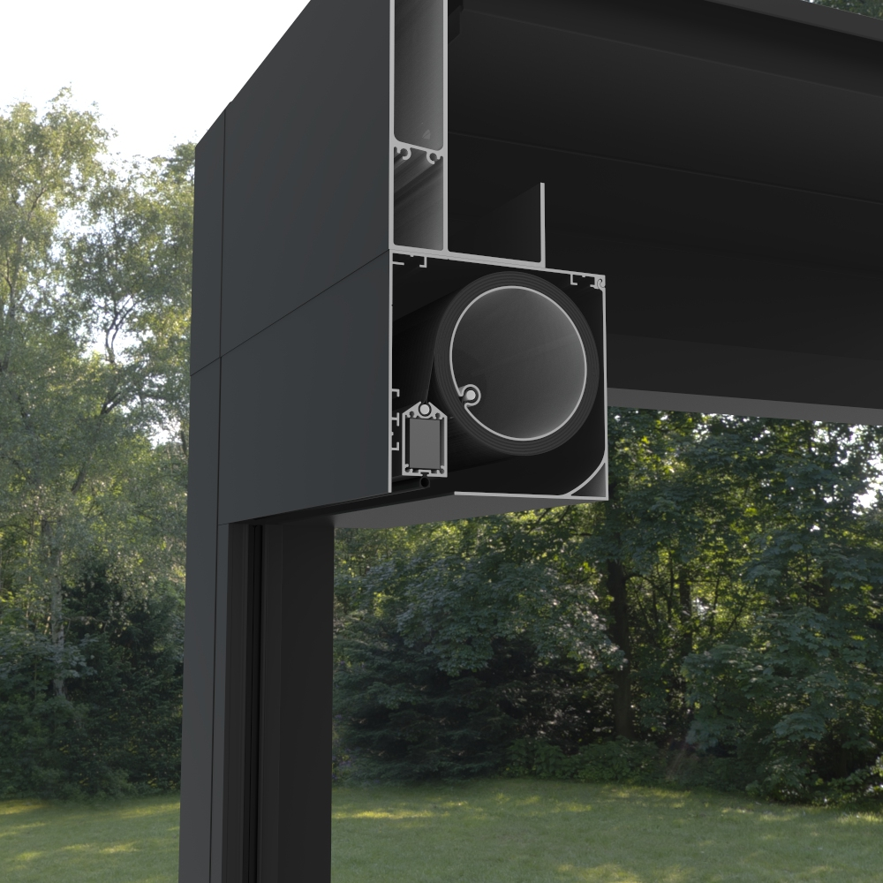

Your product features
Product type
Fixscreen® 150 IM1 Freestanding
Width
3900 mm
Higth
2330 mm
Color
Quotation Renson standard colour
Type of fabric
Fibreglass fabric Sergé
Fabric code
Quotation Fibre glass fabric Sergé
Confection
Confection 1
Side channel left
Closed side channel (G)
Side channel right
Closed side channel (G)
Crystal window
Without crystal window in the full width

Your offer.

Document: | 20/093262/0
Reference: | SO10440
Contact:
Billing address: |  | Placement address
Town: |  | Town
E-mail:
Phone:
CAM1 Camargue® Single-part
- Seaside Quality A
- Colour blades: OFF-TOPS Frame : OFF-TOPS
- OFF-TOPS - Quotation TOP RAL - Textured colours
- Passage height 2330 mm

FE151F Fixscreen® 150 IM1 Freestanding
- Windproof vertical screen
- Surface-mounted, without underlaying window
- No wrinkles or folds
- 7-year guarantee on the Fixscreen® technology
- Box (HxD): 150x155 mm
- Wind resistance up to 60 km/h
- Installation recommended using at least 2 people
- Weight: ± 23 kg/rm
- Seaside Quality A
- Colour: OFF-TOPR
- OFF-TOPR - Quotation Renson standard colour

TOTAL (excl GST) £18,033.00

Ordersignature
Done in two copies of which each party acknowledges having received one copy.
Signed: Date:

Vendor: Customer:

