
Document: 20/084591/0 CP Interiors
Reference: SO10432 Ingram 28 Rue des Pres. Tr. Est.
Contact: Jersey, JE2 7QN
Tel.1534768141

Thank you for your interest in the Renson Outdoor products.
We offer you a personalized quote.
For more information, visit the website at this link.

Camargue

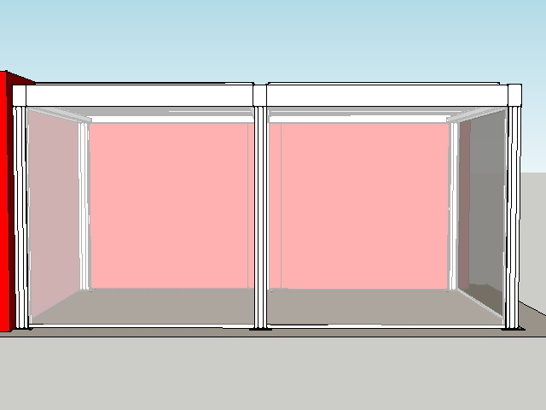

Your product features

Base structure

Product type  Camargue® 2-parts - Coupled at pivot side |  | 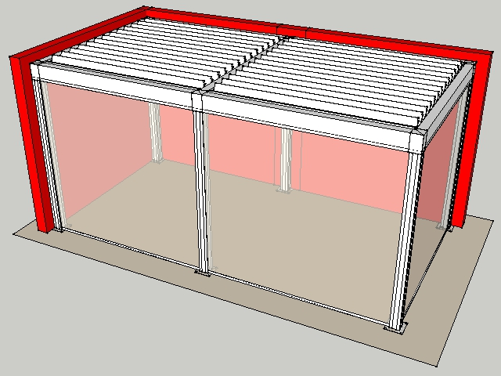
Dimension Span
3125 mm
Dimension Pivot
3250 mm
Span 2
3.125
Pivot 2
3.250
Passage height
2750 mm
Colour frame and columns
Quotation TOP RAL - Textured colours
Col lam
Quotation TOP RAL - Textured colours
Motor-side 1
P1
Motor-side 2
Coupling bar (P1)
Blade rotation 1
Sunprotection
Blade rotation 2
Sunprotection
Waterproof wall connection
Yes

Your product options

Integrated Fixscreen®  Integrated Fixscreens come in 50 colours, allowing you to customise your terrace covering and create the atmosphere you desire.  The terrace covering’s frame profiles are developed in such a way that the bottom bar is aesthetically hidden away in the box when the screen is raised.  Perfect integration into the frame and column, even after installation. | 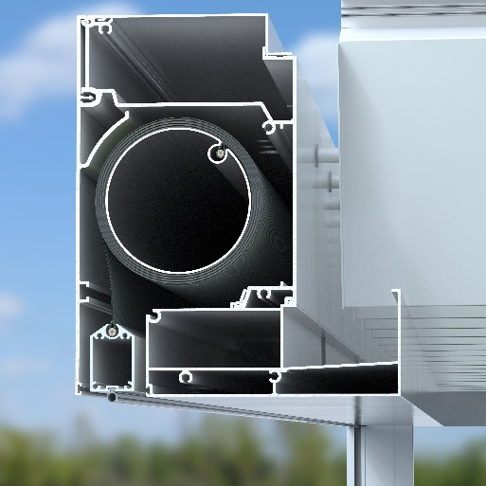

TOTAL £30,162.00

Ordersignature
Done in two copies of which each party acknowledges having received one copy.
Signed: Date:

Vendor: Customer:

