
Document: 20/075460/0 CP Interiors
Reference: SO10271 Buesnel 28 Rue des Pres. Tr. Est.
Contact: JE2 7QN Jersey
Tel.1534768141

Thank you for your interest in the Renson Outdoor products.
We offer you a personalized quote.
For more information, visit the website at this link.

Camargue

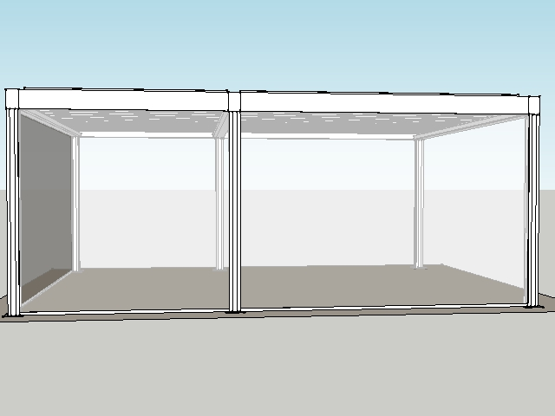

Your product features

Base structure

Product type  Camargue® 2-parts - Coupled at pivot side |  | 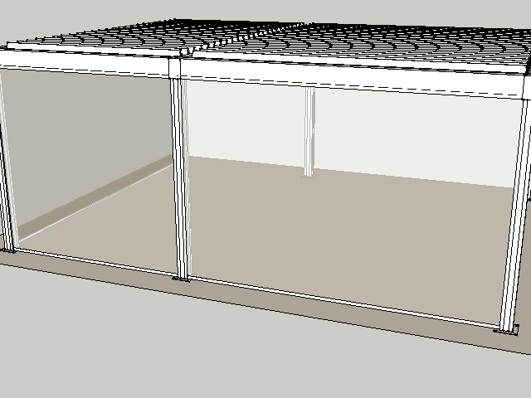
Dimension Span
3150 mm
Dimension Pivot
5800 mm
Span 2
4.350
Pivot 2
5.800
Passage height
2800 mm
Colour frame and columns
Quotation TOP RAL - Textured colours
Col lam
Quotation TOP RAL - Textured colours
Motor-side 1
Coupling bar (P2)
Motor-side 2
Coupling bar (P1)
Blade rotation 1
Sunprotection
Blade rotation 2
Sunprotection

Your product options

Integrated Fixscreen®  Integrated Fixscreens come in 50 colours, allowing you to customise your terrace covering and create the atmosphere you desire.  The terrace covering’s frame profiles are developed in such a way that the bottom bar is aesthetically hidden away in the box when the screen is raised.  Perfect integration into the frame and column, even after installation. | 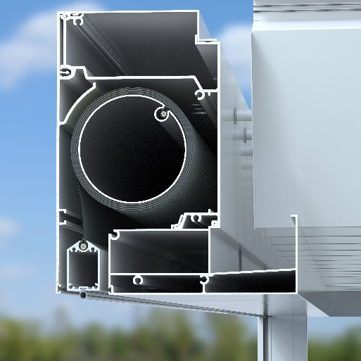

Your offer.
Document: | 20/075460/0
Reference: | SO10271 Buesnel
Contact:
Billing address: |  | Placement address
Town: |  | Town
E-mail:
Phone:

Structure Gross price excl. VAT
- Camargue® 2-parts pivot
- Corner 1A : Column at the corner
- Corner 1B : Column at the corner
- Corner 2A : Column at the corner
- Corner 2B : Column at the corner
- Camargue C2 : Camargue 2
- Corner 1C : Column at the corner
- Corner 2C : Column at the corner

Options
- Fixscreen P1.1 : Fixscreen Sergé/Natté/Privacy
- Fixscreen S1.1 : Fixscreen Sergé/Natté/Privacy
- Fixscreen S1.1 : Fixscreen Sergé/Natté/Privacy

Your offer.

Document: | 20/075460/0
Reference: | SO10271 Buesnel
Contact:
Billing address: |  | Placement address
Town: |  | Town
E-mail:
Phone:
CAM2 Camargue® 2-parts - Coupled at pivot side
- Seaside Quality A
- Colour blades: OFF-TOPS Frame : OFF-TOPS
- OFF-TOPS - Quotation TOP RAL - Textured colours
- Passage height 2800 mm

TOTAL inc GST £44,230.20

Ordersignature
Done in two copies of which each party acknowledges having received one copy.
Signed: Date:

Vendor: Customer:

