
Document: 20/074046/0 CP Interiors
Reference: SO10259 Beaumann 28 Rue des Pres. Tr. Est.
Contact: JE2 7QN Jersey
Tel.1534768141

Thank you for your interest in the Renson Outdoor products.
We offer you a personalized quote.
For more information, visit the website at this link.

Algarve Line
(Note: the images are only indicative, the product delivered may differ from the images shown)

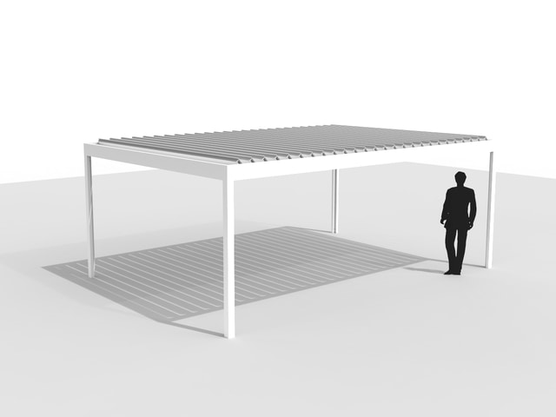

Your product features

Base structure

Product type  Algarve Line |  | 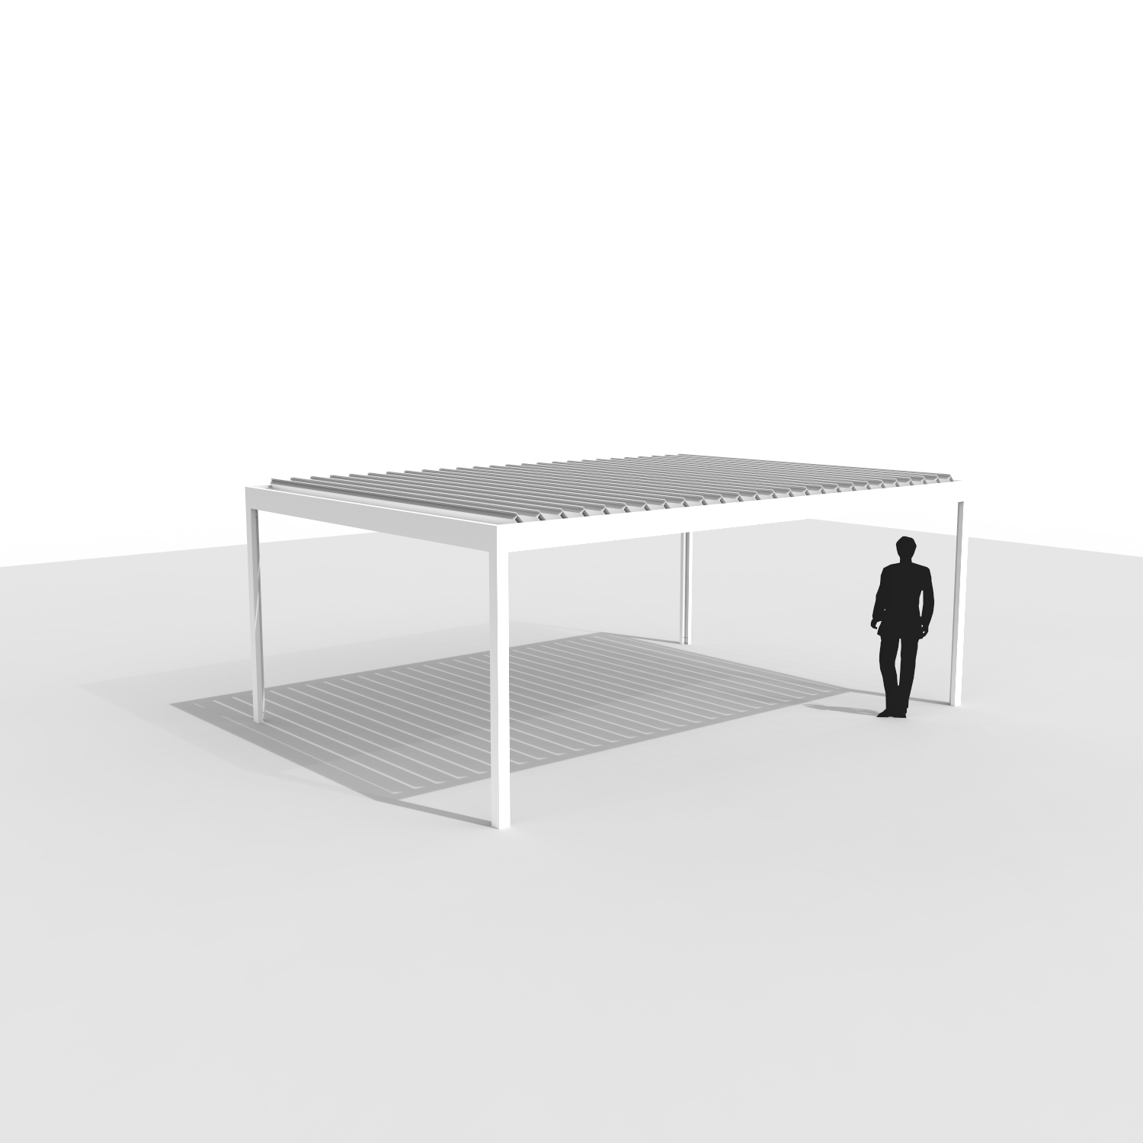
Design
Algarve
Dimension Span
3500 mm
Dimension Pivot
5410 mm
Passage height
2400 mm
Colour frame and columns
Quotation TOP RAL - Textured colours
Col lam
Quotation TOP RAL - Textured colours
Motor-side 1
P1
Drainage blade
Non-motor side
Blade rotation 1
Sunprotection

Your offer.

Document: | 20/074046/0
Reference: | SO10259 Beaumann
Contact:
Billing address: |  | Placement address
Town: |  | Town
E-mail:
Phone:
ALG3 Algarve Line
- Seaside Quality A
- Colour blades: OFF-TOPS Frame : OFF-TOPS
- OFF-TOPS - Quotation TOP RAL - Textured colours
- Passage height 2400 mm
TOTAL Inc GST £13,013.00

Ordersignature
Done in two copies of which each party acknowledges having received one copy.
Signed: Date:

Vendor: Customer:

