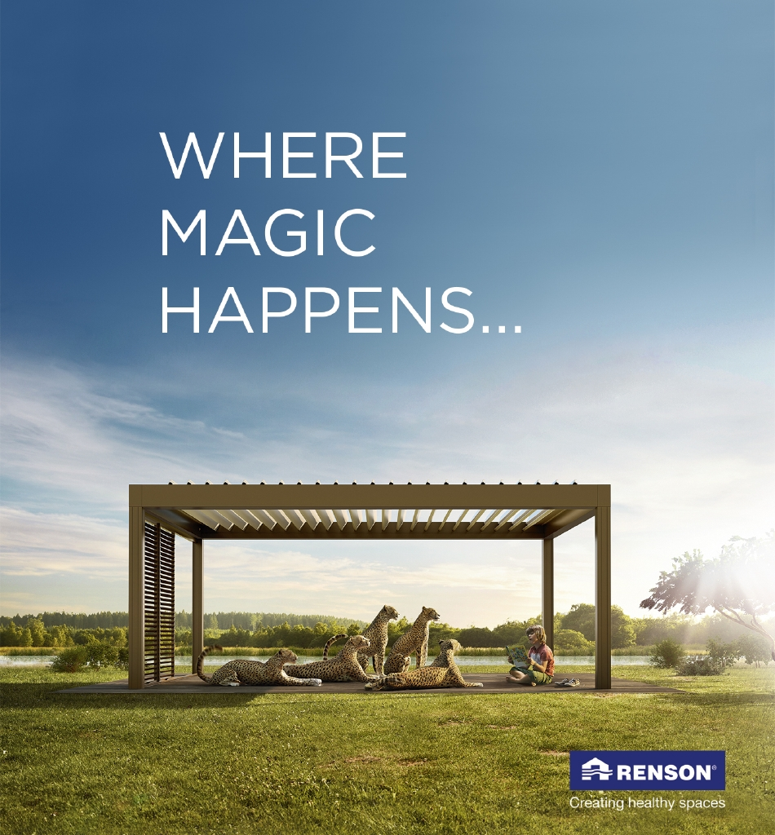
Document: 20/075682/1 CP Interiors
Reference: Wildways 28 Rue des Pres. Tr. Est.
Contact: JE2 7QN Jersey
Tel.1534768141

Thank you for your interest in the Renson Outdoor products.
We offer you a personalized quote.
For more information, visit the website at this link.

Camargue

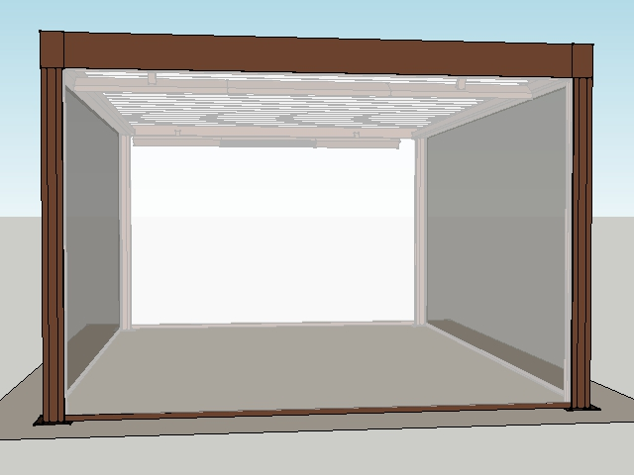

Your product features

Base structure

Product type  Camargue® Single-part |  | 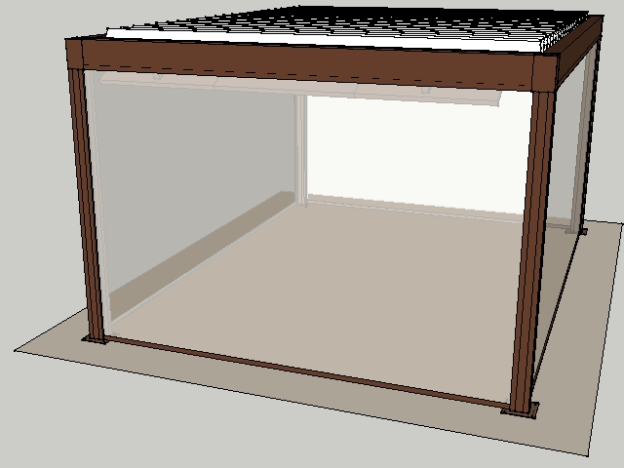
Dimension Span
4200 mm
Dimension Pivot
5500 mm
Passage height
2600 mm
Colour frame and columns
RAL 8040 Matt
Col lam
Quotation Renson not-standard colour
Motor-side 1
P1
Blade rotation 1
Sunprotection

Your product options

Beam Heat  The comfort in your terrace covering is increased even more thanks to the design beam with an integrated heating system.  The heating system uses a short-wave infrared transmitter that can be screened using a heat-resistant, black, ceramic glass plate.  The Beam can also be equipped with weather-resistant, 4-ohm speakers. | 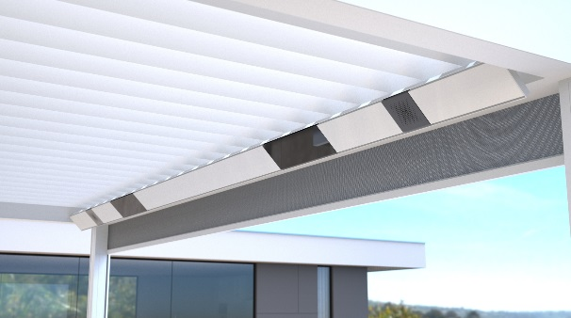

UpDown LED  Integrated LED lighting on the inside of the frame. Fitted with upwards and downwards lighting.  This lets you create indirect and/or direct atmospheric lighting.  A total of two UpDown LED lighting modules can be installed per roof section.  The LEDs are dimmable.  Up lighting is available in:  - warm white (3000 K): perfect for creating ambiance, cosy gatherings, etc.  - pure white (5000 K): perfect for reading, etc.  - RGB: perfect for creating the right ambiance  Down lighting is available in:  - warm white (3000 K): perfect for creating ambiance, cosy gatherings, etc.  - pure white (5000 K): perfect for reading, etc. | 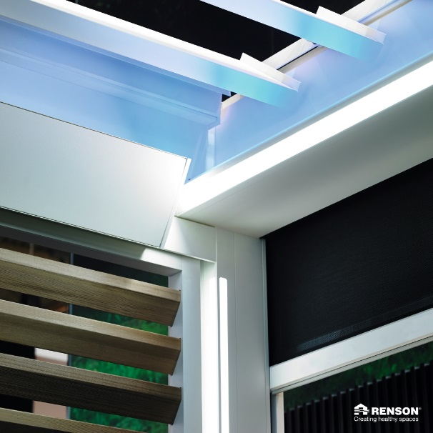

Lineo LED  Integrated LED lighting in the blades ensures even distribution without visible bright spots thanks to high-quality LEDs (180 per metre).  The LEDs are dimmable.  Available in  - warm white (3000 K): perfect for creating ambiance, cosy gatherings, etc.  - pure white (5000 K): perfect for reading, etc. | 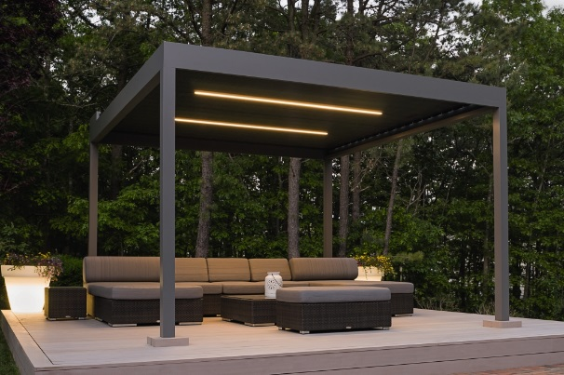

Integrated Fixscreen®  Integrated Fixscreens come in 50 colours, allowing you to customise your terrace covering and create the atmosphere you desire.  The terrace covering’s frame profiles are developed in such a way that the bottom bar is aesthetically hidden away in the box when the screen is raised.  Perfect integration into the frame and column, even after installation. | 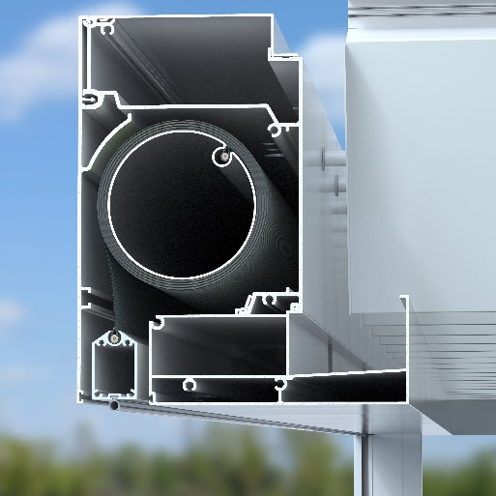

Your offer.
Document: | 20/075682/1
Reference: | Wildways
Contact:
Billing address:
Town:
E-mail:
Phone:

Structure
Camargue® Single-part

Options
- Fixscreen P1.1 : Fixscreen Sergé/Natté/Privacy
- Fixscreen P2.1 : Fixscreen Sergé/Natté/Privacy
- Fixscreen S1.1 : Fixscreen Sergé/Natté/Privacy
- Fixscreen S2.1 : Fixscreen Sergé/Natté/Privacy
- Number of LED blades : 3
- Beam Heat/Sound S1 : 1 Beam with 1 Heat
- Beam Heat/Sound S2 : 1 Beam with 1 Heat
- Heating Receiver : 1 RTS Beam Heat/Sound receiver per Heat
- UpDown LED : Up LED
- Handheld transmitters : G6002774 - Somfy Telis 16 Pure white

00006231 RAL surcharge Outdoor
- Colour inside: OFF-RSPE outside: V9001044
- OFF-RSPE - Quotation Renson not-standard colour
- V9001044 - M4K0024 - RAL 8040 Matt

