
Document: 20/071253/3 CP Interiors
Reference: SO10134 Therezien 28 Rue des Pres. Tr. Est.
Contact: JE2 7QN Jersey
Tel.1534768141

Thank you for your interest in the Renson Outdoor products.
We offer you a personalized quote.
For more information, visit the website at this link.

Camargue

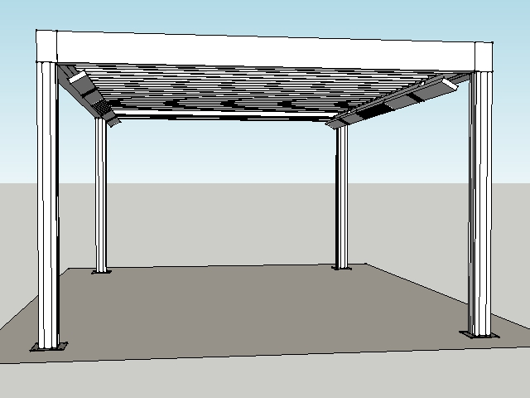

Your product features

Base structure

Product type  Camargue® Single-part |  | 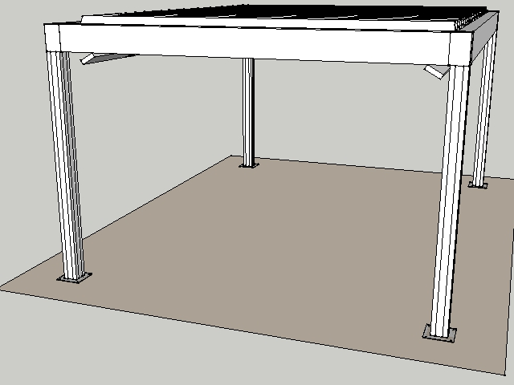
Dimension Span
4000 mm
Dimension Pivot
5500 mm
Passage height
2400 mm
Colour frame and columns
Quotation TOP RAL - Textured colours
Col lam
Quotation TOP RAL - Textured colours
Motor-side 1
P1
Blade rotation 1
Sunprotection

Your product options

Beam Heat  The comfort in your terrace covering is increased even more thanks to the design beam with an integrated heating system.  The heating system uses a short-wave infrared transmitter that can be screened using a heat-resistant, black, ceramic glass plate.  The Beam can also be equipped with weather-resistant, 4-ohm speakers. | 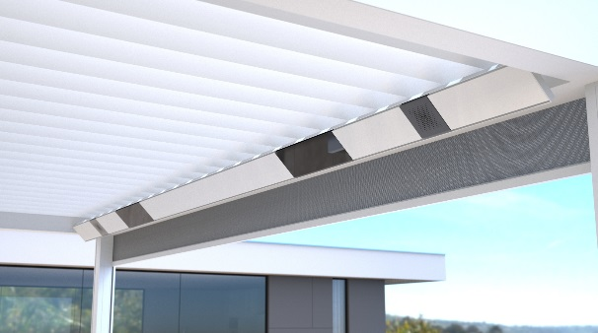

UpDown LED  Integrated LED lighting on the inside of the frame. Fitted with upwards and downwards lighting.  This lets you create indirect and/or direct atmospheric lighting.  A total of two UpDown LED lighting modules can be installed per roof section.  The LEDs are dimmable.  Up lighting is available in:  - warm white (3000 K): perfect for creating ambiance, cosy gatherings, etc.  - pure white (5000 K): perfect for reading, etc.  - RGB: perfect for creating the right ambiance  Down lighting is available in:  - warm white (3000 K): perfect for creating ambiance, cosy gatherings, etc.  - pure white (5000 K): perfect for reading, etc. | 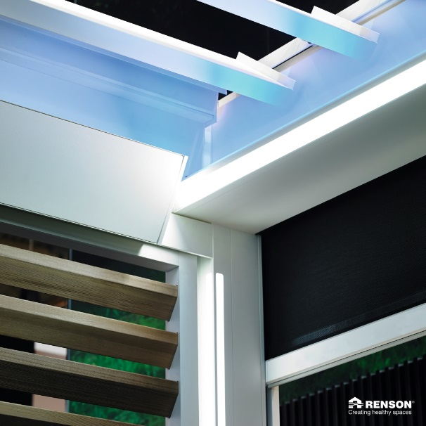

Lineo LED  Integrated LED lighting in the blades ensures even distribution without visible bright spots thanks to high-quality LEDs (180 per metre).  The LEDs are dimmable.  Available in  - warm white (3000 K): perfect for creating ambiance, cosy gatherings, etc.  - pure white (5000 K): perfect for reading, etc. | 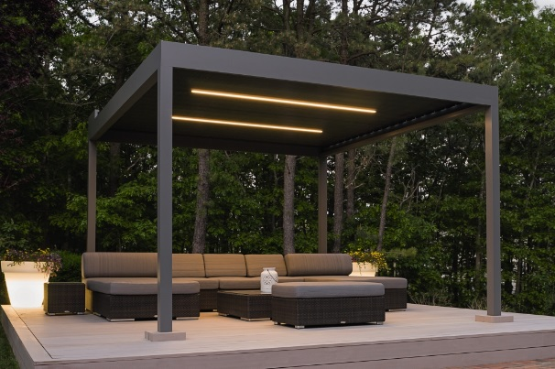

Your offer.
Document: | 20/071253/3
Reference: | SO10134 Therezien
Contact:
Billing address: |  | Placement address
Town: |  | Town
E-mail:
Phone:

TOTAL Inc GST £30,907.00

Ordersignature
Done in two copies of which each party acknowledges having received one copy.
Signed: Date:

Vendor: Customer:

