
Document: 20/071412/1 CP Interiors
Reference: SO10126 Long 28 Rue des Pres. Tr. Est.
Contact: JE2 7QN Jersey
Tel.1534768141

Thank you for your interest in the Renson Outdoor products.
We offer you a personalized quote.
For more information, visit the website at this link.

Algarve Line
(Note: the images are only indicative, the product delivered may differ from the images shown)

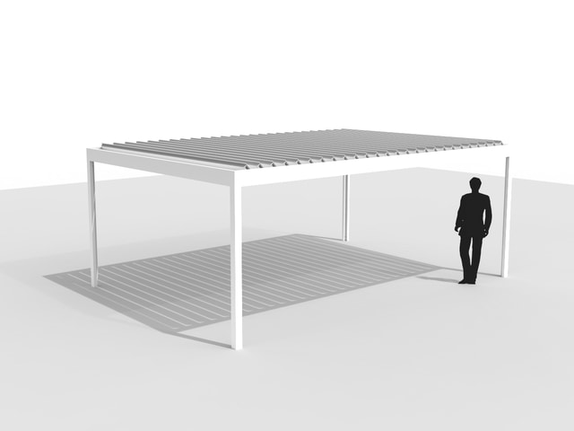

Your product features

Base structure

Product type  Algarve Line |  | 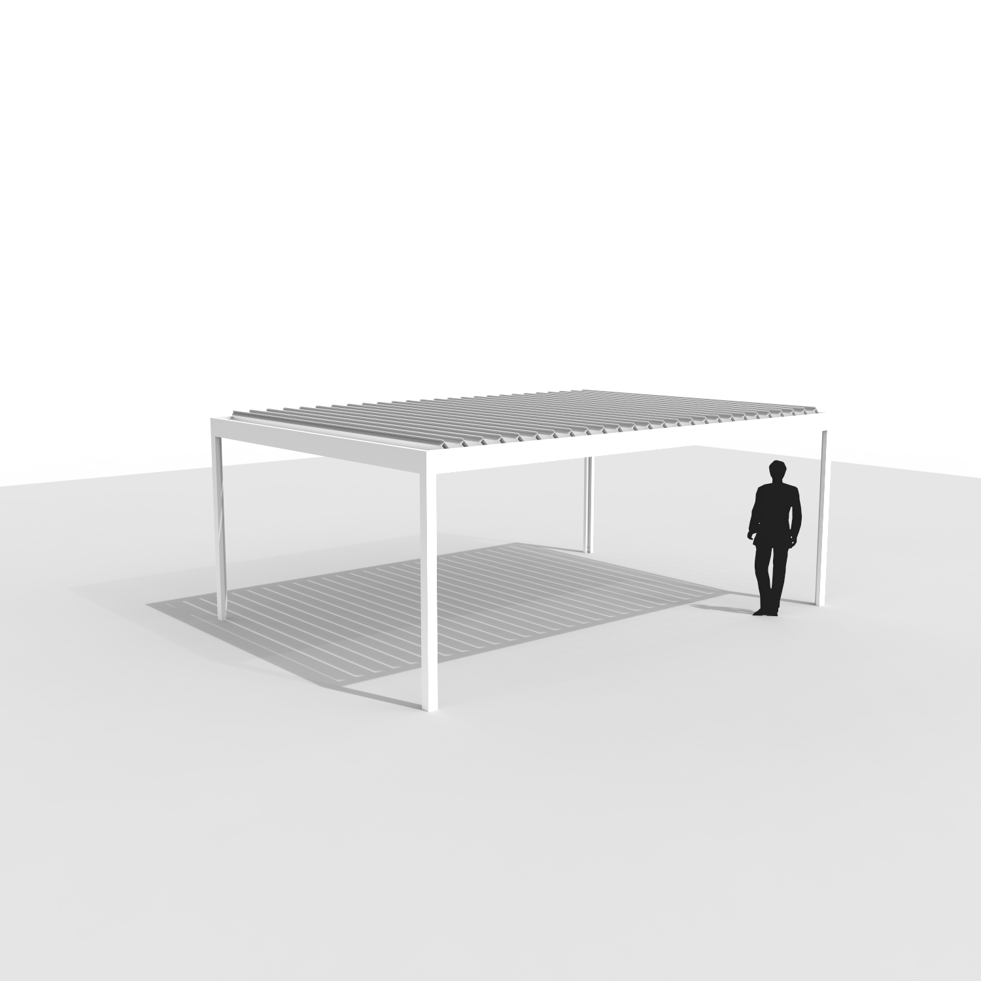
Design
Algarve
Dimension Span
4500 mm
Dimension Pivot
4000 mm
Passage height
2400 mm
Colour frame and columns
Quotation TOP RAL - Textured colours
Col lam
Quotation TOP RAL - Textured colours
Motor-side 1
P1
Drainage blade
Non-motor side
Blade rotation 1
Sunprotection

Thank you for your interest in the Renson Outdoor products.
We offer you a personalized quote.
For more information, visit the website at this link.

Fixscreen® 100 EVO Slim MS7A Freestanding

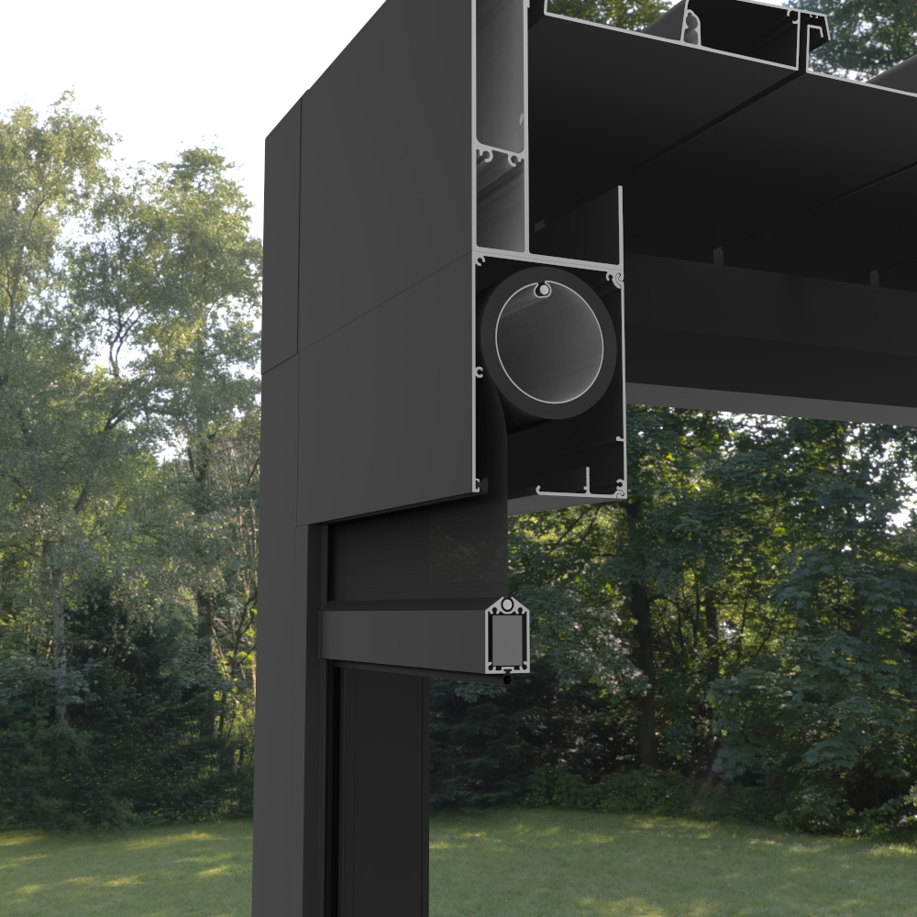

Your product features
Product type
Fixscreen® 100 Slim Freestanding IM7A
Width
4278 mm
Higth
2395 mm
Color
Quotation Renson standard colour
Type of fabric
Fibreglass fabric Sergé
Fabric code
Quotation Fibre glass fabric Sergé
Confection
Confection 1
Side channel left
Deep side channel (D)
Side channel right
Deep side channel (D)
Crystal window
Without crystal window in the full width

Thank you for your interest in the Renson Outdoor products.
We offer you a personalized quote.
For more information, visit the website at this link.

Fixscreen® 100 EVO Slim MS7A Freestanding

Your product features
Product type
Fixscreen® 100 Slim Freestanding IM7A
Width
3778 mm
Higth
2395 mm
Color
Quotation Renson standard colour
Type of fabric
Fibreglass fabric Sergé
Fabric code
Quotation Fibre glass fabric Sergé
Confection
Confection 1
Side channel left
Deep side channel (D)
Side channel right
Deep side channel (D)
Crystal window
Without crystal window in the full width

Your offer.

Document: | 20/071412/1
Reference: | SO10126 Long
Contact:
Billing address: |  | Placement address
Town: |  | Town
E-mail:
Phone:
ALG3 Algarve Line
- Seaside Quality A
- Colour blades: OFF-TOPS Frame : OFF-TOPS
- OFF-TOPS - Quotation TOP RAL - Textured colours
- Passage height 2400 mm
FE107SFA Fixscreen® 100 Slim Freestanding IM7A
- Windproof vertical screen
- Freestanding, hidden installation in front/above the construction
- No wrinkles or folds
- 5-year guarantee on the Fixscreen® technology
- Box (HxD): 150x110 mm
- Wind resistance up to 60 km/h
- Seaside Quality A
- Colour: OFF-TOPR
- OFF-TOPR - Quotation Renson standard colour

TOTAL Inc GST GBP £19,973.10

Ordersignature
Done in two copies of which each party acknowledges having received one copy.
Signed: Date:

