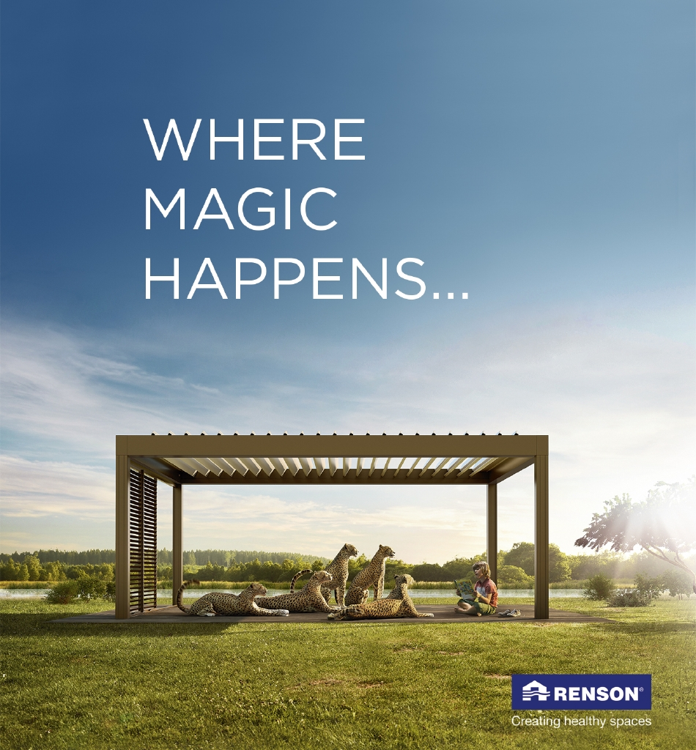
Document: 20/095818/0 CP Interiors
Reference: Le Vesconte 8m x 4m 28 Rue des Pres. Tr. Est.
Contact: Jersey, JE2 7QN
Tel.1534768141

Thank you for your interest in the Renson Outdoor products.
We offer you a personalized quote.
For more information, visit the website at this link.

Camargue

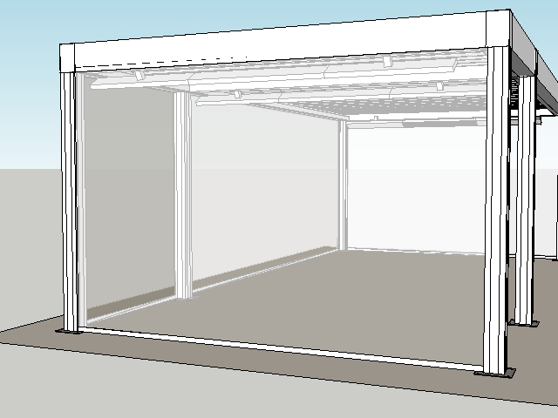

Your product features

Base structure

Product type  Camargue® 2-parts - Coupled at span side |  | 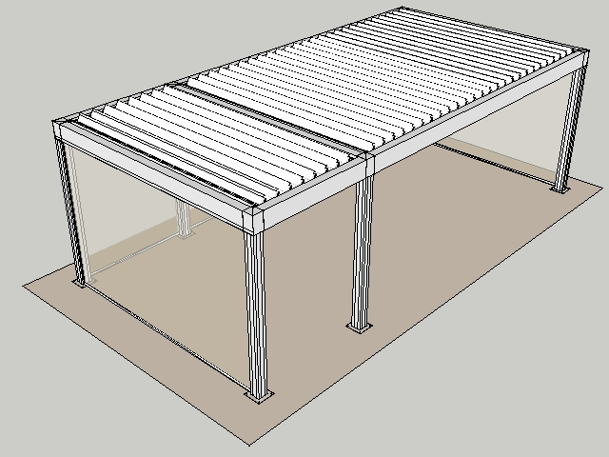
Dimension Span
4000 mm
Dimension Pivot
6000 mm
Span 2
4.000
Pivot 2
2.000
Passage height
2400 mm
Colour frame and columns
Quotation TOP RAL - Textured colours
Col lam
Quotation TOP RAL - Textured colours
Motor-side 1
P2
Motor-side 2
P2
Blade rotation 1
Sunprotection
Blade rotation 2
Sunprotection

Your product options

Beam Heat  The comfort in your terrace covering is increased even more thanks to the design beam with an integrated heating system.  The heating system uses a short-wave infrared transmitter that can be screened using a heat-resistant, black, ceramic glass plate.  The Beam can also be equipped with weather-resistant, 4-ohm speakers. | 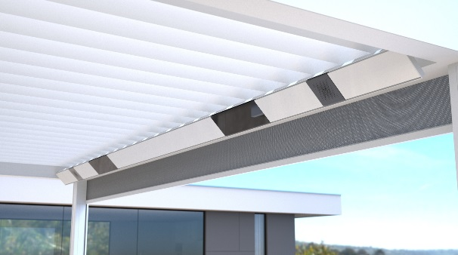

UpDown LED  Integrated LED lighting on the inside of the frame. Fitted with upwards and downwards lighting.  This lets you create indirect and/or direct atmospheric lighting.  A total of two UpDown LED lighting modules can be installed per roof section.  The LEDs are dimmable.  Up lighting is available in:  - warm white (3000 K): perfect for creating ambiance, cosy gatherings, etc.  - pure white (5000 K): perfect for reading, etc.  - RGB: perfect for creating the right ambiance  Down lighting is available in:  - warm white (3000 K): perfect for creating ambiance, cosy gatherings, etc.  - pure white (5000 K): perfect for reading, etc. | 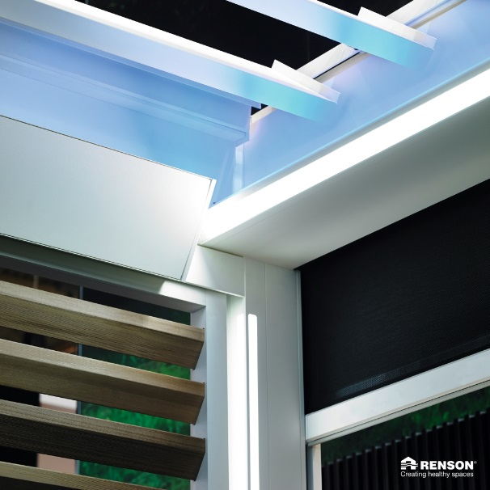

Lineo LED  Integrated LED lighting in the blades ensures even distribution without visible bright spots thanks to high-quality LEDs (180 per metre).  The LEDs are dimmable.  Available in  - warm white (3000 K): perfect for creating ambiance, cosy gatherings, etc.  - pure white (5000 K): perfect for reading, etc. | 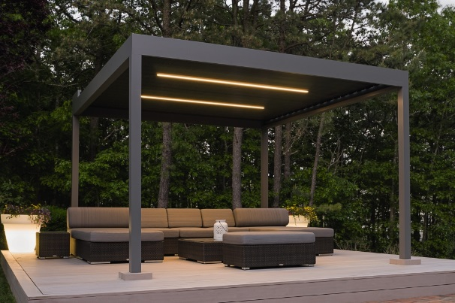

Integrated Fixscreen®  Integrated Fixscreens come in 50 colours, allowing you to customise your terrace covering and create the atmosphere you desire.  The terrace covering’s frame profiles are developed in such a way that the bottom bar is aesthetically hidden away in the box when the screen is raised.  Perfect integration into the frame and column, even after installation. | 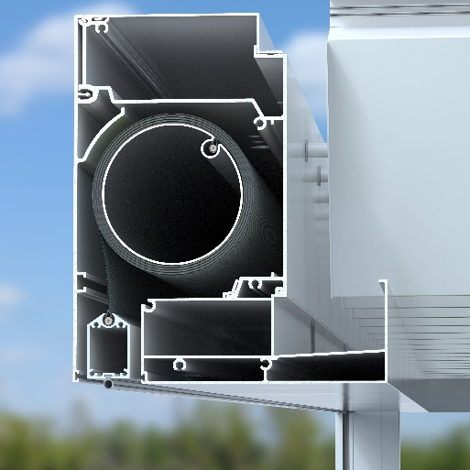

Your offer.
Document: | 20/095818/0
Reference: | Le Vesconte 8m x 4m
Contact:
Billing address:
Town:
E-mail:
Phone:

Structure
- Camargue® 2-parts span 30,338,00 GBP
- Corner 1A : Column at the corner
- Corner 1B : Column at the corner
- Corner 2A : Column at the corner
- Corner 2B : Column at the corner
- Camargue C2 : Camargue 2
- Corner 3A : Column at the corner
- Corner 3B : Column at the corner

Options
- Fixscreen P1.1 : Fixscreen Sergé/Natté/Privacy
- Fixscreen S2.1 : Fixscreen Sergé/Natté/Privacy
- Fixscreen P1.1 : Fixscreen Sergé/Natté/Privacy
- Fixscreen S1.1 : Fixscreen Sergé/Natté/Privacy 9,212,00 GBP

- Number of LED blades : 3 (6m section) warm white
- Number of LED blades : 1 (2m section) warm white 4.075,00 GBP

- Beam Heat S1 : 1 Beam with 1 Heat
- Beam Heat S2 : 1 Beam with 1 Heat
- Beam Heat S1 : 1 Beam with 1 Heat
- Heating Receiver : 1 RTS Beam Heat/Sound receiver per Heat 6.325,00 GBP

- UpDown LED : Up LED warm white
- UpDown LED : Up LED warm white 4.834,00 GBP

- Handheld transmitters : G6002774 - Somfy Telis 16 Pure white 244,00 GBP

TOTAL 55.028,00 GBP

Your offer.

Document: | 20/095818/0
Reference: | Le Vesconte 8m x 4m
Contact:
Billing address:
Town:
E-mail:
Phone:
CAM3 Camargue® 2-parts - Coupled at span side
- Seaside Quality A
- Colour blades: OFF-TOPS Frame : OFF-TOPS
- OFF-TOPS - Quotation TOP RAL - Textured colours
- Passage height 2400 mm

