Important daily Care of umbrellas

Set Up
- Remove storage straps
- Using removable handle crank umbrella to fully open position
- Lift heater arms into position (before turning heaters on)

Breakdown
1. Turn heaters and lights off
2. Allow heaters to cool before lowering heater arms
3. Using removable handle crank umbrella to fully closed position
- Follow diagrams below to fold umbrella fabric ensuring that no fabric is trapped in umbrella ribs
- Secure using storage straps as show
WARNING! Please ensure heaters cannot be turned on when umbrellas are closed as this will cause irreparable damage.

Winter storage covers have been supplied to be put on at the end of the season and removed prior to beginning of season.
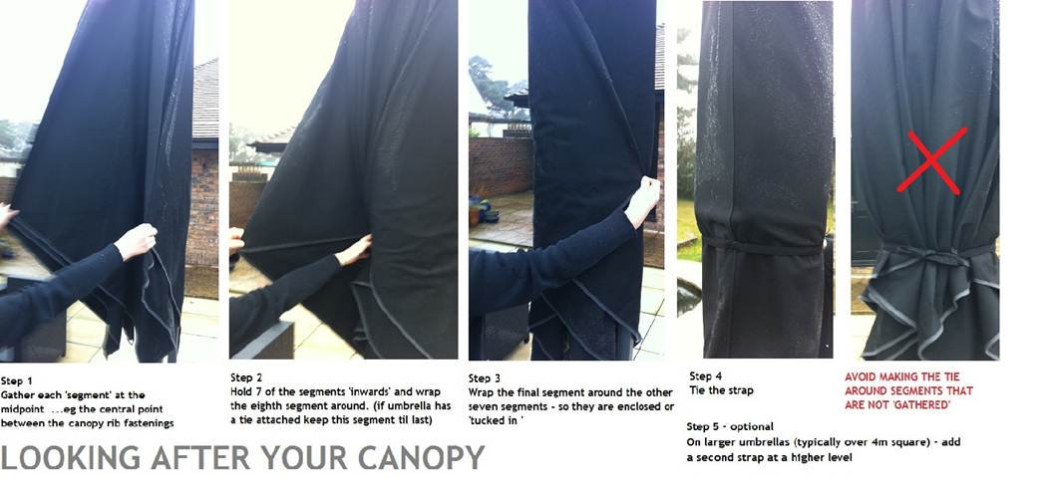

Because the 5m square is so large – you may need to secure it with additional ties in strong winds when it is closed – here is a ‘best practice’ example from a place on Bournemouth seafront

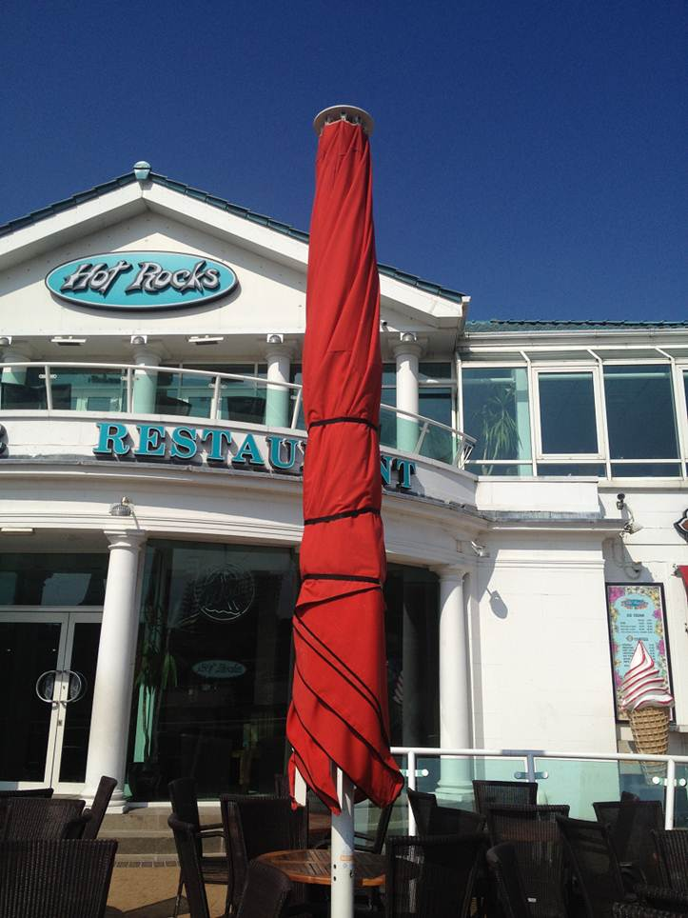



Rue des Pres Trading Estate
St Saviour
JE2 7QN
www.cpsunblinds.co.uk
T. 01534 768141

