09373 – Bates – Shaped Curtains – Double Pinch Pleat
Fabric - C&C Pittura Natural F1696/04 (Blackout Lining)
Matching tie backs – Self Piped
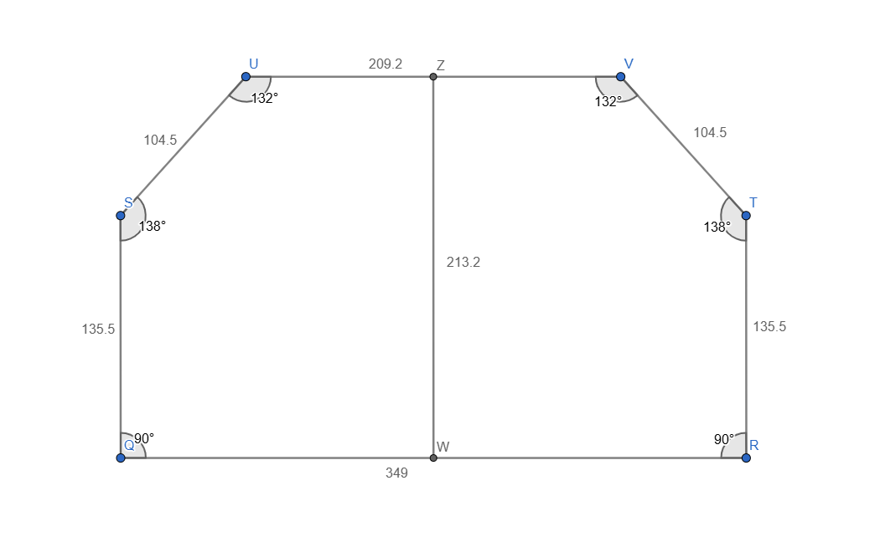
These angled edges may be
velcro’d to the track

